Lecture 10: Agenda-Setting

1. The Policy Process (position of agenda-setting)
Agenda-setting is the first stage of the policy cycle. It determines which demands enter the political system and become issues that policymakers agree to consider and potentially act upon.
It precedes policy formulation, legitimation, implementation, evaluation, and policy maintenance/succession/termination.

2. The Agenda: Definition and Clarifications
Core definition:
The agenda is the list of demands that policymakers agree to consider and, potentially, act upon.
What the agenda is not:
- Not the sum of all political demands circulating in society. Only a subset reaches the agenda.
- Not an ideological plan or program (e.g., not a “left-wing” or “right-wing” agenda in the colloquial sense).
- Not inherently pejorative. It does not imply manipulation or “hidden agendas.”

How to identify what is currently on the agenda:
- Executive agendas: Documents or speeches where the executive signals priorities.
Examples: coalition memorandum, government declaration, the Monarch’s Speech in the UK, the US State of the Union Address.
- Public agendas of parliaments and committees: The formal list of bills (proposed laws that a legislature discusses and may vote to approve) or issues scheduled for discussion.
Examples: UK “Bills before Parliament,” Saeima’s sēžu darba kārtība in Latvia.

Interpretation:
The agenda is a selective list – only items with sufficient political attention, pressure, or institutional relevance move onto it.

3. Levels of the Agenda (Birkland 2020)
Birkland’s model illustrates that not all issues in society are equally close to decision-making. Agenda-setting is a struggle over movement between these levels.
- Agenda Universe
  - All conceivable social issues and demands.
  - Most items here never enter formal politics.
- Systemic Agenda
  - Issues recognized as worthy of public concern and political discussion.
  - They are legitimate topics, but no institution is yet required to act on them.
- Institutional Agenda
  - Issues that political institutions (parliament, cabinet, committees) formally acknowledge and agree to consider.
  - They may be referred to committees, included in legislative calendars, or discussed in hearings.
- Decision Agenda
  - Issues scheduled for active decision-making.
  - The stage closest to binding policy choices (votes, regulatory decisions, budget allocations).
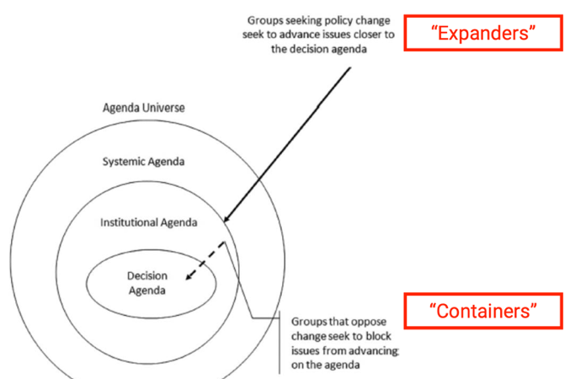
Actors in agenda movement:
- “Expanders”: Groups seeking policy change try to push issues inwards from systemic → institutional → decision agendas.
They elevate the salience of an issue using media, framing, advocacy, political entrepreneurship.
- “Containers”: Groups opposing change try to prevent issues from advancing, keeping them in outer layers.
They block attention, contest problem definitions, or exploit institutional bottlenecks.

4. Competition for Attention
Agenda-setting involves fierce competition among actors attempting either to gain or deflect public and elite attention.
A fierce competition for gaining or deflecting attention:
- Schattschneider’s insight:
  - “The definition of the alternatives is the supreme instrument of power.”
  - Control over problem definition shapes which solutions are considered legitimate.
- Problem definition is not purely objective:
  - Problems rarely present themselves fully formed; actors interpret data through values, interests, and narratives.
  - Observer-independent data alone does not determine political relevance.
- Path-dependency:
  - Actors who successfully define a problem early gain comparative advantage in specifying solutions later.
  - Early framings create cognitive and institutional “tracks” that are hard to deviate from.
- Agenda congestion:
  - Policymakers can only handle a very small number of issues at once.
  - Most problems never reach institutional attention.

Problem definition as a social process:
  - Agenda-setting is “story-telling” – framing events, assigning causes, identifying villains and victims.
  - A convincing causal story is essential for mobilizing attention and prompting action.

5. Problems Competing for Attention
This section transitions into examples showing how different actors frame the same phenomenon as a problem – or not a problem.
The central claim: attention is not automatic; it must be created and politically cultivated.

6.1 Defining a Problem: Case 1 – Golden Visas
Initial framing:
Golden visas (You invest money → you get residency rights or even citizenship) were promoted positively by industry actors:
- Marketed as tools for “global mobility.”
- Framed as “insurance policies” against economic and political instability.
- Presented as beneficial for high-net-worth individuals and advantageous to host countries (FDI, real-estate investment, post-crisis recovery).
Key point:
No “problem” exists unless actors define it as such. Early industry actors framed golden visas as opportunities, not risks.

6.2 Policy Context (Europe by March 2022)
A map shows wide variation across Europe in investor visas and citizenship-by-investment schemes:
- Orange: jurisdictions with investor visa programs (residence-by-investment).
- Purple: jurisdictions with both investor visas and citizenship-by-investment.
- Grey: no investor programs.
This snapshot establishes the policy landscape into which EU-level concerns emerged.
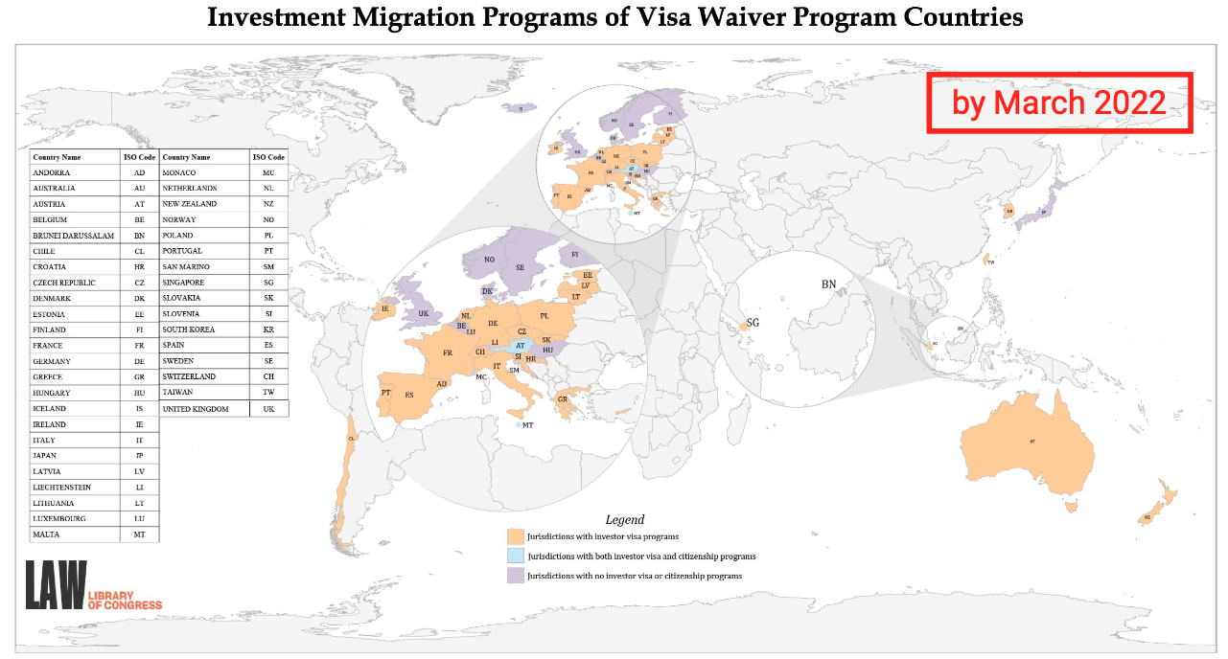

6.3 How Golden Visas Moved onto the EU Agenda
A timeline illustrates how reframing transformed golden visas from a marginal policy tool into an EU-level security concern.

Before ~2017:
- Predominantly positive framing:
  - Seen as FDI (Foreign Direct Investment) boosters, economic lifelines for peripheral states, mechanisms “bridging” East and West.
Post-2017:
- Civil society backlash; investigative journalism (e.g., Cyprus Papers) shifts the framing.
- New image: golden visas as safe havens for corrupt individuals, money laundering, and criminal networks.
August 2018:
- European Commission urges restrictions and new regulations.
- Describes golden visa programs as “a serious security risk.”
2019:
- After the EU elections, proposals for stronger due diligence stall, but civil society continues applying pressure.
March 2022:
- EC calls on Member States to repeal (cancel) investor citizenship schemes and strengthen checks for investor residence schemes.
2020–2025:
- Several states (Cyprus, UK, Ireland, Portugal, Montenegro) close or tighten their programs.

Interpretation:
This case demonstrates the reframing mechanism in agenda-setting:
Positive → negative → security-sensitive issue → regulatory action.

7. Defining a Problem: Case 2 – Latvia and the Istanbul Convention
The slide shows international news coverage reacting to Latvia’s vote to withdraw from the Istanbul Convention.
Key analytical points:
- The issue is framed dramatically differently across actors:
  - International outlets frame it as a threat to women’s protection (“pull out of treaty protecting women from violence”).
  - Domestic actors may frame it in terms of cultural sovereignty, opposition to perceived gender ideology, or constitutional identity.
- The problem definition becomes a battle over meaning:
  - Is the policy problem “violence against women”?
  - Or “international overreach into national values”?
  - Or “procedural legitimacy of treaty adoption”?
Agenda-setting depends on which framing gains traction.
Relevance:
This case demonstrates that problem definition is inherently normative and contested. Competing narratives attempt to impose different causal stories, each implying different solutions.

8. Characteristics of Problems that Reach the Agenda
Agenda-setting depends not only on objective conditions but on how actors define, frame, and communicate problems. Rochefort & Cobb (1995) identify several dimensions through which actors construct attention and mobilize support. These characteristics help explain why some issues rise quickly to the agenda while others remain invisible.

8.1 Causality: What Causes the Problem?
Understanding who or what is responsible is central in agenda-setting. Causality determines blame, urgency, and the types of solutions considered legitimate.
- Golden Visas: The issue is framed as resulting from white-collar crime (non-violent, financially motivated offenses typically committed by professionals *fraud, bribery), geopolitical adversaries (countries that oppose each other’s political or strategic interests), and the exploitation of European legal vulnerabilities. The causal story suggests intentional misuse by external actors, which heightens perceived urgency.
- Istanbul Convention opponents: They frame the Convention as a “Trojan horse” – a foreign ideological intrusion that threatens Latvian values. Thus, the “cause” becomes external pressure rather than the underlying problem of gender-based violence.

Framing causality constructs villains and shapes political responsibility. Different actors compete to impose their preferred causal story, which can radically shift the direction of debate.

8.2 Severity: How Serious Is the Problem?
Severity determines whether an issue is treated as minor, manageable, or existential. Actors strategically amplify or downplay seriousness to influence agenda placement.
- Golden Visas: The problem is framed as super serious, with national security and EU integrity at stake.
- Istanbul Convention opponents: They describe the threat as equally super serious, capable of undermining the “core family” and national identity.

Framing an issue as severe makes action appear necessary and urgent. Political actors often inflate severity to compete for limited attention.

8.3 Proximity: How Immediately Is the Problem Felt?
Proximity concerns how close – temporally or socially – the consequences appear. Issues framed as happening now or affecting familiar contexts attract more attention.
- Golden Visas: Consequences such as sanctions, corruption risks, or reputational damage are framed as immediate and unavoidable.
- Istanbul Convention opponents: They claim immediate impacts on daily life (schools, workplaces, law enforcement).

High proximity increases public pressure, making it harder for policymakers to ignore the issue.

8.4 Crisis Character: Does the Problem Require Urgent Action?
Crisis framing introduces a “now or never” logic. Problems become seen as catastrophic unless addressed quickly.
- Golden Visas: Framed as requiring action “or else the enemy wins,” linking the issue to geopolitical struggle.
- Istanbul Convention opponents: They warn of a demographic abyss or cultural loss if immediate action is not taken.

When a problem is framed as a crisis, delay becomes politically costly. Crisis framing accelerates agenda movement.

8.5 Incidence: How Many People Are Affected?
Incidence measures the breadth of the affected population. Problems framed as widespread seem more legitimate and pressing.
- Golden Visas: Everyone in the EU is potentially harmed by sanctions or loss of trust in European systems.
- Istanbul Convention opponents: They argue that “foreign values” affect all 1.8 million Latvian residents.

The greater the incidence, the easier it is to build broad coalitions for attention and action.

8.6 Novelty: Is the Problem New or Unprecedented?
Novel issues attract attention because institutions lack ready-made solutions, making them appear risky or urgent.
- Golden Visas: Advocates argue that “never has Europe faced such threats” – highlighting the program’s unprecedented risks.
- Istanbul Convention opponents: They claim “never has the liberal agenda been more threatening,” portraying the situation as historically unique.

Novelty frames justify exceptional political responses and make issues more noticeable.

8.7 Problem Populations: Can the Target Group Be Emotionally Framed?
Attention increases when actors can attach the issue to affectively compelling groups – victims, children, vulnerable families, or communities.
- Golden Visas: The EU is framed as a vulnerable democracy, acting in good faith but exploited by malicious actors.
- Istanbul Convention opponents: The phrase “Don’t touch our children!” transforms the debate into one about innocent victims needing protection.

Emotional resonance accelerates agenda movement because it creates strong public identification with the perceived victims.

9. Focusing Events
Focusing events are rare, sudden, well-known, and harmful occurrences that generate immediate attention. They serve as catalysts, pushing neglected issues onto the agenda.
- They attract massive and rapid attention to underlying problems.
- Examples include disasters, scandals, crises, or high-profile policy failures.
- They create policy windows, enabling policy entrepreneurs to advocate for solutions that previously lacked momentum.

However, focusing events also reveal limitations:
- Dramatic threats receive disproportionate attention compared to chronic issues.
- Public interest tends to fade quickly, whereas policymaking processes are slow.
- Without strategic follow-up, the attention spike often fails to produce lasting reform.

Overall, focusing events jolt the system into temporary responsiveness but do not guarantee long-term change.

10. Changes in Indicators
Indicators are statistical measures used as evidence that a problem exists. Because indicators are measurable, they heavily influence what gets recognized as politically actionable.
Key points:
- Problems that are easily measured are more likely to reach the agenda.
- Choosing the “correct” indicator is often politically contested (poverty line vs. welfare; unemployment vs. underemployment; race vs. racism; GDP vs. well-being).
- Indicators shape governance – what you measure affects what you do.

Examples of widely used indicators:
- PISA (OECD) for education.
- Corruption Perception Index (Transparency International).
- Ease of Doing Business Index (World Bank) (now discontinued).

Indicators are not neutral. They construct problems by defining what counts as evidence and which issues deserve institutional attention.

11. Downs’ Issue Attention Cycle
Anthony Downs (1972) argues that public attention follows a predictable five-stage cycle, explaining why some issues fade despite initial enthusiasm.
- Pre-problem stage:
Low public awareness; only experts and advocacy groups are concerned.
- Alarmed discovery and euphoric enthusiasm:
The public realizes the issue is serious and expects quick, decisive solutions.
- Realization of the cost of significant progress:
People recognize that meaningful change requires substantial investment, sacrifice, or behavioral adjustment.
- Gradual decline of intense public interest:
Initial enthusiasm wanes; attention shifts to new issues.
- Post-problem stage:
The issue becomes dormant, but institutions created during the crisis often remain in place.

Modern research shows that the cycle has become faster: attention is more volatile, and issues rise and fall increasingly quickly.

12. The Agenda-Setting Role of the Media
The media play a central role in shaping what people perceive as important. They do not simply reflect reality; they select, highlight, and frame issues in ways that influence both the systemic and institutional agendas.
Key functions:
- Amplifying certain issues while downplaying others.
- Choosing which events and voices receive coverage.
- Setting “what to think about,” even if not “what to think.”
Through these choices, the media create asymmetries in political visibility and can make certain problems appear urgent even when they are not objectively more severe than others.

13. The Media – Policy Nexus
This dynamic illustrates how media coverage can trigger a chain reaction within political and administrative institutions.
The Swiss financial regulation example demonstrates this process:
- A notable event occurs (accident, scandal, irregularity).
- Journalists ask regulators to comment, creating pressure to appear attentive.
- The media publish articles stating that the regulator is “worried.”
- Prosecutors respond publicly.
- Politicians step in, demanding action.

This becomes a self-fulfilling prophecy: each actor responds to perceived pressure created by the previous step. The media thus act as catalysts, accelerating the movement of certain issues toward the decision agenda.

14. The Agenda-Setting Power of TV News – Effect of Content Type
Cable news has a powerful agenda-setting function because it shapes what viewers perceive as important problems. The slide compares how different types of content affect TV viewership and therefore public attention.
Key insight:
Culture-war content (political and social conflict between groups with different values, identities, and beliefs) attracts more attention than economic content. Issues likae crime/terrorism, anti-elite narratives, race/gender conflicts, and immigration generate noticeable increases in viewership. Economic topics – education, healthcare, welfare, economic policy – tend to decrease or only mildly increase attention.
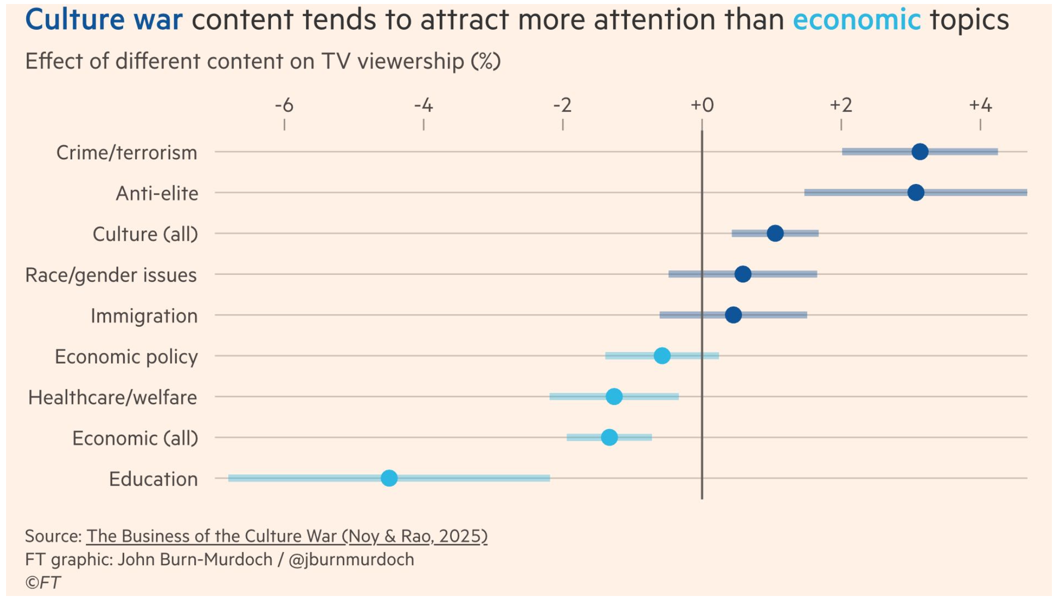
Implications for agenda-setting:
- Culture-war themes provide higher “attention returns,” making them attractive for broadcasters seeking engagement.
- This skews the public problem agenda toward high-salience, emotionally activating cultural conflicts rather than slow-moving economic issues.
- Politicians and other agenda entrepreneurs respond strategically, knowing these topics mobilize audiences and receive more coverage.

15. Cable News and the Rise of Cultural Polarisation
The introduction and growth of cable news changed long-term patterns of political attention in the US. The graphs show two trends:

1. Polarisation over time
- After the launch of cable news (around the 1990s), polarisation (people or groups becoming sharply divided into two opposing sides) on cultural issues increases sharply compared to economic issues, which remain comparatively stable.
- This suggests cable news amplified value-laden, identity-driven conflicts.

2. Public perception of “most important issues”
- The share of Americans naming a polarising cultural issue as the most important rises significantly post-2000.
- Culture-war attention expands especially steeply after the early 2000s.

Interpretation:
Cable news acts as a polarisation accelerator, particularly for cultural topics. The slide even notes that cable news growth accounts for roughly one-third of the increase in cultural conflict since 2000. This illustrates how media power is not neutral – it shapes the contours of national debate.

16. When Do Media Maximize Their Agenda-Setting Power?
This slide presents a matrix showing how media influence depends on two conditions:
- Public awareness of an issue (high or low)
- Elite attitudes (consensus or dissensus)
Main logic:
- When awareness is high and elites agree → media reflect consensus.
- When awareness is high and elites disagree → media amplify dissensus, increasing conflict visibility.
- When awareness is low and elites agree → little media coverage, because there is neither controversy nor urgency.
- When awareness is low and elites disagree → media can take sides, influencing not just public opinion but potentially the government itself.
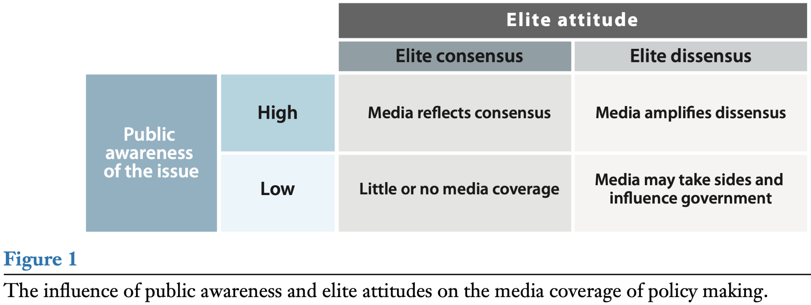

Interpretation:
Media power peaks when the public knows little and elites are divided. In such cases, journalists and editors essentially become agenda entrepreneurs.

17. The Agenda-Setting Power of Social Media
Social media alters the historical policy-media relationship in several ways:
- The media system becomes more hybrid: traditional outlets (newspapers/TV) lose gatekeeping capacity because information flows around them.
- New actors – influencers, activists, fringe outlets – gain visibility and can push issues onto the agenda without institutional mediation.
- Mainstream politicians increasingly respond to and monitor social-media dynamics.
- Governments lose control over the media agenda and must react to emerging, viral issues.
- There is growing evidence of ideological segregation in political news exposure, meaning citizens increasingly inhabit politically homogeneous information environments. => People are sorting themselves into separate, like-minded media bubbles, making public debate more polarized and less informed.

Implication:
Agenda-setting becomes more decentralized, competitive, and unpredictable. Viral dynamics can elevate issues quickly, bypassing traditional filters.

18. Algorithmic Curation and Polarisation (Facebook Study)
The study compares 2014 vs 2020 data on exposure to cross-cutting content – content from the opposing political side.
Findings:
- Across all panels (A, B, C), exposure to cross-cutting content declines sharply from “random” potential exposure to what users are actually exposed to and engage with.
- Conservatives exhibit especially low levels of cross-cutting exposure in 2020.
- Algorithms amplify users’ pre-existing tendencies: friend-based exposure shows a similar decline.

Interpretation:
Algorithmic curation reduces ideological diversity in news exposure, reinforcing echo chambers. Over time (notably by 2020), these effects strengthen, contributing to deeper political polarisation.

19. Algorithmic Incentives and Content Composition
This slide shows how social-media algorithms alter the type of political content users see.
Without algorithms:
A balanced distribution of outgroup criticism, ingroup praise, and neutral content.
Algorithm based on engagement (2010s norm):
Strong increase in outgroup criticism – the most emotionally activating content.
Neutral content becomes marginal.
Algorithm based on view time (2020s norm):
Still heavily weighted toward negative political content, though slightly less extreme.
Interpretation:
Algorithms systematically favor:
- negativity,
- conflict,
- outgroup hostility.
This increases political polarization and encourages agenda-setting around conflictual, emotionally charged issues.

20. Four Main Models of Agenda-Setting (Focus on Contingency Models)
This table compares four approaches; the highlighted one is contingency models.
Contingency models emphasize:
- Coupling of streams (problems, politics, policies)
- Opening of opportunity windows
- The idea that analytical components cannot be fully separated – agenda-setting is dynamic, non-linear, and context-dependent.
These models offer a more realistic depiction of how issues move onto the governmental or decision agenda: through timing, alignment, and strategic action.
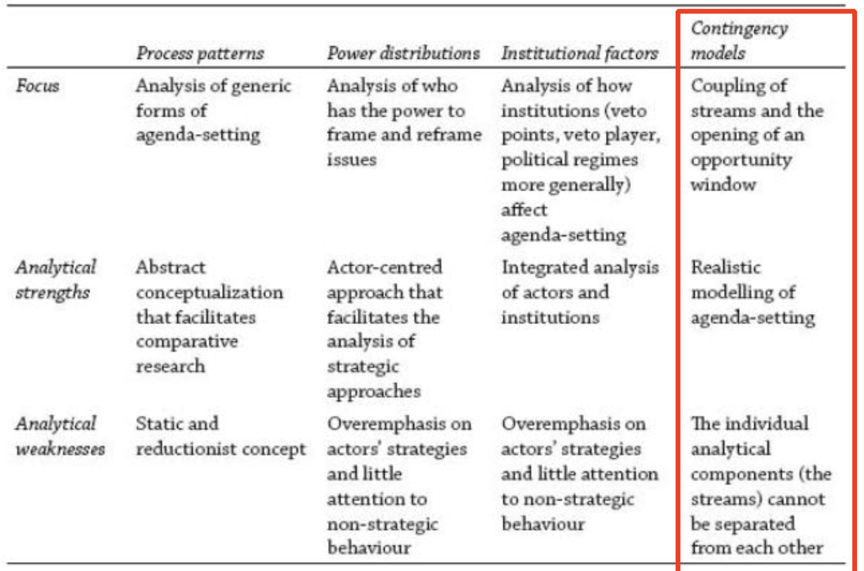

21. Kingdon’s Multiple Streams Framework (Agenda-Setting)
Modelling when problems and solutions get attention
- Problem so far: a largely descriptive approach
Before Kingdon, agenda-setting research mainly described what happened in policymaking but did not explain why some ideas advance while others disappear. MSF responds to this gap by offering actual conditions for agenda change.
- Under what conditions are problems and solutions likely to be considered? New ideas accepted?
Kingdon’s focus is on the circumstances that make policymakers pay attention – not just the content of the ideas. He asks: When does a problem become recognised as a problem? When does a solution become politically usable? MSF highlights that attention is selective and depends on timing and alignment.
- Seminal work: John W. Kingdon (1984), Agendas, Alternatives, and Public Policies
This is the foundational text that introduced MSF. It studies how issues rise to (or fall off) the governmental agenda, especially in the U.S. federal context.
- Kingdon’s central thesis:
New ideas are not accepted (and policy does not change significantly) unless three separate “streams” come together and form a “policy window”.
Kingdon identifies three independent streams:
  - Problem stream: how issues become recognised as problems.
  - Policy stream: the pool of possible solutions generated by experts.
  - Politics stream: the political climate, public mood, elections, lobbying, etc.
Each flows separately; change only occurs when they converge.
- Policymaking is not a linear exercise in rational problem-solving!
MSF challenges the idea that governments move logically from problem → analysis → solution. Instead, policymaking is fragmented, messy, and non-linear, shaped by windows of opportunity rather than orderly processes.
- Core inspiration: Cohen, March, and Olsen’s (1972) “garbage can” model of organizational choice
The garbage-can model describes decision-making where problems, solutions, and participants each exist independently and float around until they randomly connect. Kingdon adapts this to the policy process: solutions may exist before problems, problems may lack solutions, and the right mix only occasionally comes together.

22. Multiple Streams Framework – Interpreting the Diagram
The diagram shows how agenda change happens when Kingdon’s three streams align and are actively coupled by a policy entrepreneur. Each box represents a different logic that operates independently before coming together.

1. Problem Stream – How issues become seen as problems
This stream explains why policymakers pay attention to some conditions and completely ignore others, even when both are objectively important.
- Indicators (data trends, statistics) show whether something is getting worse or better; they act as warning signals.
- Focusing events (crises, scandals, disasters) suddenly make an issue unavoidable, pushing it up the agenda.
- Feedback from existing policies signals that something is malfunctioning or has unintended consequences.
But attention alone is not enough. Policymakers must also interpret the issue:
- They compare it to past experiences (“Is this like the 2008 crisis?”).
- They categorize it (“Is this a security issue? A public-health issue?”).
This interpretation shapes whether the condition is understood as a real problem requiring governmental action.

2. Political Stream – The political climate that enables or blocks action
This stream represents the political environment in which decisions are made.
- National mood (public sentiment) influences what is politically acceptable.
- Organized interests (lobbies, advocacy groups) push or resist issues.
- Elections and shifts in party composition change which issues leaders prioritize.
Importantly, even a serious problem will not move forward unless politics is favorable.
A “political window” opens when events such as elections, crises, or leadership changes create a supportive climate.

3. Policy Stream – The pool of ideas and solutions
Here, experts, analysts, and policy communities generate possible solutions long before they are used.
Ideas must meet criteria for survival:
- They must be technically feasible.
- They must align with prevailing values.
- Their costs must be acceptable.
- Decision-makers must be receptive to them.
“Softening up” means gradually familiarizing policymakers with proposals – through consultations, reports, pilot projects – so that when the time comes, the solution feels legitimate and ready.
This stream operates somewhat like a marketplace of ideas in which only the strongest survive.

4. Policy Entrepreneurs – The agents who connect the streams
These are individuals or groups who actively work to couple problems, solutions, and politics.
They invest time, resources, and reputation because they care about an idea or stand to benefit.
Their success depends on:
- Getting access (“claim to a hearing”),
- Using political connections or negotiation skills,
- Being persistent enough to wait for the right moment.
They are the ones who push the solution into the policy window when it opens.

5. The Policy Window – The moment of opportunity
The policy window is the critical moment when:
- A problem is recognized,
- A feasible solution exists,
- The political climate is favorable.
Only when all three streams converge does an issue rise from the governmental agenda (“things the government cares about”) to the decision agenda (“things the government is actually ready to act on”).
This is where agenda change becomes possible.

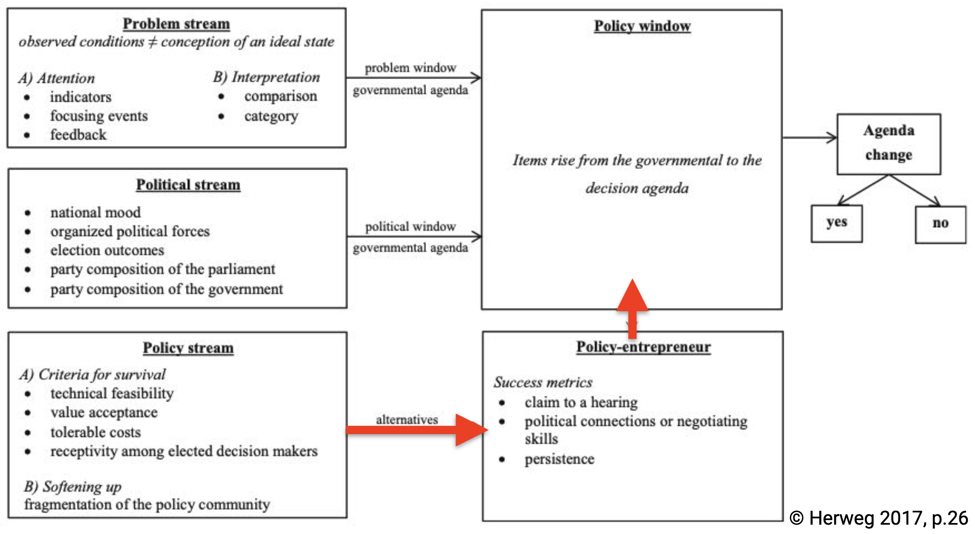

23. Kingdon’s Multiple Streams: Problem, Policy, and Politics Streams

1) Problem stream
Problem stream is about how certain conditions become recognized as problems that deserve government attention. Not every condition becomes a policy problem – attention is scarce, selective, and heavily shaped by interpretation.
- Problems as social constructs – conditions only become “problems” when actors frame them as such.
- Only a tiny fraction of problems gain attention, and securing that attention is already a major success because attention moves quickly to new topics.
- Venue shopping – when one institutional venue fails to respond, actors try alternative arenas (courts, ministries, committees) to gain visibility or action.

2) Policy stream
The policy stream refers to the pool of ideas, proposals, and potential solutions circulating among experts, analysts, and policy communities.
- Solutions develop in a policy primeval soup – ideas are proposed, debated, adjusted, sometimes discarded.
- Softening up – repeated presentation of proposals so they become familiar, technically feasible, and acceptable to policymakers.
- Solutions need time to be refined and gain support inside policy networks.

3) Politics stream
The politics stream concerns the broader political environment and whether it is receptive to action.
- Policymakers must have both the motive and power to act.
- Influenced by national mood, interest group pressure, party competition, election outcomes, and institutional veto points.
- Even a good solution cannot move forward if the political context is closed or hostile.

4) Policy Entrepreneurs
Policy entrepreneurs are actors who invest time, energy, expertise, reputation, and sometimes money to push issues onto the agenda in exchange for expected future gains (material, purposive, or solidaristic).

Key characteristics:
- Can be any policy-relevant actor (formal or informal): politicians, civil servants, researchers, NGOs, activists, business actors.
- Comparable to a policy broker in the Advocacy Coalition Framework – but more proactive and strategic.
- Promote their preferred solutions, often called pet projects, and adjust them to fit political and policy realities.
- Work to couple a recognized problem with a viable policy solution and a favorable political climate.
- Success depends on seizing the policy window – when all three streams align.

Practical implication:
When problems, policies, and politics converge and an entrepreneur pushes an idea at the right moment, the chance of that issue entering the agenda increases sharply.

5) Examples of Policy Entrepreneurs
(From the slide visuals)
- Al Gore – environmental and climate policy advocacy.
- Nancy Pelosi – major legislative entrepreneur within U.S. politics.
- Eurostack Initiative – policy entrepreneurship in digital/tech sovereignty and EU industrial policy.
- Fintech start-ups (e.g., Klarna) – pushing for regulatory changes enabling new financial models (e.g., buy-now-pay-later frameworks).
These illustrate that entrepreneurs can be individuals, networks, or organizations — both public and private.

6) The Policy Window
A policy window is a brief opportunity during which all three streams can be coupled, allowing an issue to rise onto the decision agenda.

Key points:
- Windows usually open for a short time – crises fade, governments shift, or attention moves elsewhere.
- Some windows are predictable (elections, legislative cycles); others appear unpredictably (disasters, scandals, crises).
- Perception matters: a window exists not just when conditions objectively change, but when key actors recognize the moment.

Why policy windows matter:
- Entrepreneurs must be ready to act quickly – hesitation may cause the window to close.
- Missing the window may require waiting years for another opportunity, and maintaining coalitions in the meantime is costly.

24. Key Takeaways from the Lecture
- Agenda-setting is competitive. Social problems (real or perceived) compete for limited political attention, and most issues never reach the decision agenda.
- Problem definition is socially constructed. How an issue is framed – the “causal story” told about it – shapes whether it is viewed as important or solvable.
- Agenda movement depends on multiple factors: the nature of the issue, the actors involved, institutional rules, and often unpredictable political or social dynamics.
- Successful agenda-setting happens when the three streams align. Problem, policy, and politics streams must come together – this is “coupling.”
- Timing matters. Because attention cycles change rapidly, policy entrepreneurs often push solutions before problems are recognized – meaning “solutions might chase their problems.”

Reading #10: Problem Definition and Agenda-Setting

1. Why Agenda-Setting is Difficult: Structural & Cognitive Constraints
Knill & Tosun emphasize several underlying reasons why most societal problems never reach the political agenda — these go beyond the “competition for attention” discussed in lecture.

Key additional constraints:
- Cognitive limitations of policymakers
Policymakers cannot process unlimited information. They rely on heuristics, simplifying frames, and selective exposure → most issues remain invisible.
- Attention scarcity is institutionally structured
Attention is not just limited; it is systematically shaped by:
  - parliamentary rules
  - committee jurisdictions
  - administrative compartmentalization
  - election cycles
These institutional structures “filter” what issues can even be taken seriously.
- Agenda-setting is path dependent
Once an institution has been socialized to handle a certain type of issue (e.g., environment, security), it becomes easier for similar issues to re-enter the agenda later.

2. The Four Models of Agenda-Setting — Deep conceptual meanings
Lecture showed the table but not the rich conceptual detail. Here is what the reading adds.

Model 1: Process Patterns (Generic processes of attention)
This model looks at how issues move across attention cycles, regardless of actors or institutions.

Additional insights:
- Issues rise and fall in predictable “issue-attention cycles"
Borrowing from Downs (1972):
  - Pre-problem stage
  - Alarmed discovery
  - Realization of the costs
  - Gradual decline in interest
  - Post-problem stage
- Non-linearity
Issues do not move smoothly but in bursts of attention.
- Symbolic politics
Politicians may place an issue on the agenda symbolically without intent to act.
Value added: This model explains why some issues repeatedly fail despite high public interest.

Model 2: Power Distributions (Who influences the agenda?)
This model emphasizes power, framing struggles, and strategic behaviour among actors.

Not covered in lecture:
- Agenda-setting as a strategic battlefield
Actors use:
  - framing
  - problem definition
  - media influence
  - venue shopping (moving an issue to a more favourable institutional forum)
- Conflict expansion vs. conflict containment
Borrowing from Schattschneider (1960):
  - Actors may expand an issue to mobilize larger audiences.
  - Opponents try to contain it to keep it off the agenda.
- Policy monopolies
Stable coalitions of experts, bureaucrats, and interest groups may “lock down” an issue area to prevent change.
Value added: Agenda-setting becomes a power struggle, not a neutral process.

Model 3: Institutional Factors (How institutions shape what is possible)
Lecture barely touched this — the reading elaborates.

Additional institutional mechanisms:
- Veto points reduce agenda access
More veto players → more restricted agendas (Tsebelis logic).
- Administrative routines
Bureaucracies focus on “their” types of problems; issues that do not fit existing administrative structures struggle.
- Policy legacies
Existing laws and past decisions shape which issues appear solvable → institutions “bias” future agendas.
- Venue shopping (Baumgartner & Jones)
Actors strategically shift issues across venues (courts, agencies, parliaments) to find a favourable institutional setting.
Value added: Institutions are not neutral — they structure what issues even count as “problems.”

Model 4: Contingency Models (Multiple Streams etc.)
Lecture covered the streams briefly, but the reading adds conceptual background.

Additional insights:
- Agenda-setting as inherently chaotic
Inspired by the “garbage can” model, contingency theories see agenda-setting as driven by timing, luck, and coincidence.
- Streams are analytically separate but empirically fused
In reality, actors rarely perceive problems, solutions, and politics as separate — but analysts do to understand the mechanism.
- Policy entrepreneurs are risk-takers
They invest resources without a guarantee of success, acting strategically to couple streams.
- Policy windows vary in “width” and “duration”
The reading distinguishes:
  - structural windows (e.g., elections)
  - event-driven windows (crises)
  - institutionally triggered windows (legislative deadlines)
Value added: Agenda outcomes depend on unpredictable alignments, not orderly processes.

3. A More Detailed Categorization of Policy Problems
Knill & Tosun offer a typology NOT covered in lecture:

Problems differ by:
- Complexity (simple vs. wicked problems)
- Conflict level (consensus vs. conflictual)
- Uncertainty (well-defined causes vs. ambiguous)
- Solvability (technically feasible vs. diffuse)
This matters because:
- Clear, simple, solvable problems reach agendas more easily.
- Wicked problems (e.g., climate change) struggle because causes, solutions, and responsibilities are contested.

4. The Role of Ideas and Knowledge (Epistemic dimension)
Lecture didn’t cover the epistemic foundations of agenda-setting.

Key deep concepts:
- Epistemic communities
Networks of experts who shape what policymakers consider “real problems.”
- Causal beliefs
Policymakers act on perceived causes, not objective reality.
- Policy frames change the perceived urgency
Example: reframing “unemployment” from “economic failure” to “skills deficit” leads to different agenda priorities.
Why this matters:
Ideas define problems → problems define agendas.

5. Feedback Mechanisms
Knill & Tosun emphasize agenda feedback, absent in lecture.

Types of feedback:
- Positive feedback
Small changes generate increasing returns (e.g., media amplification → rapid attention expansion).
- Negative feedback
Institutions suppress or dampen attention to maintain stability.

Implication:
Agenda-setting is dynamic and self-reinforcing — early signals matter disproportionately.

6. The Agenda as a Multi-Level Structure
Lecture mentioned levels but the reading goes deeper.

Additional interpretation:
- Movement between levels requires “triggering events”
Issues rarely move spontaneously; windows, focusing events, or reframing are needed.
- Different levels involve different actors
  - Agenda universe → general public, activists
  - Systemic agenda → media, NGOs
  - Institutional agenda → parliament, government
  - Decision agenda → executive coalitions, committee chairs
This structure helps identify where an issue is “stuck.”

7. Special Chapter Insight: Institutional Friction and Punctuated Equilibrium
Another concept not discussed in lecture:

Agenda evolution is “punctuated”
- Long periods of stability
- Interrupted by sudden bursts of activity or change
This is due to:
- institutional bottlenecks
- information-processing limits
- political shocks
This aligns with Baumgartner & Jones’s punctuated equilibrium theory.

8. Actors Beyond Policy Entrepreneurs
Lecture focused on entrepreneurs; the reading expands the cast.

Additional actor types:
- Gatekeepers (committee chairs, party leaders)
Control access to the institutional agenda.
- Mediators/brokers
Connect issues, actors, and frames.
- Negative agenda-setters
Work to block or delay issues (often more powerful than promoters).

Lecture 11: Guest Lecture by Vladlens Kovalevs
Practitioner’s Perspective on Public Affairs

1. Introduction & Context (Slides 1–3)
Public affairs (strategic management of an organization’s relationship with governments, policymakers, and society to influence policy, gain legitimacy, and protect long-term interests) is presented as a professional service sector embedded in the political and regulatory environment.
Key ideas:
- Public affairs firms operate as intermediaries between business, civil society, and political institutions.
- VA Government (Rud Pedersen Group) (leading and fastest-growing public affairs and communications group in Europe) emphasizes full-service advocacy, combining political insight, policy analysis, and communication.
- Their geographic spread (20 offices, 600+ consultants) signals cross-jurisdictional expertise, which is crucial for clients interacting with EU, regional, and national institutions.
- The framing is intentionally practitioner-oriented: public affairs is a craft requiring situational judgment, not just theoretical knowledge.

Conceptual implication:
Public affairs functions as a specialized knowledge industry – a hybrid of political intelligence, strategic communication, and stakeholder management.

2. Public Affairs Services (Slide 4)
The listed services reflect the multidimensional nature of advocacy (act of supporting, promoting, or arguing for a cause, policy, or group’s interests in public debates or decision-making):
- National government relations: long-term engagement with ministries, agencies, Saeima committees, and advisers.
- Municipalities & local authorities: increasing importance as decentralization shifts regulatory power locally.
- Policy analysis: evidence gathering, regulatory impact assessment, risk/benefit mapping.
- Campaign advocacy: strategic mobilization of stakeholders over specific issues; mirrors election campaign logic but applied to policy battles.
- Association management: building and coordinating coalitions; reflects collective action logic (Olson-type problems).
- Political intelligence & procurement support: monitoring political developments, assessing government demand, identifying entry points into procurement cycles.
Core insight:
Public affairs is not lobbying alone – it encompasses research, message architecture, coalition management, and institutional navigation.

3. Public affairs & campaign mindset (Slides 5–6)
Public affairs is conceptualized as ongoing campaigning, not episodic lobbying.
The mindset requires:
- Deep understanding of the policy arena: actors, arenas, timing, institutional constraints.
- Mastery of government mechanics: legislative procedures, the informal norms of ministries, committee calendars, and political culture.
- Familiarity with both elected and non-elected officials and their motivations (e.g., electoral incentives vs. bureaucratic incentives).
- Proficiency with advocacy tools: stakeholder mapping, message development, coalition formation, policy briefs, political risk assessment, grassroots mobilisation.
- An organized, comprehensive perspective: issue management, sequencing of actions, long-term strategizing.

Analytical significance:
This reflects a professionalization of interest representation: expertise becomes as important as access.

4. Interest Representation Index – Concept and Purpose (Slides 7–9)
The Index is a diagnostic tool for evaluating the state of interest representation in Latvia.
Its purpose:
- Promote debate on transparency, effectiveness, and quality of interest representation.
- Compare practices across businesses, NGOs, and public institutions.
- Identify structural patterns in how interest groups interact with the legislative process.

Key findings and conceptual implications

A. Openness is low
- Openness ranks lowest among dimensions.
- This signals institutional opacity in policymaking.
- The emphasis is not on more bureaucracy but on better-designed regulation that facilitates transparent engagement.
Implication:
Transparency deficits weaken legitimacy, invite suspicion, and hinder evidence-based policymaking.

B. Interest representation is driven by social organizations
- Social organizations (NGOs, associations) demonstrate greater intensity in representing interests than individual businesses.
- Businesses often lack internal capacity → rely on associations or consultants.
Implication:
Collective actors reduce transaction costs and amplify voice; aligns with classic interest group theory.

C. Engagement dominates in early legislative stages
Most interest representation occurs during:
- Initiation
- Drafting
- Adoption or application of legislative acts
Rarely used in the context of public funding.
Implication:
Advocacy is concentrated where policy content is shaped, not where resources are allocated.

D. Effectiveness perceptions
- Effectiveness assessments are similar across NGOs and businesses, regardless of intensity.
- More frequent representation does not automatically increase effectiveness of representation – strategy matters more than volume.
- Public concerns about corruption and undue influence remain high.
- Belief among respondents (people working in public institutions, as well as
- businesses and social organisations surveyed) : good interest representation improves institutional performance.
Implication:
Quality, strategy, and transparency determine influence – not merely access or activity levels.

5. 4Ps/TIME Analysis
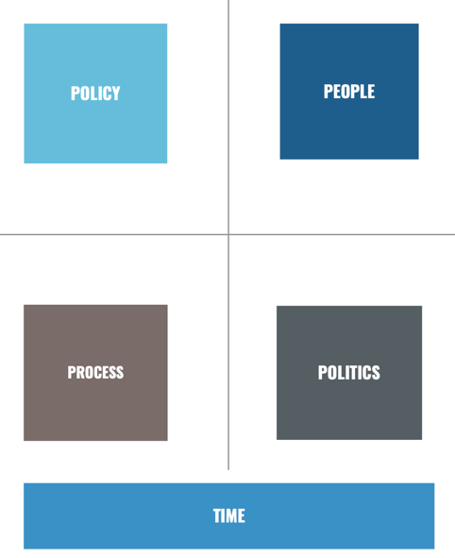
A structured framework for evaluating the political environment through four interacting dimensions:
- Policy – the substance of the issue.
- People – actors, coalitions, stakeholders.
- Process – institutional pathways and decision-making procedures.
- Politics – the broader political climate, power distribution, and cycles.
- Time – the sequencing and temporal dynamics.

This model encourages strategic foresight. Each dimension influences the others: actors shape process, political cycles shape opportunity windows, and policy goals shape who enters the arena. TIME functions as the cross-cutting factor because political influence unfolds over a timeline, not in isolated moments.

5.1 Policy Dimension
Key evaluative questions focus on the clarity, feasibility and legitimacy of the policy objective:
- Are goals clear and achievable?
- Are they new or part of an ongoing agenda?
- Are they justified and supported by credible argumentation or evidence?
- How is the policy perceived socially or politically?
- Who stands to benefit or lose?

Elaboration:
This dimension ensures that organisations understand the substantive core of what they’re advocating for. If goals are vague, politically toxic, or misaligned with institutional priorities, no amount of stakeholder engagement will compensate. “Perception” matters because political decision-making is as much interpretive as it is rational.

5.2 Process Dimension
Analysis of when and how the issue moves through institutions:
- Identifying timing: when the issue will formally enter debate or be joined.
- Mapping required institutional actions (committee reviews, ministry steps, consultations).
- Mobilising the coalition: motivating supporters, maintaining unity.
- Defining strategy, tactics, and message.

Elaboration:
Public affairs work must follow the sequence of administrative procedures. Understanding process means spotting leverage points — e.g., where amendments can be introduced, when consultations open, or who drafts the first version of legislation. The process determines access, speed, and political vulnerability.

5.3 People Dimension
Understanding actors is central to political influence:
- Who manages the effort (internal leadership or external partners)?
- Identification of key supporters and opponents.
- Knowledge of stakeholder motivations, constraints, and priorities.
- Opportunities to broaden the support base among decision-makers.
Elaboration:
Political influence is relational. Actors have incentives, loyalties, histories, and institutional cultures. Effective advocacy requires mapping not just formal powers but informal influence — senior civil servants, party advisers, industry associations, opinion leaders. Stakeholder intelligence is foundational for coalition-building and anticipating pushback.

5.4 Politics Dimension
Assessing the political context and power dynamics:
- Whether the current climate is inviting or discouraging.
- Distribution of political power across parties, ministries, committees, or factions.
- Identification of cyclical events (elections, budget cycles, EU presidency rotations) that could alter opportunities.
Elaboration:
The political environment shapes strategy: during pre-election periods politicians are risk-averse; during administrative transitions bureaucratic continuity weakens; during crises window-opening is possible. Power distribution determines who must be convinced and whose opposition is fatal to a campaign.

5.5 Time Dimension
Time is the overarching factor conditioning all other dimensions:
- Viewing engagement as a movie, not a snapshot — dynamic, evolving.
- Recognising that action invites reaction, meaning strategic moves change the political equilibrium.
- Anticipating the unexpected, including crises, leaks, or political turnover.
- Maintaining nimbleness: the ability to adjust, adapt, or exploit sudden changes.
Elaboration:
Political processes are non-linear. Timing can amplify influence or neutralise it. Successful public affairs campaigns incorporate scenario planning and flexibility, understanding that political momentum can shift abruptly.

17. Types of Public Affairs Campaigns
Different campaign types correspond to distinct strategic objectives. Their selection depends on the organisation’s needs, policy environment, and political constraints.

17.1 Profile Raising
The purpose of profile raising is to increase the visibility and legitimacy of an organisation in the eyes of key stakeholders, ensuring that decision-makers understand its role, relevance, and contribution to the industry.
Key objectives:
- Addressing competition issues, especially where market fairness, level playing fields or regulatory advantages are at stake.
- Ensuring the organisation secures its rightful place in the political process, meaning policymakers recognise it as a credible and necessary participant.
- Making sure politicians and civil servants are aware of the organisation before crises emerge – influence is strongest when awareness is already established.
Profile raising is fundamentally about long-term positioning, not short-term lobbying: shaping how the organisation is perceived in the policy ecosystem.

17.2 Contact Programme
A contact programme builds on profile-raising by establishing structured, ongoing relationships with public authorities.
It enables organisations to strengthen ties with civil servants, ministers, regulators, and political advisors. Crucially, strong relationships must be developed well before they are needed; proactive engagement prevents last-minute lobbying (act of directly communicating with government officials or politicians to influence laws, regulations, or public policies in favor of a specific interest).
Stages:
- Identify key decision-makers at both civil service and political levels.
- Identify key opinion leaders around those decision-makers – experts, advisers, committee chairs, informal influencers.
- Keep contacts warm, meaning regular interaction, updates, and dialogue that maintain relevance.
This type of campaign ensures the organisation becomes viewed as a trusted, recurring actor in its sector.

17.3 Policy Planning
Policy planning involves shaping regulatory or legislative outcomes early in the policy cycle, when influence is strongest.
Main points:
- Engaging during the formulation and planning phases helps shape the structure of future laws and regulations.
- It is one of the most important long-term public affairs activities, because it helps justify the ongoing need for public affairs capacity.
- Engagement occurs through formal and informal channels: working groups, advisory councils, tripartite dialogues, consultations, and expert input.
Policy planning ensures the organisation’s vision is present before draft laws exist, reducing the need for late-stage firefighting.

17.4 Influencing Legislation
This stage concerns direct efforts to propose, amend, or suspend legislation or regulation.
Key points:
- Often treated as the “core” of public affairs, but arriving here often means intervening too late.
- It becomes relevant when previous attempts at shaping thinking (e.g., during planning) were unsuccessful.
- Requires active participation: building support coalitions, mobilising stakeholders, and maintaining close cooperation with public authorities.
- Political feasibility becomes central – success depends on whether political actors are willing and able to adopt the changes.
This is the most visible but not always the most effective phase of engagement.

18. Issue Maturity Curve
This slide illustrates how potential impact decreases as an issue matures.
Early stages – defining the problem, agenda setting, exploring alternative solutions – offer the highest impact because policy ideas are still fluid.
Later stages – validation, technical adaptation, compliance – are dominated by legal and administrative logic, leaving little room for influence.
Key takeaway:
Public affairs is strongest in early stages (agenda setting & public debate), while legal/compliance teams dominate later stages (legislative drafting & implementation).
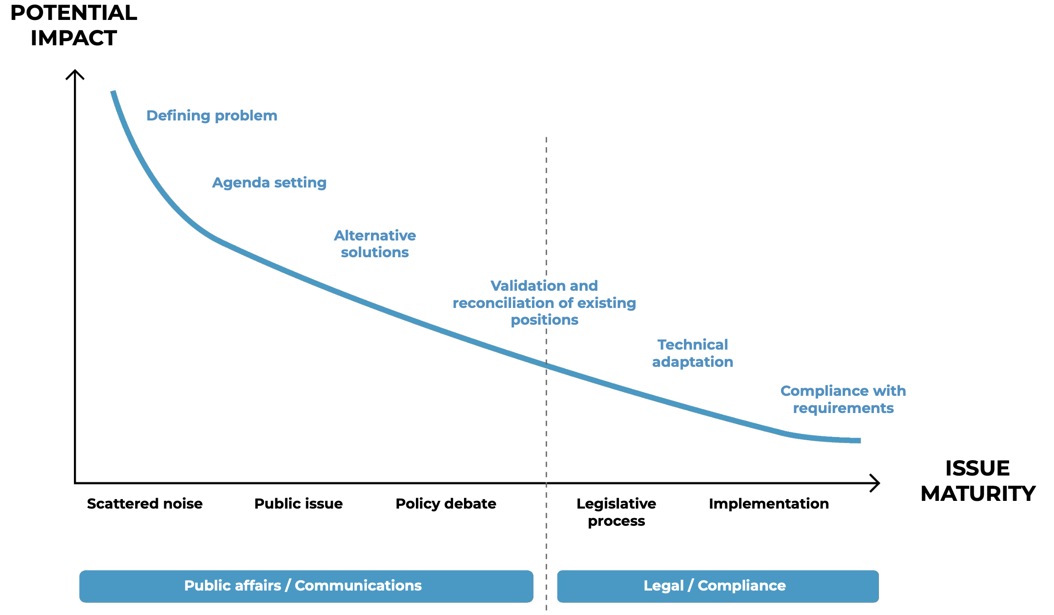
Lecture 12: Policy Adoption

1. Position of Policy Adoption in the Policy Process
In the full policy cycle, policy formulation and adoption come immediately after agenda-setting and before legitimation, implementation, evaluation, and policy maintenance/succession/termination.
At this stage, policymakers consider policy alternatives, evaluate their viability, and choose a specific course of action that becomes a policy output. This is where political intentions turn into formal decisions.

2. The Policy Adoption Stage: Key Sites and Key Actors
Key sites of policy adoption:
- Parliamentary phase
– The formal legislative arena where bills are debated, amended, and voted on.
– Committees, floor debates, and parliamentary rules shape outcomes.
- Pre-parliamentary phase
– Work done before a proposal reaches parliament: executive drafting, intra-government negotiations, consultations, and preparatory assessments.

Key actors involved in adoption:
- The legislative: Parliament as the institution responsible for approving or rejecting proposals.
- MPs (Members of Parliament), parties, interest groups: These actors negotiate, lobby, signal preferences, and form coalitions that influence adoption.
- The executive: Holds significant power over policy initiation and may possess executive privilege (priority in introducing legislation and controlling timing).
- Government agencies and self-regulatory organizations (SROs): SROs such as FINRA, NYSE, ICANN, EASA can exercise delegated authority to set standards or regulations. Their involvement can shape policy content even before parliament votes.
This reflects how not all policy adoption is strictly parliamentary – some takes place through regulatory or quasi-regulatory actors.

3. Key Processes at the Adoption Stage
At this stage, policymakers engage in the formulation and design of policies and policy alternatives. This involves four key processes:
- Setting and trading off broad objectives
– Broad goals such as efficiency, fairness, and political feasibility are balanced against each other.
– Trade-offs (choosing more of one goal means having less of another) are necessary because objectives may conflict.
- Setting narrow, measurable objectives
– These objectives define the intended policy outcome and policy impact.
– They must align with the underlying causal story of the issue (how the problem works and what causes it).
- Defining the set of feasible instruments
– Not every instrument can be used; feasibility depends on legality, capacity, resources, and political acceptance.
- Selecting adequate instruments by estimating their impact
– Policymakers must assess how different instruments are likely to perform.
– The chosen set becomes the policy output once adoption occurs.

4. Instrument Choice: Policy as the Production of Counterfactuals (Schneider & Ingram 1990)
Schneider and Ingram argue that public policy produces counterfactuals – changes in behaviour that would not occur without intervention.

Two types of counterfactual outcomes:
- Getting people to do things they otherwise would not have done
– Example: getting vaccinated, recycling, following speeding rules.
– These involve induction or coercion.
- Enabling people to do things they want but might not do otherwise
– Example: eating healthier, saving for retirement.
– These remove barriers or support desired behaviour.
The choice of policy instruments reflects behavioural assumptions about what drives individual decision-making and agency.

Key underlying idea: individuals are not merely passive consumers; they are co-producers of public policy.
If individuals fail to change behaviour in large numbers, policy outcomes cannot happen.
Schneider & Ingram introduce a shift:
- From a supply-side focus (technical and political constraints)
- Toward demand-side behavioural factors (how individuals think, perceive, and act)
This reorientation is crucial for selecting effective instruments.

5. Behavioural Obstacles to Realizing Policy Objectives
Policies may fail because individuals do not exhibit the “correct” behaviour needed to produce the desired outcome.
Major behavioural obstacles:
- Individuals believe the law does not direct or authorize them to act.
- Lack of incentives or capacity to take action.
- Disagreement with the values implicit in the instrument or objective.
- Uncertainty about the nature of the problem itself.

The upshot:
A sound policy instrument mix must incorporate behavioural considerations alongside:
- resource constraints (resources/efficiency), and
- political and technical feasibility.

6. Hood & Margetts’ Policy Typology
Hood and Margetts classify policy instruments by the basic resource that government leverages and the governance principle that guides action.

A. Nodality (Information)
- Basic resource: information
- Governance logic: indirect stimulation of behavioural change through information and persuasion
- Typical instruments: information campaigns, research funding, nudges

B. Authority (Law)
- Basic resource: law
- Governance logic: command-and-control, direct prescription of behavioural rules
- Typical instruments: prohibitions, permits, standards, certifications

C. Treasure (Money)
- Basic resource: money
- Governance logic: indirect stimulation via financial incentives
- Typical instruments: taxes, user charges, grants, tax deductions

D. Organisation (Capacity)
- Basic resource: government structures and capacity
- Governance logic: provision of public goods by the state or public enterprise
- Typical instruments: public companies and public service delivery

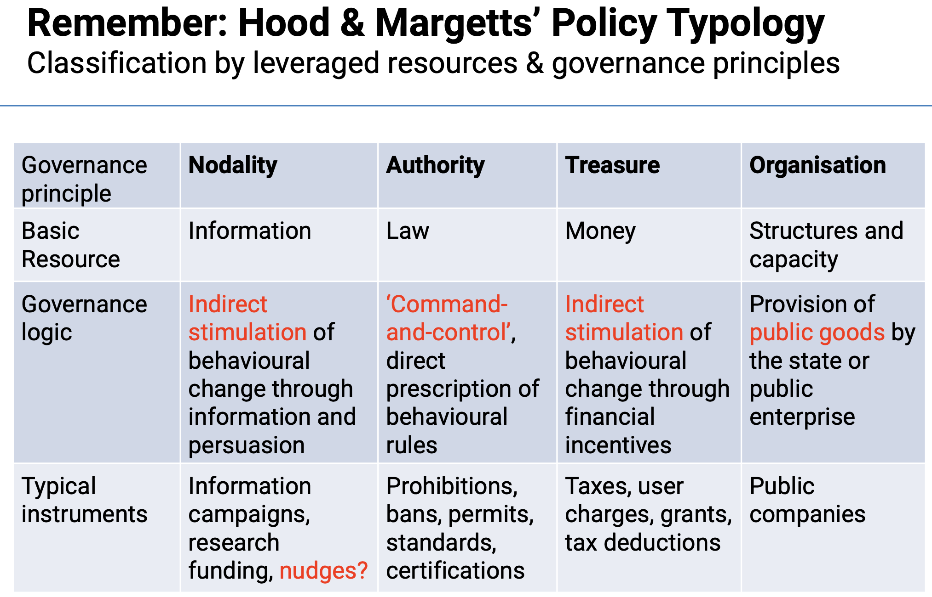f

7. Four Heuristics for Selecting Instruments
These four guiding questions help determine which instrument is most appropriate:
- Is the instrument’s causal model (“program theory”) likely to work?
– Does it produce change without unintended effects?
- Are sufficient government resources available?
– Consider financial, administrative, and political resources, and how quickly they might be depleted.
- Does the instrument fit the institutional context?
– Must be compatible with existing institutions’ capacity and constraints.
- Does the instrument fit the policy context?
– Interaction with existing policies must be coherent rather than contradictory.

8. Regulatory Instruments (“Authority”)
Regulatory instruments align with command-and-control logic and rely on enforceable rules.
Characteristics:
- Can be very specific/technical or broad.
- Program theory: if there is a credible threat that non-compliance will be detected and sanctioned, behaviour will change.
- Work best when standards are clear and enforcement is consistent.

Key problems:
- Regulated actors have complex motivations; compliance depends on others’ behaviour (real or perceived) (regulated actors don’t always comply because their decisions are influenced by their own mixed motivations and by how they see others behaving, not just by the rules themselves).
- Some regulations may be legally impossible (e.g., soda bans in NYC schools).
- Flexible regulations may sometimes be more effective or efficient than strict bans.

Examples of challenges:
- Debate on banning e-scooters.
- Sanctions (penalties or punishments imposed for breaking rules) being perceived as a “badge of honor”( shows their strength, bravery)
- Failure to incentivize cooperation (e.g., pollution abatement done where cheapest rather than most effective).

9. Financial Incentive-Based Instruments (“Treasure”)
Financial instruments rely on positive and negative (dis-)incentives.
Program theory:
Individuals are rational agents, maximizing utility under financial constraints.

Key problems:
- Behaviour changes only if incentives outweigh perceived benefits/costs.
- Incentives that are too small may backfire, legitimize defection, or erode trust.
- Incentives alone rarely determine consumption behaviour.
=> Behavioural complications:
- “Bad” or misinformed preferences may override financial logic.
- Cognitive biases distort how individuals assess costs and benefits.

10. Information-Based Instruments (“Nodality”)
Information-based instruments use the state’s position as a central node in networks to influence behaviour through information, persuasion, and communication. They are often chosen when the state is reluctant to use coercive (authority) or financial (treasure) resources.

Program theory:
- Old assumption: More information → more rational decision-making.
This assumes individuals process information logically and adjust behaviour accordingly.
- New assumption: Information must be aligned with insights from social psychology and behavioural economics, acknowledging that individuals have cognitive biases and are not fully rational.
To affect behaviour, information needs to appeal to emotions, biases, heuristics, and mental shortcuts.
A major innovation here is nudges (also known as “libertarian paternalism”).
Nudges attempt to influence behaviour by altering the choice architecture – the context in which decisions are made – while preserving formal freedom of choice.

Common problems associated with information-based instruments include:
- Intransparency (nudges may not be visible or understandable to citizens).
- Difficulty in assessing impact (hard to measure behavioural change caused solely by information).
- Paternalism-in-disguise (influencing people without their awareness).
- Elite-bias (designers assume they know better than citizens).

Illustrative examples:
- Speed displays with smiley/frowning faces that react to driving speed (emotional feedback).
- WWF paper towel dispenser showing South America shrinking as more paper is used (visualizing environmental impact).
These examples demonstrate nudging, using visual cues to direct behaviour without coercion or financial incentives.

11. Nudges: Libertarian Paternalism and the “Choice Architecture”
Nudges are grounded in the idea that individual decision-making is boundedly rational (doing your best to decide, but not perfectly). People are prone to systematic biases – such as status quo bias (preferring to keep things the same), optimism bias, or limited attention (not paying full attention or forgetting important details) – that inhibit optimal decisions.

Nudges advocate shaping the choice architecture rather than directly regulating behaviour. This maintains choice freedom (libertarian) while steering individuals toward choices that increase their welfare (paternalism).

Policy should aim for “nudging” individuals toward decisions that:
- Increase their wellbeing or utility, and
- Represent their true preferences – what they would choose if cognitive biases were absent.
Examples include defaults (e.g., opt-out organ donation), reminders, salience cues (signals or features that make something stand out and grab attention), and emotional feedback mechanisms (*feeling ashamed after punishment).
However, nudges face a reality-check: a major 2022 meta-analysis finds no evidence of robust nudging effects once publication bias (studies with positive results are more likely to get published than studies with weak or negative results) is removed, raising questions about their long-term effectiveness.

12. Policy Instruments Come in Packages
In practice, policy objectives almost never rely on a single policy instrument. Governments combine tools into instrument packages to achieve complex goals.
There are three main types of instrument packages:

A. Vertical instrument packages
One instrument enables or facilitates the implementation of another.
- Example: The government sets a price cap for energy producers (regulation), and producers use prices to allocate energy.
The regulation indirectly supports the policy goal of affordable energy but does not directly enforce consumption behaviour.

B. Horizontal instrument packages
Two or more instruments target the same policy objective simultaneously.
- Example: A regulation prohibits polluting technology while subsidies encourage producers to adopt sustainable production methods.
Authority and treasure-based instruments work together horizontally to push the system toward a common goal.

C. Chronological instrument packages
Instruments are introduced sequentially (often called “salami tactics”).
- Example:
  - First, information campaigns warn about plastic bags' environmental impact.
  - Then an incentive scheme requires supermarkets to charge customers for plastic bags.
  - Finally, plastic bags are banned and only eco-friendly alternatives allowed.
This sequence builds acceptability and behaviour change over time.

Instrument packages highlight that policy design is dynamic, requiring combinations and sequencing of tools to address complex problems.

13. Challenges to Policy Adoption

13.1 Veto Players (Tsebelis, 1995)
Veto players are actors whose consent is necessary to alter the status quo (actors who must agree for change to happen).

Types:
- Institutional: formal bodies (e.g., chambers, executives).
- Partisan: political parties/coordinated groups participating in decision-making.

Why they matter for adoption:
- Number of veto players: more actors → harder to reach agreement → lower likelihood of adoption.
- Ideological diversity: greater ideological distance → less agreement on preferred policy.
- Cohesion (how united the veto player is inside): cohesive veto players resist internal defection; fragmented ones may allow movement.

13.2 Determining Which Actors Matter

Actors’ Preferences & Beliefs Vary by Context
- “Where you stand depends on where you sit.” Actors' institutional roles and positions shape their preferences and beliefs.

Actors’ Resources Influence Adoption
- Voting power
- Network centrality
- Wealth
- Agenda-setting control
- Social media / communication capacity
Actors with more resources exert stronger influence over outcomes.

Venue Shopping
- Policymakers shift issues to the forum (“venue”) most favorable to their policy goals.
(e.g., courts vs. committees vs. agencies)

13.3 Political Strategies in Policy Arenas

Co-optation
- Sharing credit or blame to bring opponents on board.
- “If you can’t beat them, join them.”

Compromise
- Minimizing concessions while maximizing shared outcomes.
- Central to overcoming veto barriers.

Heresthetics
- The art of structuring decisions, sequencing votes, or manipulating procedural order to change outcomes.
- Example: 1950s U.S. civil rights legislation where actors flipped preference order through agenda manipulation.

Rhetoric
- Persuasion and framing to build support for adoption.

14. Key Takeaways
- Instrument choice is central and remains relevant throughout the policy process.
- Adoption is shaped by factors beyond technology or politics – context, behavior, values.
- Instruments vary in the level of authority they impose.
- Instruments are not neutral – they encode political relationships and have differing impacts across groups.
- Effective policy requires understanding that the governed are co-producers, not passive recipients. Behavioral assumptions must be built into design and implementation.

Reading#12: Adoption

1. Adoption vs. Implementation — a more realistic view
The reading explains that adoption and implementation are not cleanly separate.
Even after a law is formally adopted, many more decisions still have to be made in different arenas — and these act like “mini adoptions.”
New idea:
→ Implementation has its own veto players, interests, and political battles.
→ Therefore, a policy analyst must think strategically from the very beginning, assuming the process is layered and not linear.

2. Strategic thinking as a requirement, not an option
The reading pushes the idea that strategic thinking (anticipating others’ reactions) is essential for adoption.
This is not just politics — it’s part of analysis.
Key points:
- Analysts must predict how others will respond to the proposal.
- Analysts also often become part of negotiations, hearings, and behind-the-scenes political maneuvering.
This is deeper than standard lecture definitions — here the reading shows analysts as political actors, not just technical ones.

3. The Seven Policy Process Frameworks
Your lecture slides likely covered some. Below are the extra insights the reading adds.

(1) Interest Group Theory – extra insights
The reading emphasizes two mechanisms for diffuse interests to become powerful:
- Entrepreneurial politics (using public events and value-based framing)
- Organizations providing selective benefits (like the NRA)

Important: analysts should identify “sleeping giants” — groups with diffuse interests who might rebel after adoption (e.g., elderly opposing Medicare Catastrophic Act).
This is not usually in lecture slides.

(2) Institutional Rational Choice
Three levels of rules (unique detail not usually in slides):
- Operational rules (everyday behavior rules)
- Collective-choice rules (how operational rules are made)
- Constitutional rules (how collective-choice rules are made)
Insight for analysts: opponents often try to bypass operational rules by shifting the issue to another level (e.g., moving windmill approval from local to state).

(3) Path Dependence vs. State Dependence (important distinction)
The reading gives precise definitions:
- Path dependence = the sequence of past decisions changes what is possible today.
- State dependence = only the current policies matter, not the sequence.
New insights:
- Quick fixes can create hidden barriers later.
- Failed attempts also shape the political environment by revealing opposition strength.
- Policies create constituencies who defend them fiercely.

(4) Advocacy Coalition Framework (ACF) – belief hierarchy
Three layers of beliefs:
- Deep core beliefs (fundamental values, almost never change)
- Core policy beliefs (how the subsystem should work; hard to change)
- Secondary beliefs (issue-specific; easiest to change)
New concept:
→ Analysts should aim to shift secondary beliefs first to eventually influence core beliefs.
Also new:
→ “Hurting stalemates” create negotiation opportunities.

(5) Social Construction Framework – four target groups
The reading gives a typology not in most lectures:
Group | Social Construction | Political Power
Advantaged | positive | strong
Dependents | positive | weak
Contenders | negative | strong
Deviants | negative | weak
Policies allocate benefits/burdens differently depending on group type.
New insight: Analysts should frame policies in ways that take advantage of these constructions (e.g., program “for children” not “for welfare families”).

(6) Multiple Streams – extra nuances
Policy windows close quickly, and:
- Only one window opens at a time.
- Even small symbolic action can close a window.
- A viable alternative must already be prepared before the window opens.
This “urgency and timing” emphasis is not always included in slides.

(7) Punctuated Equilibrium – info-processing angle
New idea:
→ Policy outputs follow a leptokurtic distribution (many tiny changes, some huge jumps, few moderate changes).
This is a powerful empirical insight not in most lecture content.

4. Practical Guide for Assessing Political Feasibility
This section contains MANY details often missing from lecture slides.

A. Identifying Relevant Actors
Actors = those with:
- Substantive interests
- Formal authority
Plus:
→ Media editors, legal advisors, and professionals can influence decisions even without votes.

B. Motivations & Beliefs
The reading explains how to infer motivations:
“Where you stand depends on where you sit.”
Meaning: people's positions follow their role and context.
This is a classic public administration idea not always covered in slides.

C. Assessing Resources
Resources include:
- votes
- money
- information
- personal relationships
- ability to mobilize others

D. Choosing the Arena
New insight:
→ Losing actors try to shift the arena (e.g., from city to state, or to courts).
This creates “venue shopping,” similar to punctuated equilibrium.

5. Political Strategies to Increase Feasibility
This section contains unique concepts not usually taught in class.

(1) Co-optation
Getting others to support your idea by letting them feel ownership of it.
Examples:
- Co-sponsorship
- Advisory committees stacked to produce a desired recommendation

(2) Compromise
Two forms:

a) Remove features opponents hate
(“take out the red flags”)

b) Add features they like
(logrolling, packaging elements)
Negotiation becomes more successful when:
- actors interact frequently
- personal relationships matter
- both sides can appeal to higher authority
- face-saving language is used (“revenue enhancement” instead of “tax increase”)
These psychological details are absent from most lecture slides.

(3) Heresthetics
One of the most unique concepts.
Heresthetics = shaping the structure of political choice to win.
Two types:

a) Agenda manipulation
Controlling:
- which options are voted on
- the order of voting
- whether the issue is even allowed to come to a vote

b) Changing the dimensions of evaluation
Example: reframing a military spending issue into constitutional rights of the Senate.
This is a highly political concept not in basic lecture material.

(4) Rhetoric
Persuasive language to shape beliefs.
Ethical vs. unethical rhetoric:
- Ethical: clarifies true policy impacts
- Unethical: exaggerates rare risks because people overreact to them (“meltdown plus containment failure”)
New insight:
→ Stories with “victims and villains” are extremely powerful — but often oversimplify reality.

6. Analysts' Ethical Dilemma
Analysts should ideally avoid misleading rhetoric, but in reality:
- clients may expect persuasive framing
- appearing honest may be as important as being honest
This subtle ethical point is rarely included in lectures.

Lecture 13: Implementation

1. Implementation: Continuing the “Causal Story” of Policymaking
Implementation is the stage where policy outputs are turned into concrete actions. The “causal story” continues after adoption, because the intended policy outcome depends on whether implementation is done successfully.

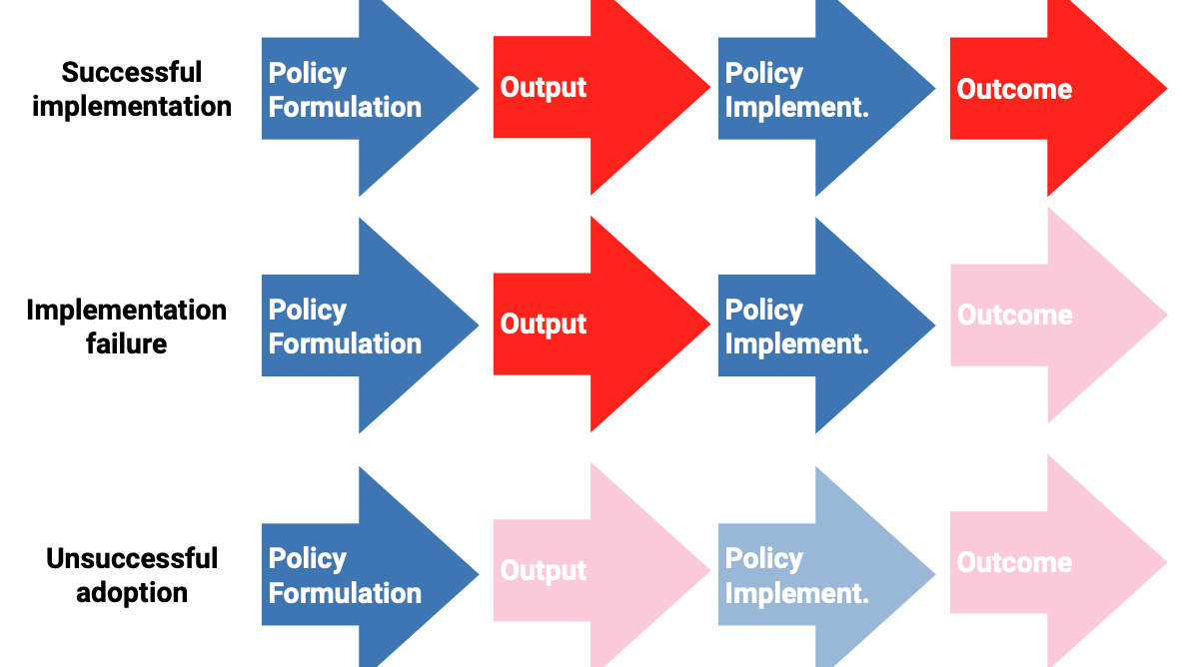

The slides outline three basic scenarios:
- Successful implementation
– Policy formulation → output → correct implementation → desired outcome.
– This means administrators follow the instrument design closely, and behaviour in the target population changes as intended.
- Implementation failure
– Policy formulation → output → flawed or partial implementation → weak or distorted outcome.
– The design may be good, but execution fails due to lack of resources, poor incentives, resistance, or coordination problems.
- Unsuccessful adoption
– Policy formulation → weak or unclear output → poor implementation → no meaningful outcome.
– Even perfect implementation cannot fix a poorly designed or ambiguous policy output.

Implementation is therefore not automatic; it is a continuation of policy design, shaped by actors, incentives, capacities, and the organizational environment.

2. Main Actors in Implementation (After Eugene Bardach 1977)
Bardach identifies three categories of actors involved in implementation: managers, doers, and fixers. Each plays a different role in translating policy into practice.

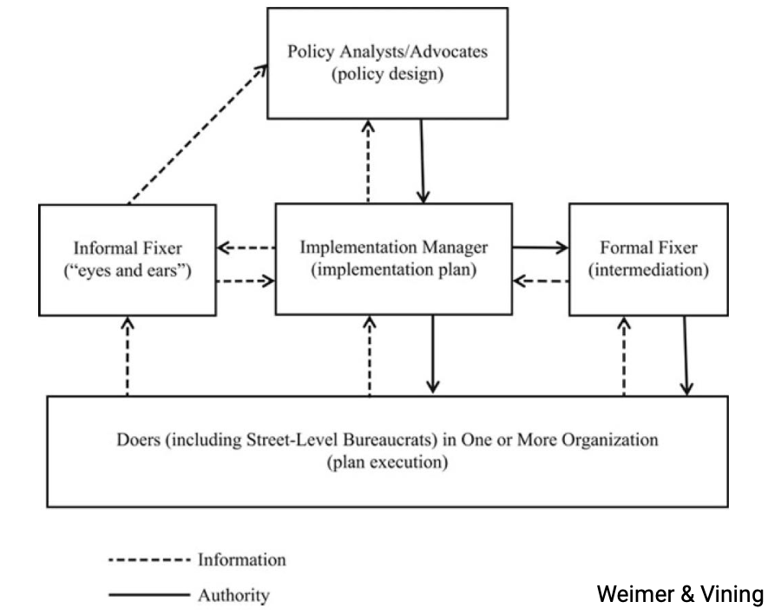

2.1 Managers
- Typically high-level officials in government departments or agencies (e.g., directors, permanent secretaries, top civil servants).
- They create the implementation design, combining managerial and political skills, often relying on external consultants (e.g., PwC, McKinsey, Deloitte).
- They decide whether to adjust existing routines or create new routines.
- Key questions: Do they have the right incentives? Do they have sufficient resources?

Examples:
- A director in a Ministry of Health designing roll-out plans for a vaccination campaign.
- Senior officials in a transport agency planning the implementation of a new road-pricing system.
- A school district superintendent deciding how to allocate teachers after a curriculum reform.

2.2 Doers
- Typically street-level bureaucrats (frontline workers) hired or contracted to carry out the policy.
- Their task is executing the adopted policy instrument with the intention of producing the desired outcome.
- They have considerable discretion, and their performance depends on incentives and available resources.
Examples:
- Police officers enforcing traffic safety rules.
- Food inspectors checking hygiene compliance in restaurants.
- Welfare case workers evaluating benefit applications.
- Teachers implementing new education guidelines.
- Immigration officers processing visa/asylum cases.

2.3 Fixers
- Intermediaries (formal or informal) who link managers, doers, and policy designers/legislative sponsors.
- They solve bottlenecks, negotiate compromises, and ensure coordination across actors and organizations.
- Bardach likens them to policy brokers in the Advocacy Coalition Framework.
Examples:
- A mid-level civil servant who translates high-level instructions into workable guidelines for frontline staff.
- A union representative mediating between administrators and teachers during reform implementation.
- A policy advisor in a minister’s cabinet working to resolve inter-agency conflicts.
- NGO or community leaders helping government implement local programs (e.g., refugee integration).

3. Top-Down Implementation (“Transmission Belt Model”)
Top-down models assume that decisions made at the top (legislators, senior executives) are transmitted downward to implementers, who execute them faithfully.
Main assumptions:
- Descriptive: Decisions are made at the top and carried out at the bottom.
- Normative: Decisions should be made at the top and faithfully executed at the bottom.
- Implementation is viewed as a technical process with clear, legal-rational authority.
- Limited feedback from doers to managers.

This reflects a control perspective:
- Focus is on ensuring administrators fully implement the intentions of their principals.
- Aim is to overcome principal-agent problems (shirking, drift, non-compliance).

Contrast with the governance model (views policy implementation as a collaborative process involving multiple public and private actors, where control is shared rather than centralized) of the state:
- Full control is impossible; discretion is inevitable and sometimes desirable.
- Decisions are and should be implemented by a broad range of public and private actors.
- Increasing emphasis on non-coercive tools and collaborative approaches.

4. Bottom-Up Implementation (Lipsky 1980: Street-Level Bureaucracy)
Lipsky argues that implementation depends heavily on street-level bureaucrats, who directly interact with citizens and form the last link between the state and individuals.
Core points:
- Street-level bureaucrats experience a constant tension: they are both agents of government and client advocates.
- They include: tax collectors, police officers, food inspectors, welfare case workers, teachers, probation officers, etc.
- They explain policy variation: even with identical rules, different frontline workers may rigorously enforce, creatively adapt, or subtly undermine policy goals.

Lipsky’s claim:
Street-level bureaucrats are the real policymakers, because their discretionary actions shape what policy actually means on the ground.

5. The Street Level as a Site of Politics (Coping Strategies)
Street-level bureaucrats work under constant pressure: limited time and resources, high caseloads, contradictory rules, pressure for results, and demands from both managers and clients. Because they cannot meet all expectations at once, implementation becomes less about perfectly following policy and more about coping with the impossible demands of their job.
To manage this pressure, street-level bureaucrats develop coping strategies – practical shortcuts that help them survive their workload but may unintentionally alter the policy’s original goals:
- Rationing: Limiting access to services, reducing extra services (e.g., shorter meetings, capped caseloads).
- Standardising: Using routines and algorithms to streamline decisions, often flagging “complicated” cases for slower processing.
- Prioritising (“creaming”): Selecting clients most likely to achieve favourable outcomes (e.g., job centres prioritising candidates easiest to place).

These strategies manage workload but can distort policy goals.

6. The Street Level as a Site of Politics (Tokenism, Delayed Compliance, Blatant Resistance)
This refers to the idea that street-level bureaucrats (frontline public servants like police officers, caseworkers, social workers, teachers, inspectors, administrators, etc.) are not simply “rule-followers.”
Instead, they exercise powerful discretion and can shape policy outcomes through their everyday actions.

Tokenism
- Street-level bureaucrats appear to follow managerial instructions but do so in ways that avoid producing any real or substantive outcome.
- This is technical compliance without meaningful impact: they follow the letter of the rule but not the spirit. They do what is measured, not necessarily what is meaningful.
- Tokenism often occurs due to limited resources, political pressure to look responsive, or performance metrics (e.g., number of forms filed) that reward visible actions rather than actual results.
- As a result, implementation becomes symbolic rather than meaningful.
Short Example:
A social worker required to “increase client check-ins” sends quick, superficial emails to meet the metric, but does not actually engage with clients or improve outcomes.

Delayed Compliance
- Street-level bureaucrats use passive resistance by slowing down implementation or withholding information critical to carrying out the policy.
- They do not openly oppose the policy; instead, they delay just enough to weaken its effectiveness.
- This strategy is common because managers face a high burden of proof to show intentional non-compliance, and street-level bureaucrats face a low risk of consequences.
Short Example:
A building inspector who disagrees with a new enforcement policy waits weeks to process permit applications, knowing the delay undermines the new rules without openly breaking them.

Blatant Resistance
- Street-level bureaucrats engage in active, open resistance – what scholars call bureaucratic “guerrilla warfare.”
- Unlike subtle forms of resistance, this involves clear pushback: refusing to implement directives, publicly criticizing them, or actively undermining them.
- A notable example is multiple U.S. federal agencies during Trump’s first administration, where bureaucrats openly resisted presidential directives.
Short Example:
Agency staff publicly oppose a new immigration policy, leak internal memos to the press, and refuse to issue updated enforcement guidelines.

7. Implementation Strategy: Do’s and Don’ts (Overview)
This section introduces practical lessons on implementation strategy through three instructive cases.

8. Three Instructive Cases
The lecture uses three examples to illustrate different implementation challenges:
- Tobacco Control – an example of a global policy regime with strong evidence but uneven implementation.
- Rail Baltica – a large infrastructure project illustrating structural constraints and cost overruns.
- Department of Government Efficiency – a political/administrative reform case (details later in slides).
These cases serve as practical illustrations for do’s and don’ts in implementing complex policies.

9. Case 1: Tobacco Control – Changing Coalitions and Policy Subsystems
- In the early 20th century (Europe & US), tobacco consumption was high, and public attention to risks was low and mostly positive.
- A pro-tobacco coalition dominated policymaking (industry + policymakers in agriculture, trade, finance).
- From the 1950s onward, this coalition weakened due to rising scientific evidence.

A new dominant coalition emerged:
- scientists
- public health stakeholders (especially WHO and national health departments)

Key developments:
- The emergence of the concept of a “tobacco epidemic”
- Tobacco control became “an idea whose time has come” → a classic case of policy image change + coalition turnover.

10. Case 1: Tobacco Control – Policy Instrument Mix (UK Example)
The UK implemented 14 tobacco control policy instruments, illustrating a broad, multi-instrument strategy (a horizontal package):
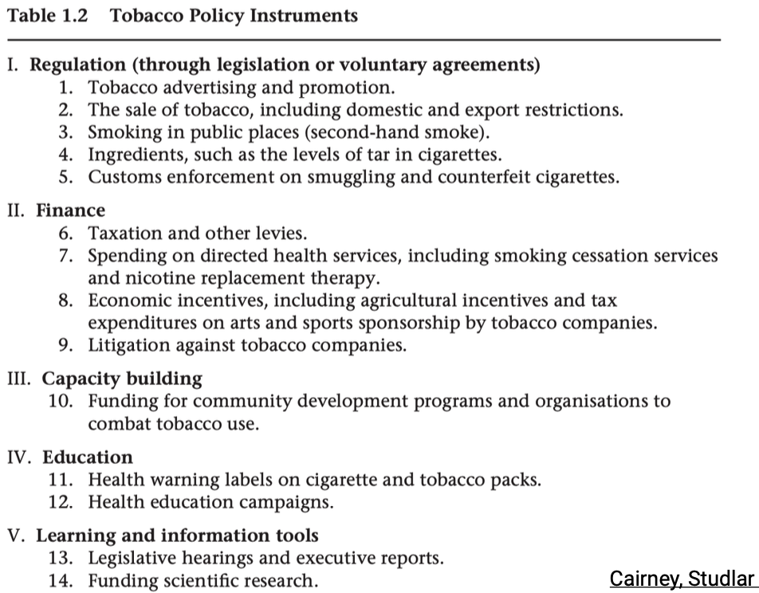

This shows a coordinated mix across all four instrument families (authority, treasure, organisation, nodality).

11. Case 1: Tobacco Control – Suboptimal Global Implementation
Despite scientific consensus, global implementation is very uneven.
Effective implementation is unlikely when:
- health departments are absent in the tobacco policy subsystem (in many countries today, health ministries still have weak influence compared to finance or agriculture ministries)
- tobacco industry interests are present and politically influential => tobacco industry is very powerful
- socio-economic conditions do not support policy change (local economic and political pressures)

Important point:
- The developed vs. developing distinction does not predict implementation quality (e.g., Brazil and China perform better than expected) (you might expect that developed countries (rich, stable, high-capacity) would implement tobacco control better than developing countries (poorer, fewer resources)).
- Even when countries have similar objectives and instruments, this does not guarantee effective implementation.
→ The subsystem context matters more than formal policy design.

12. Case 2: Rail Baltica – Fateful Constraints on Implementation Management
Rail Baltica is a cross-national megaproject shared by Estonia, Latvia, and Lithuania.
It illustrates how institutional complexity can constrain implementation.

Key structural problems shown on the slide:
- Multiple ministries involved (climate, transport, communications)
- Mixed ownership through RB Rail
- National implementing bodies across three countries
- Fragmented responsibilities and overlapping mandates
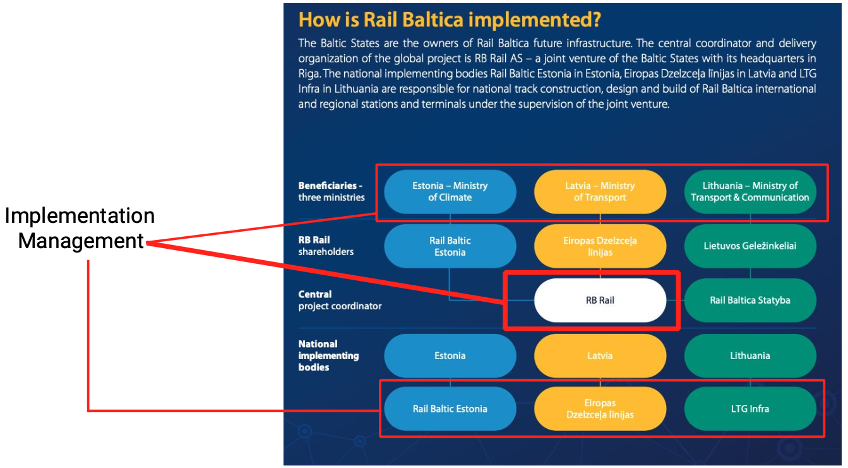
These arrangements make coordinated implementation difficult and slow.

13. Case 2: Rail Baltica – Poor Handling of Implementation Uncertainty
A major problem: cost escalation due to uncertain planning and poor risk accommodation.
According to new estimates:
- Total project cost increased more than fourfold from €5.8bn (2017) to €23.8bn (2023).
- Each country experienced dramatic increases:
• Estonia: €1.35bn → €4.03bn
• Latvia: €1.97bn → €9.59bn
• Lithuania: €2.47bn → €10.23bn
This demonstrates how large projects suffer when uncertainty is underestimated and coordination failures persist.

14. Comparison: Berlin Brandenburg Airport (BER)
The Berlin airport is a similar case of megaproject mismanagement:
- Construction began in 2006 under a public holding with an optimistic cost estimate of €2.1bn.
- From 2011-2017, controversies, scandals, and repeated delays emerged, with “salami-tactics” used by managers to manage public expectations.
- BER finally opened in October 2020 with effective costs of €7.3bn, over three times the original estimate.

The comparison shows that megaprojects frequently become political and administrative traps when forecasts are unrealistic.

15. “Salami Tactics” as a Blame Management Strategy
Large projects often rely on overly optimistic forecasts for:
- economic reasons (e.g., in cost-benefit analysis)
- psychological reasons (optimism bias)
- strategic reasons (to secure political approval)
When problems become visible, a framing contest begins.
High-level actors use salami tactics – breaking bad news into small, sequential announcements to:
- partition political blame into manageable increments
- reduce perceived welfare losses
- attract less blame
- wekaen accountability of policymakers and implementation managers
- facilitate blame shifting

This strategy maintains political survival at the cost of transparency and long-term effectiveness.

Main idea of the chart:
It shows how policymakers use salami tactics by gradually reducing an initially inflated benefit-cost ratio in small steps during implementation. Each small downward adjustment attracts less blame than revealing the full drop at once.

16. Implementation Strategy: Best and Worst Practices

1) Managers’ Incentives & Resources
What it means:
Whether high-level officials responsible for implementation have the motivation, political backing, authority, and material resources to run the project.
How to determine it:
- Do managers control sufficient budgets?
- Are their roles clear and not overlapping?
- Are they rewarded for good implementation?
- Do political leaders support them or leave them exposed?
Potential problems if weak:
- Coordination failures
- Managers avoiding responsibility
- Delayed decisions
- Over-dependence on external actors (consultants, ministries)

2. Doers’ Incentives & Resources
What it means:
Whether frontline implementers (street-level bureaucrats, engineers, inspectors, caseworkers) can actually carry out the tasks.
How to determine it:
- Do they have proper training, staffing, time, and tools?
- Are their workloads realistic?
- Do they have discretion they can use productively?
- Are they motivated or resistant?
Potential problems if weak:
- Delayed or inconsistent execution
- Low compliance, passive resistance, or sabotage
- Unequal outcomes across regions
- “Paper implementation” where rules exist only formally

3. Effective Fixers
What it means:
Whether intermediaries exist who translate goals, mediate conflicts, and ensure information flows between managers and doers.
How to determine it:
- Is there a trusted coordinating body or key actor?
- Do fixers have legitimacy and access to both sides?
- Can they solve bottlenecks before they escalate?
- Is technical expertise concentrated in these intermediaries?
Potential problems if weak:
- Miscommunication between levels
- Implementation drifting away from design
- Frequent blame shifting
- Fragmentation of the subsystem

4. Uncertainty Hedges
What it means:
Whether the policy design anticipates risk, delays, and unexpected costs – and includes buffers.
How to determine it:
- Is there contingency funding?
- Are risk analyses done early?
- Are multiple policy tools available, not just one?
- Can the system adapt if assumptions are wrong?
Potential problems if weak:
- Cost overruns
- Project delays
- Frozen decision-making when surprises occur
- Crisis-driven improvisation

5. Evaluation & Reporting Requirements
What it means:
Whether implementation includes systematic monitoring, reporting, feedback loops, and accountability.
How to determine it:
- Are progress reports required?
- Are independent evaluations used?
- Is data public and transparent?
- Do managers adjust based on findings?
Potential problems if weak:
- Problems go unnoticed until too late
- Politicians rely on guesswork or PR
- No learning over time
- Space for corruption or hidden failures

6. Flexibility & Decentralization
What it means:
Whether implementers have room to adjust the policy to local conditions rather than applying rigid rules.
How to determine it:
- Can agencies modify routines?
- Are decisions delegated?
- Does decentralization improve or worsen coordination?
- Do frontline actors have reasonable discretion?
Potential problems if weak:
- Overly rigid procedures → failures under real-world conditions
- No adaptation to local realities
- Excessive central micromanagement
- Loss of frontline creativity
Potential problems if too strong:
- Fragmentation
- Lack of uniform standards
- Inconsistent service quality

7. Enhancing Cooperative Social Norms
What it means:
Whether actors share trust, communication, and a norm of collaboration rather than competition or blame.
How to determine it:
- Do ministries trust each other?
- Do implementers feel they are “on the same team”?
- Is conflict high or low?
- Are norms historically cooperative in the subsystem?
Potential problems if weak:
- Blame games
- Implementation gridlock
- Withholding information
- Increased conflict between actors
- Low willingness to compromise or coordinate

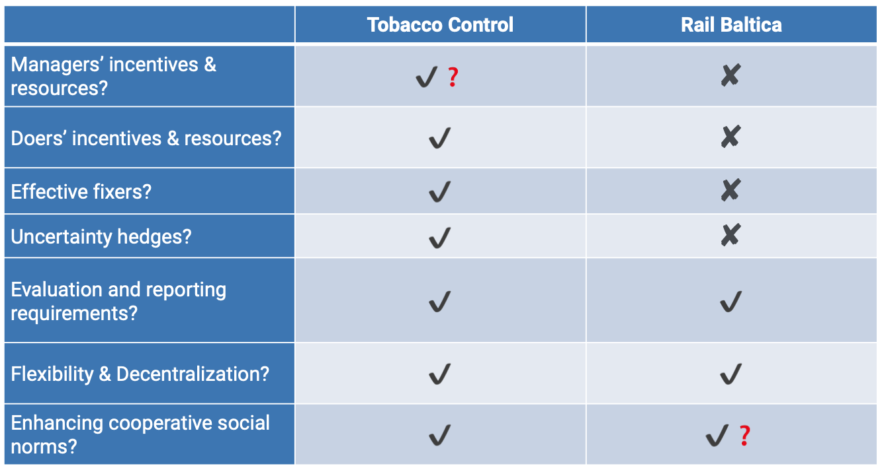
The question marks represent:

Ambiguous evidence, conditional success, or missing information depending on the case.
- Tobacco control (✔ ?) → varies widely across countries
- Rail Baltica (✔ ?) → cooperation exists but is fragile
- DOGE reforms (?) → insufficient information yet to judge

DOGE = “Department of Government Efficiency”
A hypothetical or loosely inspired example of an administrative reform meant to:
- cut bureaucracy
- improve performance
- centralize monitoring
- reduce duplication
- deliver cost savings

17. Administrative Burdens: Implementation Problems by Design
Herd & Moynihan (2018): “policy-making by other means.”
Administrative burden refers to implementation costs intentionally or unintentionally built into a policy.
Three types:

1. Learning Costs
Citizens must learn rules, deadlines, eligibility, documents.
High learning burdens discourage participation.

2. Compliance Costs
Time and effort required to complete procedures.
Example from the slide:
- US Treasury paperwork creates 6.7 billion hours of administrative work
- This accounts for 75% of all federal paperwork time in the US.

3. Psychological Costs
Stigma, stress, fear of mistakes, or navigating complex state interactions.

18. Attempts to Lower Learning Costs (EITC Nudges)
The IRS experimented with simplified notices for the Earned Income Tax Credit:
- Clear message: “You may be eligible for a refund of up to $5,751.”
- Summary section explains eligibility in plain language
- “What you need to do” gives simple steps

Purpose: reduce learning costs so more eligible low-income workers actually claim the benefit.
This is an implementation improvement through better communication, not a change in policy design.

Reading#13: Implementation

1. The Logic Chain & Assembly Metaphor (Missing in Lecture)

Logic Chain
The reading emphasizes that every policy requires a plausible chain of hypotheses connecting:
Adoption → Actor behaviors → Outputs → Outcomes
Each link is a possible failure point.
Lecture did not discuss this structured “chain-of-hypotheses” way of thinking.

Assembly Metaphor
Eugene Bardach’s idea: implementation = assembling essential elements from different actors.
Implementation becomes harder when:
- Elements are numerous
- They are heterogeneous
- They are tightly coupled (“domino syndrome”)
This provides a systemic understanding of complexity not presented in the lecture.

2. The Roles of Actors: MUCH more elaborate in the reading
The lecture briefly mentioned fixers, doers, street-level bureaucrats, but the reading provides richer, deeper insights:

Implementation Managers
Beyond incentives/resources (from lecture), the reading adds new concepts:
- Goal congruence between policy and organization
- Visibility of responsibility (blame/credit clarity)
- Tacit knowledge and prior implementation experience
- Authority vs. treasure vs. political support as three different resource types
These nuanced dimensions weren’t covered in the lecture.

Doers (Street-level Bureaucrats)
The lecture discussed resistance styles, but the reading includes:
- Doers can be professionalized (lawyers, doctors) and higher-status than managers
- Problems with contracted (non-government) service deliverers
- Noncompliance can be inadvertent, due to:
  - Local procedural rules
  - Incompetence
  - Coordination delays
This richer understanding goes beyond the lecture’s token/delay/resistance framework.

Fixers
The reading covers:
- Informal fixers vs. formal fixers
- Fixers as boundary spanners
- Risks when interest-group fixers divert policy toward their own goals
The lecture only mentioned fixers conceptually and briefly.

3. Forward Mapping & Backward Mapping (Not in lecture)

Forward Mapping
A systematic technique to:
- Write a detailed scenario of implementation
- Critique each actor’s incentives and possible resistance
- Revise with more plausible assumptions
This is a formal tool for analysts, much more structured than anything in the lecture.

Backward Mapping
Start from the outcomes → identify required behaviors → move upward to policy design.
This supports bottom-up approaches and is completely absent from the lecture.

4. Error-Correction Design Mechanisms (Only partially in lecture)
Lecture mentioned “uncertainty hedges,” but the reading adds detail:

Redundancy & Slack
- Redundant suppliers, alternative implementation routes
- Slack resources for “learning” and “buffering shocks”

Designing in Evaluation
Evaluations must be intentionally built into the policy:
- Randomization
- Baseline data
- Comparisons to controls
Lecture never covered evaluation design principles.

Termination Mechanisms
- Sunset provisions
- Ad hoc organizations to reduce resistance at termination
- “Buying off” beneficiaries when ending policies
The lecture did not discuss termination at all.

5. Responding to Heterogeneity (Not in lecture)

Bottom-up processes
- Self-selection (like in San Francisco parking example)
- Local advisory boards
- Negotiation forums

Capacity Building
Long-term strategies for improving local organizational capabilities.

Phased Implementation Strategies
Two approaches:
- Representative sites
- “Stack the deck” with easy cases first
Lecture mentioned uncertainty, but not these structured strategies.

6. Repeated-Game Insights (Completely new compared to lecture)
The reading introduces rational choice institutionalism, far beyond what the lecture covered:

Social & Organizational Norms
Cooperation depends on:
- repeated interaction (probability δ)
- long-term expectations
- punishment strategies like “grim trigger” or “tit-for-tat”

Leadership & Corporate Culture
Leaders:
- solve coordination problems
- create focal points
- embed norms
Corporate culture:
- stabilizes norms beyond the actions of individual leaders
- can be damaged by poorly designed policies
The lecture did not discuss repeated games, norms, leadership, or culture.

7. Additional Concepts Unique to the Reading

Scenario Writing as an Evaluation Tool
Very detailed method the lecture didn’t cover.

“Dogs that didn’t bark”
Identify actors not included in the plan but likely to resist.

Political design choices that influence feasibility:
- distribution of credit/blame
- coupling of organizational routines
- subtle strategic interactions
These details were not part of the lecture.

Lecture#14: Evaluation

1. Where We Are in the Policy Cycle
The slide places this lecture in the evaluation phase of the policy process (after implementation).
Evaluation is not just the last step – it feeds back into agenda-setting, helping define new problems, update priorities, or terminate failing policies.
Key idea:
Evaluation closes the loop and reopens it: it determines whether the policy’s causal story was correct and whether outcomes match intentions.

2. Sites & Actors of Policy Evaluation (Admin, Economic, Scientific etc.)

1) Administrative Evaluation
- Conducted by specialist government bodies (audit offices, regulatory oversight units, parliamentary budget offices) or private consultants.
- Can occur ex ante (before implementation), ex post (after results emerge), or in media res (during implementation).
- Main goal: ensure policies reach goals with minimal cost and minimal burden on target groups.
How to understand this:
Administrative evaluation is about efficiency and compliance. It checks whether agencies did what they were supposed to, within rules and budgets.
Potential problems:
- Evaluators may depend on the ministries they evaluate → lack of independence.
- Can become a ritualistic, “check-the-box” process rather than deep learning.

2) Economic Evaluation
- Conducted by government economists or private consultants.
- Compares costs (inputs) with benefits (outcomes) of alternative policies.
- Uses tools like:
  - Cost–Benefit Analysis (CBA)
  - Cost-effectiveness analysis
How to interpret this:
This type assumes decisions should reflect economic rationality – maximizing net social benefit.
Typical problems:
- Hard to monetize intangible benefits (justice, dignity, health equity).
- CBA can be biased by model assumptions → “benefit inflation” or “cost suppression”.

3) Scientific Evaluation
- Done by universities or think tanks.
- Goal: provide neutral, research-based answers about effectiveness.
- Often uses experiments, quasi-experiments, or longitudinal studies (see: Basic Income experiments).
Interpretation:
Scientific evaluation tries to separate politics from knowledge, but in practice results can still be contested.
Problems:
- Politicians may ignore or selectively use findings.
- Research may be too slow or too complex for policymakers.

4) Judicial Evaluation
- Courts check whether policies comply with constitutional and legal rules.
- Focus: assess the legal (constitutional) compliance of policies and their implementation, rights protection, procedural fairness, proportionality.
Interpretation:
Judicial evaluation may stop, delay, or reshape policies regardless of policy goals.
Potential issues:
- Courts are not elected → accusations of “judicial activism”.
- Courts evaluate legality, not effectiveness.

5) Political Evaluation
- Conducted by political parties, interest groups, or politicians.
- Goal: frame policies positively or negatively to shape public perception.
Interpretation:
Evaluation becomes a battle over narratives, not evidence.
Problems:
- Selective use of evidence (“cherry-picking”).
- Parties may claim success or failure for strategic reasons, unrelated to actual outcomes.

6) Performance Evaluation
- Focuses on agency management (ties to NPM reforms).
- Conducted internally or via consultants.
- Measures organizational performance relative to goals.
Interpretation:
This is about managerial efficiency, e.g., meeting KPIs, service delivery metrics.
Problems:
- Overemphasis on measurable outputs → “gaming the metrics”.
- Can create incentives for superficial success rather than meaningful outcomes.

3. What Successful Policy Evaluation Should Do
A good evaluation should:

a) Check whether the causal story was correct
- Did the policy’s assumed logic (problem → output → outcome) match reality?
- Many policies fail because the wrong mechanisms were targeted.

b) Measure goal attainment
- “Did it work?” – not in theory, but empirically.

c) Reveal types of policy failure
- Design failures (wrong instruments)
- Regulatory disasters (bad rules)
- Implementation failures (bad execution)

d) Handle the attribution problem
The biggest challenge: how do we know which factor caused the outcome?
Two sources:
- Confounding factors (economic shocks, demographic trends, etc.)
- Complexity of policy mixes (many instruments interact)

e) Enable policy learning
- Especially learning from mistakes, not just celebrating success.
- Learning requires evidence-based feedback, not stories or political spin.

But… evaluation is often political
In reality, evaluation battles revolve around:
- Reputation
- Blame avoidance
- Agenda-setting power
Because of this, policy learning mixes scientific knowledge with political narratives.

4. Policy Learning: Two Distinct Logics
Policy learning = acquiring new policy-relevant knowledge under uncertainty and bounded rationality.
This is learning from past policies and evaluations in order to design better policies and avoid repeating failures in the future.

A. Evidence-Based Policymaking (Instrumental Learning)

Learning from evidence (evaluations, data, best practices) about how to improve policies and fix problems:
- Voluntary transfer of best practices
- Reducing uncertainty
- Avoiding repeated mistakes
- Avoiding “reinventing the wheel”
- Updating actors’ beliefs
Interpretation:
This is the idealistic model of learning – rational, problem-solving, collaborative.
Problems:
- Requires trust in data, experts, and processes
- Slow and costly
- Vulnerable to political manipulation

B. Political Learning (Power over Knowledge)

Learning from political pressures (veto players, crises, power struggles) about how to navigate politics, survive, and protect legitimacy:
- Involuntary transfer of “best practices”
- Linked to conditionality (e.g., IMF Washington Consensus, EU Copenhagen Criteria)
- Coping strategies for survival
- Manipulating agendas, overcoming veto players
Interpretation:
Here, learning is not about becoming smarter – it’s about survival, influence, and legitimacy.
Problems:
- Who controls knowledge controls policy
- “Learning” might formalize power imbalances
- May pressure governments into policy convergence even if policies do not fit local needs

5. What Counts as Evidence?
Majone’s definition:
Evidence = selected information used to persuade a specific audience at a specific moment.
The slide’s nested boxes show:
- Facts ⟶ Data ⟶ Information ⟶ Evidence

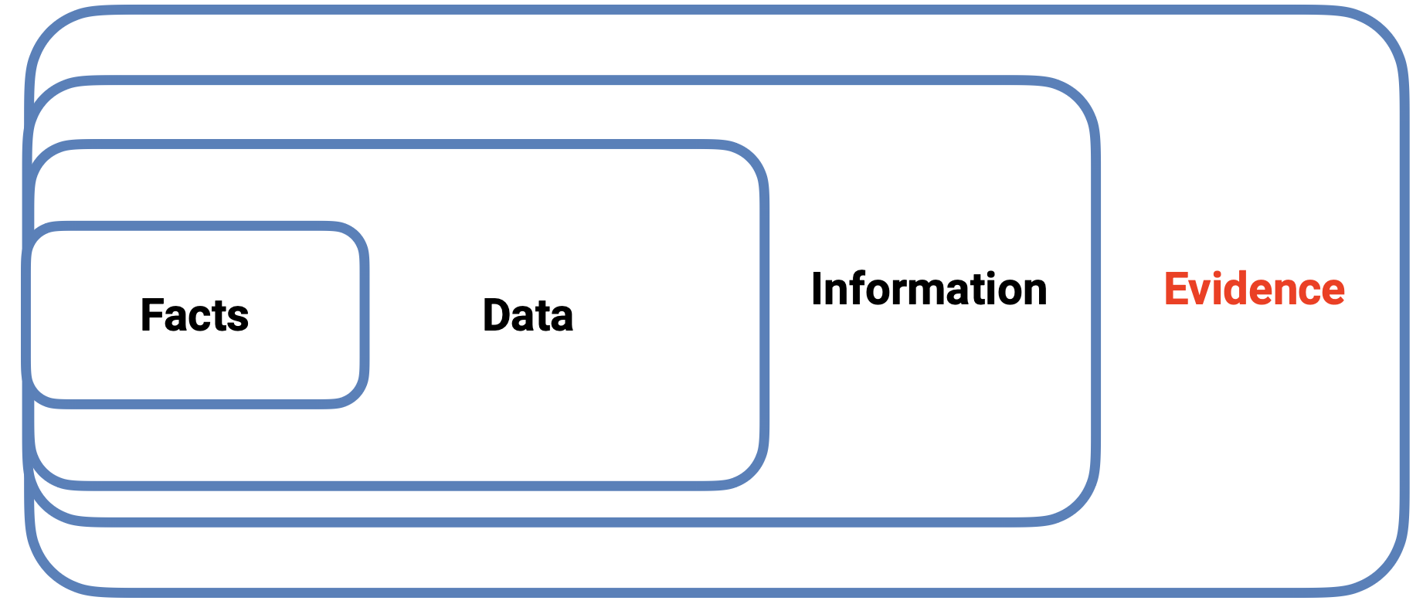

Interpretation:
Evidence is not neutral – it is produced, selected, and framed for persuasive effect.

Implications:
- Competing actors produce competing evidence.
- “Good evidence” is rarely agreed upon.
- Experts hold epistemic authority – but that authority is increasingly contested (epistemic authority is the right to be believed because you are an expert. Now people question that authority more often).

6. Evidence-Based Policymaking: Challenges
- Evidence is the “gold standard”, but contested politically.
- Evidence can be strategically produced (e.g., tobacco control, sugary drinks, formula milk lobbying).
- Uncertainty about what counts as “good evidence”.
- Heavy reliance on experts, whose authority is increasingly questoned.
- Experts hold epistemic authority – but that authority is increasingly contested.

Interpretation:
Evidence doesn’t speak for itself – it must be interpreted, trusted, and legitimated.

7. Policy Transfer (Diffusion & Convergence)
Definition (Dolowitz & Marsh, 2000):
Policy transfer is the process by which knowledge about policies, institutions, or administrative arrangements from one political system (past or present) is used to shape policy development in another political system.
Policy transfer can be understood through two complementary lenses:

A. Policy Diffusion
Focus: the patterns of spread
Policy diffusion studies how and why policy ideas spread from one jurisdiction to another.
It is about the movement of policy innovations across the globe.
Diffusion is often driven by:
- Learning – countries adopt ideas that have empirically worked elsewhere
- Competition – states adjust policies to stay economically or politically competitive
- Emulation – copying admired or prestigious models
- Networks – diffusion through IOs (IMF, OECD, EU), NGOs, and epistemic communities
Key point:
Diffusion describes the spread, not whether the systems eventually become similar.

B. Policy Convergence
Focus: the results of transfer and learning
Policy convergence examines whether different policy systems end up more similar over time.
It measures the degree of alignment in policies across countries.
Convergence can be caused by:
- Emulation of successful or prestigious models
- Exchange of ideas and best practices
- Interdependence, such as EU membership requiring policy harmonization
- External pressure, e.g., IMF conditionality, OECD standards
- Penetration, when international organizations or powerful states push reforms
Key point:
Convergence does not mean direct copying of one model – countries may become similar through different pathways.

8. Examples of Policy Transfers
These cases show both diffusion (spread) and convergence (growing similarity):
- Adoption of Scandinavian welfare-state principles in multiple European and non-European countries
- The global wave of privatizing 8,500 state-owned enterprises (1980–1992, across 80+ countries)
- Worldwide spread of New Public Management (NPM) reforms in the 1980s and 1990s
- Anti-money laundering policies adopted by ~170 countries over ~20 years
- Diffusion of Silicon Valley-style innovation ecosystems and entrepreneurial policy models

What These Examples Show
- Policy transfer is global, cutting across regions, ideologies, and political systems.
- Transfers are often ideologically motivated, especially with neoliberal reforms.
- International organizations, consultants, and epistemic communities play a major role in promoting and standardizing policy ideas.
- Some transfers lead to diffusion without convergence, while others produce convergence as countries end up with more similar policy frameworks.

9. The Four Challenges of Evaluation Design
These four questions structure ANY evaluation strategy. They seem simple, but each hides conceptual and political dilemmas:

1. What should be evaluated?
Choosing the object of evaluation: entire policies, specific instruments, implementation processes, outcomes, target groups.
→ The core issue: evaluation is selective – and what gets evaluated shapes what counts as “success” or “failure.”

2. How should it be evaluated?
Choosing methods that fit the policy and the available data (experiments, RCTs, qualitative methods, mixed methods).
→ The challenge: balancing methodological rigour with feasibility, ethics, and context.

3. Who should evaluate?
Choosing actors: independent scientists? bureaucrats? political bodies? consultants?
→ Core tension: impartiality vs. political control.

4. What should be done with the results?
Deciding how evaluation findings feed back into the policy cycle.
→ Challenge: whether results actually shape redesign/termination or get used politically.

10. What Should Be Evaluated?

Key Question:
Which policies – or which parts of a policy – should be evaluated?

Mainstream Position: Evaluate every policy regularly
This follows a managerial logic: ongoing monitoring should continually improve quality and efficiency.
Mechanisms:
- Sunset clauses: policies automatically expire unless renewed.
- Review provisions: scheduled reassessment points.
Strengths:
- Ensures outdated, ineffective, or harmful policies are corrected or updated.
Risks:
- Congestion: too many evaluations → overload → shallow, rushed assessments.
- Tokenism: evaluations become “tick-the-box” exercises with no real learning.

Alternative Position: Evaluate only important or contested policies
Evaluations should focus where stakes are high.
Issue:
Who decides what is “important”?
- Bureaucrats?
- Firms?
- Citizens?
→ This becomes political because “importance” reflects power, interests, and values.

Role of Process Evaluations
Sometimes how a policy was implemented matters more than whether it worked.
Useful when:
- Policies are complex
- Outcomes depend on many interacting factors
- Attribution is difficult

11. How Should It Be Evaluated?

Method choice must match the policy
Different policies require different research tools (quantitative, qualitative, mixed methods).

Gold Standard since the 2010s: Experiments, especially RCTs
RCT = Randomised Controlled Trial
Participants are randomly placed into a treatment group or control group to identify causal effects.
Referenced in the slide:
- Banerjee & Duflo (2009): foundational work in development economics using RCTs.
Why RCTs are valued:
- Strong causal inference
- Reduction of confounders
- Seen as objective, credible, and rigorous

Challenges of RCTs
- Ethical constraints
  - Cannot randomise life-saving interventions or rights-based policies.
- External validity
  - Results from one country/group may not apply elsewhere.
  - RCTs show “what worked here”, not “what will work everywhere.”
- Spillovers
  - Treatment effects can “contaminate” the control group.
- Complex interventions
  - Hard to isolate which component of a multi-part policy caused the effect.
Bottom line: RCTs are powerful but not always feasible or appropriate.

Example: OECD’s PISA (Programme for International Student Assessment)
PISA compares educational achievement (outcome) across countries based on policy inputs (resources, curricula, teaching methods).

Purpose of PISA:
Provide evidence on which education policies work and help countries improve schooling.

Well-known problems with PISA feedback:
- Teaching to the test (unintended effect)
  - Schools teach exam techniques rather than real learning.
  - Distorts behaviour in response to measurement pressure.
- Attribution problem
  - Hard to know whether PISA results are caused by specific policies.
  - Education outcomes are shaped by culture, parents, inequality, etc.
- Biased conception of achievement
  - PISA tests only one model of “good education” (math/reading/science).
  - Neglects creativity, emotional skills, citizenship, etc.

12. Who Should Evaluate?

Ideal Model:
Evaluations conducted by objective, impartial, highly qualified scientists with strong methodological expertise.

Reality: Co-production
Evaluations are often shaped – strategically – by policymakers and implementing agencies.
Risks:
- Political or organisational rent-seeking:
  - Avoiding blame
  - Protecting budgets
  - Maintaining reputation

In practice:
- Evaluations are frequently triggered by governments or MPs
- Often carried out by for-profit consultants (highlighted in Mazzucato & Collington’s The Big Con)

Political use of evaluations
Performance evaluations can be:
- Used by executives to signal competence to voters
- Commissioned to shape agendas, justify reforms, or legitimize cuts
- Directed more by strategic motivations (control, reputation) than learning
Perverse effect:
Growing pressure to justify actions with “big data” may distort evaluation priorities and methods.

14. What Should Be Done with the Results?

Ideal Scenario:
Evaluation evidence should:
- Feed back into agenda-setting
- Trigger reassessment of the underlying problem
- Lead to policy termination if necessary

Reality:
- Termination almost never happens
Policies persist even when evidence is negative.
- Evaluations are often used for agenda-setting, not learning (not to learn but to support a political goal)
Example: used to justify welfare state retrenchment.
- Common managerial use: weed out inefficiencies (identifying and removing underperforming activities, people, or units to make the system more efficient)
Example: UK’s Research Excellence Framework (REF) (The REF does this by ranking university departments and allocating funding only to the strongest performers).

Transparency Dilemma
- Full transparency → may politicise evaluation criteria
- Internal use only → risk of cherry-picking and weaker accountability
The transparency dilemma refers to the trade-off in deciding how evaluation results should be shared. Full transparency risks politicising evaluation criteria and methods, while restricting results to internal use risks cherry-picking, reduced accountability, and selective reporting. The dilemma is about finding a balance between openness and political misuse.

15. The Bottom Line
Main challenge:
Finding a balance between:
- Technocratic exaggeration of evidence
(the idea that evidence provides clear, objective answers)
and
- Politicisation of evidence
(when evidence is selectively used to push political goals)

Core Lessons
- Evaluation findings are important inputs – but they do not replace political debate.
- Data do not speak for themselves: interpretation depends on values, criteria, and ambiguity.
- Multiple stakeholder perspectives are normal and should inform evaluation design.
- Process evaluations can be more useful than outcome evaluations in complex systems, because they show how policies work on the ground.

16. Key Upshots
- Evaluation feeds back into agenda-setting → “policy makes politics.”
- Policy failure is unavoidable – all policies have gaps, flaws, or unintended effects.
- Success and failure are observer-dependent – they rely on whose goals and causal story we use.
- Evaluation must deal with the attribution problem – what outcome was caused by what?
- RCTs help identify causal effects but face limitations (ethics, external validity, spillovers, complexity).
- Evidence-based policymaking increasingly influences earlier stages, not just evaluation.
- Evidence and evaluation methods reflect political choices – what counts as “good evidence” is not neutral.

Reading#14: Learning from Regulatory Disasters

1. What Is a Regulatory Disaster? (New Concept)
Black defines regulatory disasters as catastrophic events that cause serious harm to life, health, finances, or the environment, caused partly by failures in the design or operation of regulatory regimes.
Examples: Pike River mine, Deepwater Horizon, Buncefield explosion, RBS collapse, NZ leaky buildings.
Black - 2014 - Learning from re…
How it differs from terms used in class:
- Unlike policy failures, these are failures of risk regulation systems, not general policymaking.
- Unlike policy blunders (King & Crewe), regulatory disasters include judgement errors, systemic issues, and complex interactions — not just poor high-level political decisions.
- Excludes political disasters (where the main harm is to the reputation of politicians).
What makes them special:
- They can be systemic (industry-wide) or single-event disasters.
- They often reveal latent failures hidden inside a regulatory system until something catastrophic happens.

2. Six Common Contributory Causes of Regulatory Disasters (Not in Lecture)
Black identifies six recurring causes across disasters — these are a major conceptual contribution of the article.
Black - 2014 - Learning from re…

1. Incentives on individuals or groups
- Conflicting incentives distort behaviour (e.g., production > safety in Pike River).
- Regulators themselves can have incentives that undermine safety (e.g., US MMS rewarded for fast licensing, not for scrutiny).

2. Organisational dynamics & system complexity
- Failures in leadership, culture, skills, training, information flow.
- Large organisations ignore low-probability/high-impact risks.
- Fragmented regulatory responsibilities create blind spots.

3. Weaknesses or contradictions in regulatory strategies
- Prescriptive rules may be outdated.
- Outcomes-based regimes may lack “scaffolding” (detailed guidance).
- Management-based regulation fails if firm incentives diverge from regulator goals.

4. Misunderstandings of the problem or available solutions
- Regulators may misunderstand how risks accumulate or interact.
- Some risks appear trivial individually but catastrophic in aggregate.

5. Communication problems and conflicting messages
- Regulators send mixed messages (e.g., “minimise compliance costs” undermining safety culture).
- Agencies do not share critical information.

6. Trust & accountability failures
- Regulators may trust firms excessively (“regulatory capture light”).
- Accountability systems may reward the wrong behaviours.
These six categories are central to Black's framework and were not addressed in your lecture.

3. Importance of Organisational Culture (Not in Lecture)
Black shows that regulatory disasters are often cultural failures, not just technical failures.
Black - 2014 - Learning from re…

Key findings:
- Informal norms override formal safety rules (Pike River).
- Regulators internalise political or industry priorities (MMS giving “green light” to drilling).
- Training gaps and weak expertise affect both regulators and firms.
- Experts and generalists clash, causing coordination failures.
- Senior leadership often does not understand the risks (“tone-deaf boards”).
This organisational behaviour lens is missing from your policy evaluation lecture — important to emphasise.

4. Regulatory System Complexity (New Concept)
Black highlights how regulatory failures often stem from fragmented, multi-layered systems. This is not covered in the lecture, which focuses more on political dynamics.
Black - 2014 - Learning from re…
Examples:
- Pike River: multiple agencies with narrow mandates; no one saw the full picture.
- Buncefield: regulators had conflicting priorities; poor data sharing; incompatible systems.
- Deepwater Horizon: overlapping MMS + Coast Guard responsibilities → paralysis.
Key insight:
Regulatory disasters often come not from one failure but from multiple agencies failing to connect the dots.

5. The Vulnerabilities of Different Regulatory Techniques (Not in Lecture)
Your lecture covers evaluation and evidence, not regulation design.
Black provides a highly relevant typology:

A. Prescriptive regulation
- Tight rules but quickly become outdated (Deepwater Horizon).
- Cannot keep up with technological innovation.

B. Performance-based/outcome-based regulation
- Sets goals (e.g., “safe mining”), not methods.
- Vulnerable if not supported by minimum standards or technical guidance.
- Loses “institutional memory” when detailed rules are removed.

C. Management-based regulation (safety case approach)
- Firms design their own risk systems.
- Works only when incentives align.
- Fails if firms treat it as paperwork or if regulators cannot assess complex systems.
These distinctions are unique to Black and not included in your course slides.

6. Failures of Monitoring & Inspection (New Concept)
This is a major analytical contribution not present in your lecture.

Black notes systemic problems:
- Inspectors focus on visible defects, not deeper systemic risks.
- Regulators often choose the path of least resistance (checklists, tick-boxes).
- Inspections may be too narrow (Pike River → no cultural or strategic audits).
- Others too broad but shallow (RBS → processes checked, business model ignored).
- Overreliance on lagging indicators instead of predicting future risk.
Important: inspection strategy is a regulatory tool, and its failures are a major driver of disasters.
Black - 2014 - Learning from re…

7. Knowledge, Risk Perception, and Uncertainty (Not in Lecture)
Black emphasises misunderstandings of risk, including:

Known risks ignored
- Low-probability but catastrophic risks receive little attention.
- “We haven't had an accident yet” → complacency.

Unknown unknowns (true uncertainty)
- Buncefield vapor-cloud detonation mechanism still not understood.
- Financial crisis assumptions proved entirely wrong: extreme events happening “every day”.

Regulators cannot prevent all disasters
Risk regulation operates under deep uncertainty.
These epistemic limits are not covered in your lecture.

8. Communication & Trust Dynamics (New Concept)
Key risks:
- Regulators send mixed messages (e.g., “low compliance costs” vs. safety).
- Over-trusting relationships with firms undermine oversight.
- “Regulatory dividend” (UK FSA) → trusting cooperative firms too much.
- Agencies fail to coordinate or communicate with each other.
Your lecture talks about evaluation uses, not trust dynamics in regulation — so this is new material.

9. Meta-Insight: Disasters Reveal “Latent Failures” (Very Important Concept)
Black stresses that disasters reveal hidden structural weaknesses that accumulate silently until a triggering event occurs.
Black - 2014 - Learning from re…
Examples:
- Failing mine ventilation systems.
- Poor bank capital structures.
- Weak inspection routines.
- Outdated regulatory frameworks.
This idea of latent failure is not in your evaluation lecture but is essential to understanding regulatory governance.

10. Why Learning From Disasters Is Difficult (New Concept)
Black notes several obstacles:
- Political defensiveness after disasters.
- Pressure for quick blame → shallow diagnosis.
- Regulators rarely have incentives to deeply reform themselves.
- Some “black swan” events cannot be predicted.
Yet disasters often provide the only opportunity to expose system weaknesses.

Lecture 15: Cost-Benefit Analysis

1. Under-Appreciated Reciprocity Between Economics and Public Policy
Economics and public policy influence one another more than is often acknowledged. Each field highlights blind spots in the other, and understanding their interaction leads to more realistic analysis.

What Economics can learn from Public Policy
- Economics is not value-free; choosing welfare maximisation as the central objective is itself a normative decision.
- In practice, welfare maximisation is too narrow to guide policy everywhere, because real policy decisions involve competing goals, political constraints, and institutional considerations.
- Economics implicitly contains ethical concerns beyond efficiency, and public policy helps make those concerns more explicit.

What Public Policy can learn from Economics
- Even when societies face value conflict, economic reasoning remains useful and should not be dismissed.
- Economics reveals the entanglement of efficiency and fairness, helping public policy avoid conceptual mistakes when evaluating outcomes.
- Tools like cost-benefit analysis (CBA) show how economic reasoning can structure complex policy decisions and clarify their welfare consequences.

2. Applying the Pareto Criterion in Public Policy
The slide emphasises that pure Pareto improvements are rare because nearly every policy produces both winners and losers. This makes the strict Pareto rule impractical for policymaking.
To address this, economists asked how to evaluate a policy that shifts society from point A to
point B when utility increases for one group but decreases for another.
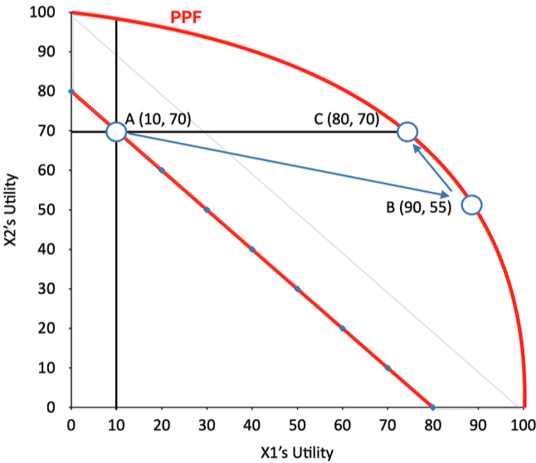

Kaldor-Hicks compensation principle
Kaldor and Hicks (1939) proposed assessing whether the gainers could theoretically compensate the losers. Actual compensation does not need to occur; the test simply asks whether compensation would be possible. If so, the policy creates a potential Pareto improvement.

Illustration with the slide’s example
- Individual X₁ gains +80
- Individual X₂ loses –15
- Net social benefit: +65
Because the gain exceeds the loss, compensation is feasible and the move from B to C can be justified under the Kaldor-Hicks criterion.

This approach relaxes the unrealistic strictness of the Pareto rule and provides a practical welfare test for policies with mixed effects.

3. “Is Policy Project X Increasing Welfare?”
Policymakers want evaluations grounded in quantifiable, actionable evidence, ideally expressed in monetary terms. The central tool for this is the Net Present Value (NPV) of a project.

NPV formula
Net (Present) Value of a Project = (present value of) Benefits - (present value of) Costs.
Because both benefits and costs often unfold over long periods, discounting is used to convert them to present values.

Decision logic
If the net present value is positive, meaning that benefits exceed costs, the project should be undertaken. This reflects the same logic as potential Pareto improvements: a positive NPV indicates that society’s “pie” is larger and that, at least in principle, losers could be compensated.
In essence, NPV gives policymakers a clear, consistent metric for judging whether a project increases overall welfare.

4. Economic Appraisal Structure (EU Context)
Economic appraisal for major EU infrastructure projects is highly structured and rests on several integrated analytical components. The process ensures both EU compliance and the ability to evaluate wider economic and social impacts.
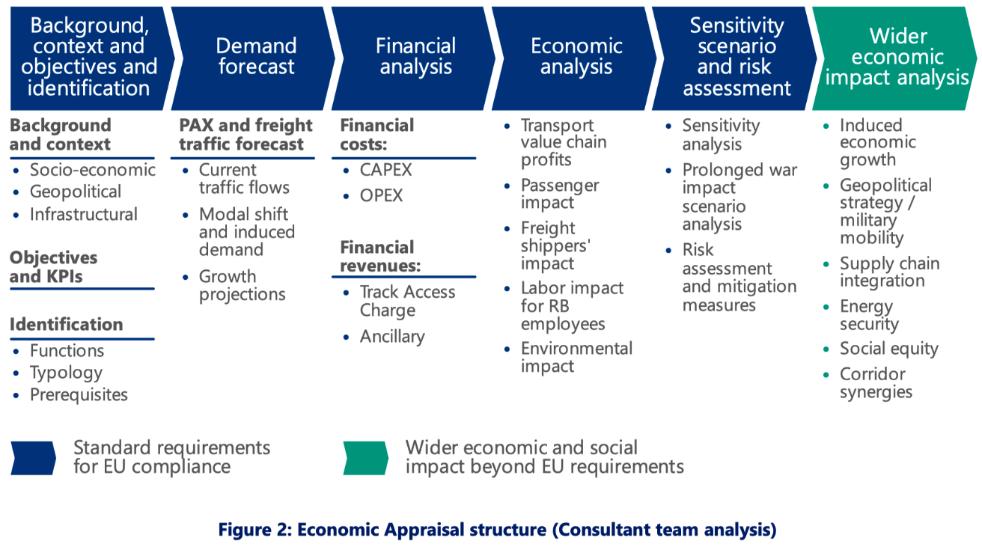

1. Background, context, identification
This establishes why the project is needed and how it fits into existing socio-economic, geopolitical, and infrastructural conditions. Objectives and KPIs are set, and the project’s functions, typology, and prerequisites are identified.

2. Demand forecast (PAX & freight)
Forecasts consider:
- Current traffic flows,
- Expected modal shifts (e.g., from road to rail),
- Induced demand created by better infrastructure, and
- Long-term growth projections.
These forecasts strongly affect projected benefits.

3. Financial analysis
- CAPEX: construction and capital investment
- OPEX: operation and maintenance
- Revenues: track access charges and ancillary income
This produces the project’s Financial NPV, which is often negative for public infrastructure but does not reflect its broader societal value.

4. Economic analysis
Here the appraisal captures:
- Passenger benefits (time, cost, accident savings),
- Freight shipper benefits,
- Effects on labour markets and employment,
- Transport value chain efficiency,
- Environmental impacts.

5. Sensitivity & risk assessment
This step tests how results change under different assumptions. It includes:
- Sensitivity analysis,
- Prolonged war scenario analysis,
- Risk assessment and mitigation measures.

6. Wider economic impact analysis
These effects go beyond EU minimum requirements and include:
- Induced economic growth,
- Geopolitical and military mobility value,
- Supply chain integration,
- Energy security,
- Social equity,
- Corridor synergies.

These wider impacts often provide the strongest justification for major infrastructure investments.

5. Rail Baltica’s Economic Impact (BCG 2024)
The Rail Baltica case shows the difference between financial performance and economic impact.

Key finding
Rail Baltica’s total economic impact exceeds its financial performance by €6.6bn over its lifetime.

Breakdown
- Financial NPV: –21.5bn
(reflects high construction and operational costs)
- Economic impact NPV: +28.1bn
from:
  - Passenger benefits,
  - Environmental gains (GHG, noise, air pollution),
  - Freight shipper savings,
  - Direct labour benefits,
  - Transport value chain profits.
Combining both yields a Total Economic NPV of +6.6bn.

Wider impacts
An additional €15.5–23.5bn of indirect economic impact arises through:
- Military mobility advantages,
- Environmental sustainability,
- Social equity improvements,
- Supply chain and corridor synergies.

Overall, the financial side alone would not justify the project, but the economic and strategic value clearly does.

6. Rail Baltica CBA 2017
The earlier CBA found even stronger socio-economic benefits.

Net socio-economic benefits (undiscounted):
More than +16bn EUR

Main benefit categories
They covered all key stakeholder groups:
- Travellers (time and cost savings),
- Freight shippers (reduced time and cost),
- Railway undertakings (operating profit),
- Residents near roads/airports (noise and air quality improvement),
- General public (climate change reduction).
Benefits were dominated by:
- Air pollution reduction (18%),
- Climate change reduction (17%),
- Freight travel time savings (16%),
- PAX travel time savings (13%).

Costs and total net flows
- Socio-economic costs: –1.634bn
- Financial costs: –4.048bn
- Total net socio-economic cash flows:
  - +12.178bn (undiscounted)
  - +879m (discounted)
Discounting reduces long-term benefits sharply, but even then the project remains positive.

7. Choosing the Appropriate “Solution Method”
These slides summarise Weimer & Vining’s decision logic for choosing the right evaluation method depending on what can be monetised.
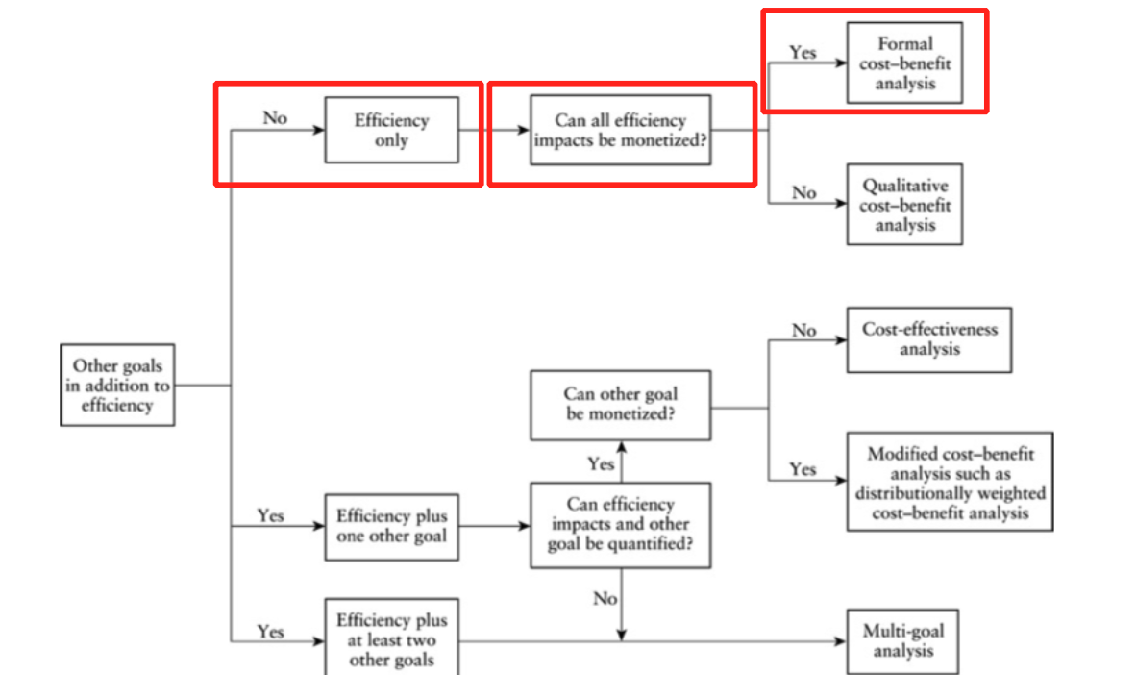

1. If efficiency is the only goal
- If all impacts can be monetised: Formal CBA
- If some cannot: Qualitative CBA

2. If there are additional goals (e.g., fairness)
- Ask whether the other goal can be monetised.
  - Yes:
    - If both efficiency and the other goal can be quantified → Modified CBA (e.g., distributionally weighted CBA)
    - If not fully quantifiable → Cost-effectiveness analysis
  - No:
→ Multi-goal analysis

This framework makes clear that CBA is not universally applicable, especially when fairness or distributional equity cannot be expressed in monetary terms.

8. Endowment Dependence of CBA
CBA may clash with fairness because WTP/WTA (Willingness to pay/Required compensation for a loss => Willingness to accept) depends heavily on endowment (what a person already has before any policy change happens).
Due to the diminishing marginal utility of income, wealthier individuals value marginal changes more in monetary terms, even if the real utility change is smaller.

(Because money has lower marginal utility for rich people, giving up money barely reduces their well-being. This means they can pay more (or demand more) for the same change without feeling much utility loss. So their WTP/WTA is higher, even though the actual utility gain is smaller)

Implication
- Richer individuals have higher WTP/WTA for identical welfare changes.
- Thus, CBA implicitly gives more weight to the preferences of the wealthy.

Two meanings of “endowment”
- Initial resources (transferable and non-transferable):
  - Income, wealth, property, environmental exposure
These shape both ability and willingness to pay.
- Internal resources (non-transferable):
  - Cognitive abilities, health, physical capacity
These affect how individuals experience gains and losses.

Because these endowments differ across people, CBA can reinforce existing inequalities, raising serious fairness concerns.

9. CBA: Generic Steps
Boardman et al. outline the standard sequence for conducting a cost-benefit analysis. These steps ensure the analysis is systematic, transparent, and comparable across policy alternatives.

1) Specify the set of alternative projects
- CBA always compares multiple options, not just the proposed policy.
- Alternatives may include: different designs, different levels of investment, or simply “do nothing.”

2) Decide whose benefits and costs count (standing)
- Determine which groups are included in the analysis: citizens, firms, government, foreigners, future generations, etc.
- This shapes the evaluation because some impacts may fall outside the chosen perspective.

3) Identify impact categories and select metrics
- Catalogue all relevant impacts: time savings, pollution, safety, operating costs, etc.
- Choose metrics that can later be monetised or quantified.

4) Predict impacts over the life of the project
- Requires modelling, forecasting, expert evidence, or empirical analogies.
- Must consider the full time horizon, often decades for infrastructure.

5) Monetize all impacts
- Convert each impact into a monetary value using WTP/WTA or revealed/constructed markets.

6) Discount benefits and costs
- Future impacts are worth less than present ones; discounting adjusts for time preference.

7) Compute the net present value (NPV) for each alternative
- The NPV determines whether benefits exceed costs.

8) Perform sensitivity analysis
- Check how results change when assumptions or parameters vary.

9) Make a recommendation
- Recommend the alternative with the highest NPV (or justify deviations).

This structure ensures decisions are rooted in coherent welfare logic, not intuition or political impulse.

10. Cost–Benefit Analysis (CBA)
Cost–Benefit Analysis provides a structured way to compare policy alternatives by translating all relevant impacts into a common monetary metric and assessing their net present value. The process is sequential, but each step interacts with the others, forming an internally coherent evaluation.

1) Specify the Set of Alternative Projects
The first step is to define the policy alternatives that will be compared. CBA never evaluates a project in a vacuum; it always compares it to feasible alternatives.
Typical alternatives include:
- Do nothing (status quo)
- Scaled versions of a project (small vs. large investment)
- Different designs or policy models
- Alternative delivery mechanisms (public vs private provision)
Importantly, the “current policy” baseline anchors all comparisons. Net benefits are calculated relative to this baseline, not in absolute terms. This matters because the perceived gain or loss depends on what would happen without intervention – the counterfactual.

2) Decide Whose Benefits and Costs Count (Specify Standing)
Standing determines whose welfare is included in the analysis.
Depending on perspective, the analysis may include:
- Global perspective: all individuals affected anywhere
- National or provincial perspective: only residents of a particular political jurisdiction
- Specific stakeholder groups (e.g., local communities, businesses)
The slide’s highway example shows how shifting the perspective (global vs. provincial) changes the accounting of benefits (e.g., time savings, safety benefits, new users) and costs (e.g., construction, maintenance, toll collection).
This step is normative, not just technical – it defines who "matters" in welfare calculations.

3) Identify the Impact Categories
All relevant consequences of each alternative must be listed, categorized, and expressed with measurable indicators.
Typical impact categories include:
- Social benefits: time savings, operating cost savings, safety benefits, new users, reduced congestion, environmental improvements
- Social costs: construction costs, maintenance, operational costs (e.g., toll collection), negative externalities
The aim is to build a complete impact inventory across alternatives, ensuring nothing important is omitted.
Even intangible or non-market outcomes (environmental quality, mortality risk, educational effects) must be included – later steps will handle how to monetize them.

4) Predict the Impacts Quantitatively Over the Life of the Project
Different domains require different prediction methods:
Choosing the right time horizon:
- Educational achievements: very long-term effects, often decades
- Non-pharmaceutical interventions: shorter-term behavioral or epidemiological outcomes
- Climate change: impacts unfold over generations
Evidential basis for predictions:
- Price elasticity estimates (e.g., to estimate behavioral responses)
- Experiments (randomized controlled trials, quasi-experiments)
- SIR models for public health (infection dynamics, transmission rates)
- Climate scenarios (IPCC-based projections)
The predictions form the numerical foundation for valuing benefits and costs.

5) Monetize All Impacts
CBA requires converting all impacts into monetary equivalents.

Opportunity Costs vs Fiscal/Notional Costs
A key distinction: opportunity costs do not always equal expenditures.
Example from the slide: with positive supply externalities, government spending may overestimate the real opportunity cost because resources might trigger productivity benefits not captured in the expenditure figure.

Common Monetization Methods
- WTA / WTP
Willingness-to-Accept and Willingness-to-Pay represent how individuals value gains or losses. These are central when a market price is absent (e.g., clean air, safety).
- Constructed (imputed) markets
Used when no real markets exist; analysts create hypothetical or shadow prices.
- Hedonic pricing
Observing how market prices (e.g., housing, wages) incorporate the value of attributes like noise levels or safety risks.
- Contingent valuation surveys
Asking people directly how much they would pay or accept to obtain or give up a non-market good.

Special Case: The Value of a Statistical Life (VSL)
A major part of monetizing safety and mortality reductions.
The slides show international VSL estimates differing by income levels (e.g., Norway at $16M, Liberia at $0.07M), illustrating how willingness to pay for small mortality risk reductions varies across countries.
Three common methods for monetizing tricky benefits (VSL):
- Wage-based evaluation: discounted value of lifetime earnings
- Contingent evaluation: stated willingness to pay for lower risk (e.g., safer flights)
- Revealed preferences / hedonic pricing: deriving values from real-world choices (e.g., buying airbags)
Example: If an airbag costs $350 and reduces fatality risk by 1 in 10,000, the implied value of life is at least $3.5 million.

6) Discount Benefits and Costs to Obtain Present Values
Because individuals and societies exhibit time preference, future costs and benefits must be discounted:
- $1 tomorrow is worth less than $1 today.
- Future benefits and costs are discounted; thus converted into Present Discounted Values (PDVs).

Formula



Choosing the discount rate
Typically fixed to government bond rates.
Guidelines:
- US OMB: 3% or 7%
- EU currently: ~4%

Illustration
The slides show:
- Upfront cost of 4000 in year 0
- Annual benefits of 1000 for several years
- Discounting reduces future values (e.g., 1000 becomes 909, 826, 751…)
This yields a total discounted benefit (e.g., 4355) and a comparison to the cost (4000), resulting in a net present value (NPV) – in the example, 355.

7) Compute the Net Present Value (NPV) of Each Alternative
Once impacts are monetized and discounted, the next task is to combine everything into an NPV for each policy option. The NPV expresses whether the benefits exceed the costs in present-value terms.
- In pandemic interventions (as in Thunström et al. 2020), the benefits come mainly from lives saved, monetized using the Value of a Statistical Life (VSL).
- Costs come from lost GDP, caused by social distancing or lockdowns.
- The model needs:
  - A VSL measure.
  - The difference in deaths with and without the policy.
  - A planning horizon (how long costs and benefits unfold).
  - GDP forecasts under both scenarios (controlled vs. uncontrolled).
  - A discount rate to convert future impacts to present values.
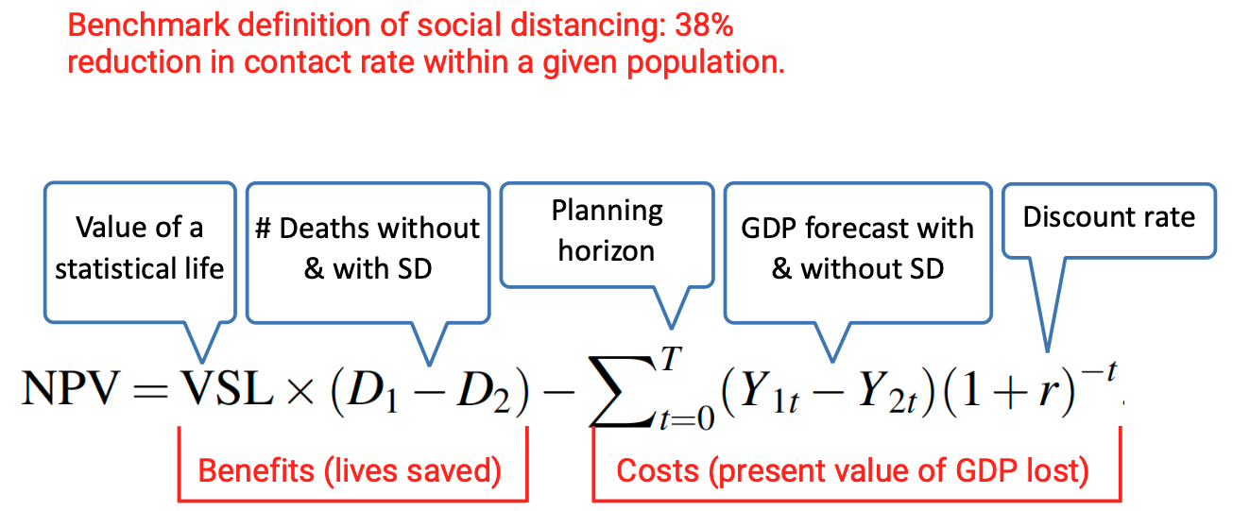
- The first term captures benefits (value of lives saved).
- The second term captures discounted GDP losses.

Example findings (Thunström et al., 2020):
- Uncontrolled scenario: very high deaths → very high value of lives lost.
- Controlled scenario: fewer deaths but large GDP decline.
- Net benefit of social distancing = $5.16 trillion, indicating that benefits outweigh costs substantially under benchmark parameters.

8) Perform Sensitivity Analysis
CBA results depend heavily on assumptions. Sensitivity analysis tests how robust the conclusions are when key parameters change.
Why it's necessary
- Small changes in assumptions (e.g., discount rate, mortality rate, reduction in contacts, VSL) can lead to large shifts in NPV.
- This is especially true for policies where benefits and costs occur at different times – such as pandemics or climate interventions.

Typical parameters to vary
- Discount rate
A higher rate lowers the value of future benefits → may reduce NPV of long-term policies.
- Planning horizon
Long horizons increase accumulated benefits or costs.
- Elasticities (e.g., price elasticity, VoT/GDP elasticity).
- Mortality rates or infection dynamics (public health models).
- GDP decline assumptions.
- Reduction in contact rate (effectiveness of social distancing measures).
- Value of statistical life (VSL).

Example: pandemic sensitivity analysis
Slides show:
- Benchmark contact reduction: 38%
- Benchmark VSL: $10 million
- Benchmark controlled initial GDP decline: 6.2%
Break-even analysis reveals:
- If the discount rate rises to certain levels, NPV may drop below zero.
- If VSL is significantly lower, NPV shrinks.
- If social distancing reduces contacts less than expected (e.g., under ~20%), policy may no longer yield net benefits.
Sensitivity analysis thus reveals how fragile or robust the findings are.

9) Make a Recommendation (and the limits of CBA)
The final step is using the NPV comparison to recommend the project or policy with the highest net benefits. However, this should be done with awareness of CBA’s limitations.

CBAs do not necessarily maximize efficiency.
Why?
- A CBA ranks alternatives based on net benefits, but:
  - Efficiency is maximized where marginal benefit = marginal cost.
  - Policies evaluated in CBA are discrete, not continuous → you choose between options, not between marginal quantities.
- The optimal allocation (Q*) on the graph is where the distance between benefits and costs is greatest.
- Projects with positive NPVs may still be below the truly efficient level.
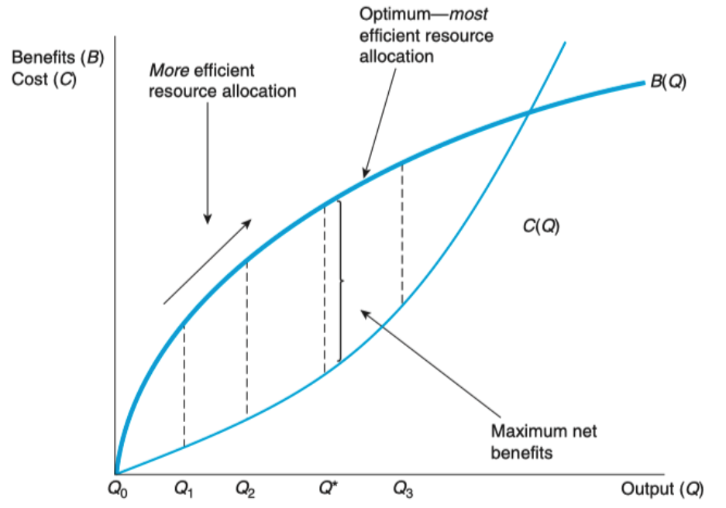
Therefore:
- Efficiency is maximized at MB = MC; if MB > MC, output is still too low – so CBA can support positive-NPV projects that are not yet at the truly efficient point.
- CBA is a decision-making aid, not a perfect instrument of welfare maximization.
- It helps reject policies with negative NPVs and compare alternatives, but the underlying efficiency frontier may be broader.

10. Integrating Equity Considerations in CBA

Kriström (2005): Accounting for Distribution

1. Identify and catalogue distributional impacts
The first step is to map how costs and benefits are distributed across groups. This includes physical units (e.g., lives saved, hours gained) and, when possible, monetary terms. The point is to see clearly who gains and who loses, since aggregate totals often hide these differences.

2. Identify implicit distributional weights
Sometimes projects with negative aggregate net benefits may still be considered desirable because the gains go to groups society particularly cares about. Implicit weights ask:
“What weight would those gains have to receive for the project to become socially positive?”
This uncovers the value judgments policymakers are implicitly making.

3. Apply explicit distributional weights
Once distribution is known, analysts can assign explicit equity weights to different groups and recalculate net benefits. This produces a distributionally-sensitive CBA where results reflect both efficiency and fairness.

11. Explicit Distributional Weights (“Equity Weights”)
CBA can incorporate equity by adjusting the value of benefits according to income levels.
Because marginal utility of income declines, a euro for a poor individual counts more than a euro for a rich one.
A commonly used formula:
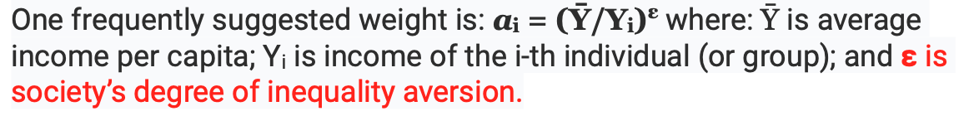

Inequality aversion is the extent to which society places greater weight on the welfare of poorer individuals than richer ones when evaluating policy outcomes.

Example
Average income: 60,000
Two people affected:
- X₁: +200 EUR, income 90,000
- X₂: –100 EUR, income 30,000
As degree of inequality aversion increases:
- X₁’s +200 receives a lower weight.
- X₂’s –100 receives a higher weight.
- The total net benefit falls from +100 (ε=0) to –311 (ε=2).
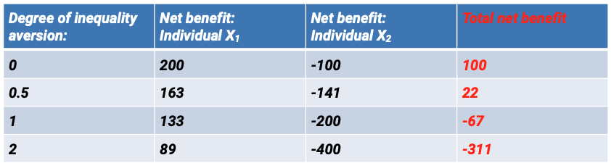
A project that is efficient without weighting may become undesirable once equity is considered.

12. Inequality Aversion Parameter (ε)
ε measures how quickly marginal utility drops as income rises.
- ε = 0 → society does not care about inequality; all euros count equally.
- Higher ε → strong preference for redistribution; benefits to the poor are weighted more.

Slide example
- Average income: 60,000
- With ε = 0.5, someone earning 30,000 receives a weighting factor ≈ 1.41.
- A euro going to a person earning 90,000 is valued at 77% of a euro going to someone at average income.
Graph interpretation:
- Higher ε curves drop faster – stronger inequality aversion.
- 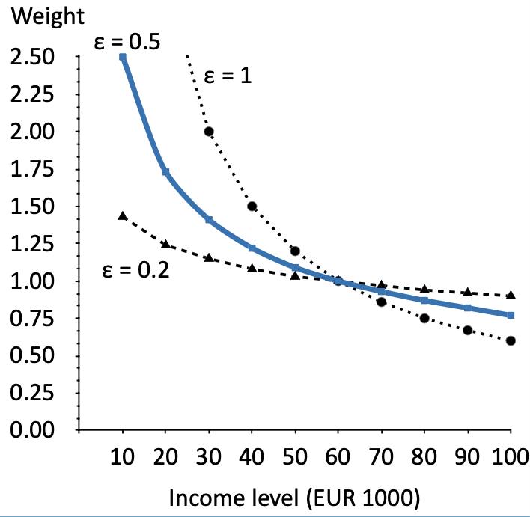

Reading#15: Cost-benefit Analysis

1. Regulatory Impact Analysis (RIA)
Policy Analysis - Concepts and …
The reading explains how RIA became institutionalized in U.S. federal rulemaking:
- Executive Order 12291 (Reagan) introduced mandatory cost–benefit analysis for major regulations (≥ $100M annual effect).
- Executive Order 12866 (Clinton) expanded coverage.
- Executive Orders 13563 and 13610 (Obama) required:
  - Retrospective evaluations of past CBAs.
  - Agency plans for ongoing reviews.
- Executive Order 13579 recommended that independent agencies (not formally controlled by the president) also use RIA.
New idea:
→ The reading stresses the political–institutional evolution of CBA and how executive power shapes analytical requirements.
This institutional history is not referenced in your slides.

2. International Spread of CBA Requirements
Policy Analysis - Concepts and …
Beyond the U.S., other governments have institutionalized CBA:
- Canada: Treasury Board requires CBAs for regulatory proposals.
- United Kingdom: The Green Book mandates CBA for central government appraisal.
- Australia: Productivity Commission advocates and uses CBA.
- European Union: CBA required for funding major infrastructure projects in Cohesion Fund contexts.
New idea:
→ CBA is globally embedded in governance frameworks — not discussed in the lecture slides.

3. CBA as a Tool for NGOs and Social Impact Bonds
Policy Analysis - Concepts and …
The reading notes that:
- NGOs increasingly use CBA-like frameworks (e.g., Social Return on Investment).
- Social Impact Bonds should base payments on measured social value, making accurate CBA crucial.
New idea:
→ CBA supports not only public-sector decisions but also nonprofit finance and private contracting for social outcomes.

4. Preview of Juvenile Justice CBA (WSIPP Approach)
Policy Analysis - Concepts and …
The book describes the Washington State Institute for Public Policy (WSIPP), an influential model for evidence-based CBAs:
- WSIPP produces standardized, replicable CBAs across social areas (childhood interventions, reentry programs, etc.).
- Their approach influenced other states through the MacArthur Foundation, Pew Charitable Trusts, and Results First Initiative.
New idea:
→ Standardized, institutionalized CBAs shape policy across multiple states — this detailed example is not in slides.

5. Incremental Net Benefits vs. Absolute Net Benefits
Policy Analysis - Concepts and …
The reading emphasizes a conceptual point missing from slides:
- CBA evaluates incremental net benefits relative to current policy, not absolute levels of welfare.
- Analysts compare changes from one policy to another rather than total welfare under each policy.
Why this matters:
Current policy is treated as the baseline with net benefits = 0.
Alternatives are judged only by improvements/worsening relative to it.

6. The Concept of “Standing” in CBA
Policy Analysis - Concepts and …
“Standing” determines whose costs and benefits count:
- Borrowed from legal doctrine (“standing to sue”).
- Typically limited to the national population — but can be widened or narrowed.
This is a normative decision with ethical implications.
New idea:
→ Standing introduces value judgments in CBA that are often hidden.

7. Limits of Cataloguing Impacts & “Meaningfulness”
Policy Analysis - Concepts and …
The reading elaborates on the practical limits of cataloguing impacts:
- Full cataloguing is impossible — analysts decide which impacts are “meaningful.”
- “Meaningful” lacks a precise definition.
- Analysts must balance:
  - Risk of omitting an important impact
  - vs. wasting time on negligible ones
Example not in slides:
Secondary market effects (e.g., housing price changes due to school quality changes).

8. Handling Unmeasured But Relevant Impacts
Policy Analysis - Concepts and …
If an impact cannot be monetized but might matter:
- It must be flagged and included in sensitivity analysis.
- Analysts ask: “How large would this unmeasured impact need to be to flip the net benefit sign?”
New idea:
This structured treatment of non-monetizable impacts is not in slides.

9. Use of Empirical Elasticities and Meta-Analysis in Prediction
Policy Analysis - Concepts and …
The reading describes advanced empirical tools in prediction:
- Using elasticities from:
  - RAND Health Insurance Experiment
  - Meta-analyses (cigarettes, gasoline, drugs, water, electricity)
- Borrowing elasticities from the “closest available market” if exact data are missing.
New idea:
→ The empirics behind prediction; lectures did not discuss real-world estimation.

10. Expert Elicitation and the Delphi Method
Policy Analysis - Concepts and …
When data is unavailable:
- Analysts may rely on expert opinion.
- The Delphi Method coordinates judgments across multiple experts.
New idea:
→ Structured expert elicitation is a recognized prediction tool in CBA.

11. Statistical Distributions for Prediction Uncertainty
Policy Analysis - Concepts and …
The reading goes deeper into uncertainty:
- Analysts must specify distributions, not just point estimates.
- Standard errors → assumptions about normal or t-distributions.
- Guestimates → uniform or plausible ranges.
This forms the basis for Monte Carlo simulation later used in sensitivity analysis.

12. Detailed Treatment of Opportunity Cost by Market Type
Policy Analysis - Concepts and …
The reading explains how the market structure affects opportunity cost estimation:
- Competitive markets → prices approximate opportunity cost.
- Distorted markets → require shadow pricing.
- Non-market inputs → require special methods.
New idea:
→ Opportunity cost is context-specific and may require complex adjustments.

13. Borrowing and Adjusting Shadow Prices Across Contexts
Policy Analysis - Concepts and …
Issues when using shadow prices from other studies:
- Population comparability (e.g., studies from different cultures or risk environments).
- Income level adjustments (important for VSL).
- Year of estimation requiring inflation adjustments (e.g., via CPI).
New idea:
→ How to rigorously adapt values from existing research.

14. Production Possibility Frontier (PPF) Rationale for Discounting
Policy Analysis - Concepts and …
A conceptual justification of discounting:
- Intertemporal trade-offs can be illustrated with a PPF between present and future consumption.
- The slope of the PPF reflects the marginal rate of transformation, linking resource allocation across time.
New idea:
→ The macroeconomic justification for discounting, not included in slides.

15. Analytical Honesty & Replicability
Policy Analysis - Concepts and …
The reading emphasizes professional norms:
- CBAs must be fully documented for replication.
- Transparency is essential, especially for complex bottom-line numbers.
- Uncertainty should be communicated clearly.
New idea:
→ Ethical and professional standards for conducting real-world CBAs.

16. Disaggregation for Political Analysis
Policy Analysis - Concepts and …
The text highlights a strategic purpose of CBA:
- Disaggregation of net benefits identifies winners and losers.
- This is crucial for:
  - Predicting political support or opposition.
  - Designing compensation or mandates.
New concept absent from slides:
→ CBA is not only technical; it has a political forecasting function.

17. Standing, Rights, and Ethical Debates in CBA
Policy Analysis - Concepts and …
The reading mentions:
- Ethical critiques of CBA (Kelman, Posner).
- Debates about whether CBA must incorporate rights, not just preferences.
- The theoretical basis of the Kaldor–Hicks criterion (Hicks, Kaldor).
New idea:
→ Philosophical foundations and ethical disputes behind CBA methodology.

18. Controversies in Valuing Addictive Goods (“Lost Pleasure”)
Policy Analysis - Concepts and …
The reading discusses:
- FDA regulations that attempted to include lost consumer surplus (“lost pleasure”) for smokers.
- Severe controversy over whether addiction undermines rational WTP.
New concept absent from slides:
→ Behavioral complications: should addicted choices reflect welfare?

19. External vs Internal Validity in CBA Evidence
Policy Analysis - Concepts and …
The book stresses:
- Internal validity → causal identification
- External validity → how widely results apply
In CBA, external validity is critical because benefits often generalize across populations and contexts.

20. Natural Experiments & Quasi-Experimental Methods in CBA
Policy Analysis - Concepts and …
The reading lists research designs used to estimate key inputs for CBAs:
- Natural experiments
- Regression discontinuity designs
- Difference-in-differences
- Propensity score matching
These methods provide causal estimates when RCTs are not feasible.
New idea:
→ The methodological toolkit underlying the empirical parameters in CBA.

Lecture 16: Navigating Uncertainty

1. Where Policymakers Face Uncertainty
Policymakers must make decisions even when information is incomplete, contradictory, or impossible to obtain.

a) Balancing market- and government failures
Policymakers must judge whether markets fail so severely that intervention is needed, or whether government intervention might introduce its own failures (bureaucratic inefficiency, misaligned incentives). The uncertainty lies in comparing two imperfect alternatives.

b) Is there a coherent “will of the people”? (and how can we measure it?)
Public preferences are unstable and context-dependent. Measuring a unified “public will” is uncertain because preferences change with framing, information, and identity politics.

c) Agenda-setting contingency (Kingdon’s MCF)
Kingdon’s model emphasizes the contingency (future event which is possible but cannot be predicted with certainty) of agenda-setting. Problems, solutions, and politics flow separately and only occasionally align. When a “policy window” opens is unpredictable, creating uncertainty around when action is possible.

d) Predicting algorithmic power in policymaking
As algorithms mediate decisions (credit scoring, policing, welfare allocation), policymakers face uncertainty about how much influence these systems will exert, how they reinforce biases, and what unintended side-effects appear.

e) Evidence-based policymaking as an ideal
Evidence-based policymaking is useful but limited: evidence may be incomplete, methodologically weak, or contradictory. Policymakers must decide under uncertainty even when the empirical base is shaky.

f) (Risk-)cost-benefit analysis under uncertainty
CBA is a workhorse tool for quantifying trade-offs, but it struggles when:
- uncertainty is deep (not measurable),
- probabilities cannot be estimated,
- or key outcomes are ethical, not economic.
Policymakers must determine when CBA remains viable and when it “passes out.”

2. Risk vs. Uncertainty

Knight: measurable vs. unmeasurable uncertainty
Knight distinguishes:
- Measurable uncertainty (“risk”) – outcomes and probabilities can be estimated.
- Unmeasurable uncertainty (“true uncertainty”) – outcomes and probabilities are unknown or unknowable.
In his view, once uncertainty becomes measurable, it becomes a statistical calculation, not true uncertainty.

Keynes: no scientific basis for probabilities
Keynes argues that in many domains we “simply do not know,” and there is no scientific basis to assign probabilities at all (future wars, long-term commodity prices, social change).
This is deeper than risk; it is fundamental unpredictability.

3. Uncertainty vs. Ambiguity

Uncertainty
Uncertainty comes in two forms:

a) Resolvable uncertainty (“risk”)
This is uncertainty that can in principle be reduced through more data, better models, or experimentation.
Key features:
- Range of outcomes is known.
We know the possible consequences.
- Probabilities are known or at least knowable.
Even if estimates aren’t perfect, they could be improved.
Policy context example:
Predicting the effect of a fuel tax.
You know that people might drive less, switch to public transport, or do nothing. You know the range of responses. And models can estimate elasticities, even if imperfectly. More data → better predictions → uncertainty shrinks.
This is what economists traditionally call risk.

b) Radical uncertainty
Radical uncertainty arises when reality is too complex, novel, or poorly understood for modelling to reliably capture it.
Key features:
- Range of outcomes unknown.
You cannot list all possible consequences.
- Probabilities unknown and unknowable.
No amount of data or modelling will fix this.
Policy context example:
Regulating super-intelligent AI or solar geoengineering.
We don’t know all possible failure modes or societal impacts. The uncertainty is fundamental, not reducible.

Radical uncertainty forces policymakers to rely on:
- heuristics
- robustness approaches
- precautionary principles
instead of prediction models.

Ambiguity
Ambiguity refers to:
- An ill-defined problem that can be interpreted in different ways.
Unlike uncertainty (which concerns outcomes), ambiguity concerns the meaning of the situation itself.

4. Radical Uncertainty Within and Across Models
The slides distinguish two types:

1) Within-model uncertainty
This is uncertainty inside a single model, due to:
- incompletely defined parameters,
- noisy metrics,
- unstable assumptions,
- limited data.
The model structure is fixed, but the predictions remain uncertain because the input variables are unreliable or poorly understood.

2) Between-model uncertainty
This arises when different models give different predictions about policy effects.
Uncertainty exists not within one model, but across a whole family of competing models.
Policymakers do not know which probability distribution to trust.

Examples

Super-intelligent AI (both types)
- Within-model uncertainty: Parameters like “takeoff speed” or “alignment difficulty” cannot be pinned down.
- Between-model uncertainty: Entire models disagree – some predict catastrophic risk, others predict none.

Nuclear fusion reactors (both types)
- Within-model uncertainty: Engineering parameters (efficiency, materials limits, cost curves) remain highly uncertain.
- Between-model uncertainty: Some models forecast commercial fusion in decades; others say it may never be viable.

GM crops (both types)
- Within-model uncertainty: Unknown long-term ecological effects, gene interactions, and health implications.
- Between-model uncertainty: Competing models disagree on environmental risks and benefits.

Solar radiation management (SRM) (both types, especially strong across-model one)
- Within-model uncertainty: Local climatic reactions cannot be precisely modelled.
- Between-model uncertainty: Models disagree dramatically on global side effects and tipping points.

Pandemic school closures (both types)
- Within-model uncertainty: Transmission parameters, behavioural responses, and learning-loss metrics are noisy.
- Across-model uncertainty: Epidemiological models offered completely different predictions about the effect of school closures.

5. Dealing with Uncertainty in CBA
CBA must evaluate costs and benefits even when inputs are highly uncertain. Two main strategies are emphasized:

Sensitivity Analysis
Sensitivity analysis tests how changes in assumptions affect results.
Purpose:
- Identify which parameters drive outcomes.
- Assess robustness: does the recommendation hold under many assumptions?
- Show where uncertainty matters most.
Parameters often tested:
- discount rates,
- construction delays,
- behavioural elasticities,
- modal shift (transport),
- pollution trajectories,
- safety evolution,
- induced demand.
If small parameter changes produce large swings in net benefits, the policy conclusion is fragile.

Break-even Analysis
Break-even analysis asks:
“How extreme must a parameter become before the policy is no longer beneficial?”
This is useful when:
- parameters are highly uncertain,
- or probabilities are unknowable.
If the break-even point is unrealistic, the policy is robust.
If it is plausible, policymakers must be cautious.

6. Tracking Recipients and Beneficiaries of Risky Policies
Policies under uncertainty shift who makes decisions, who gains, and who pays.
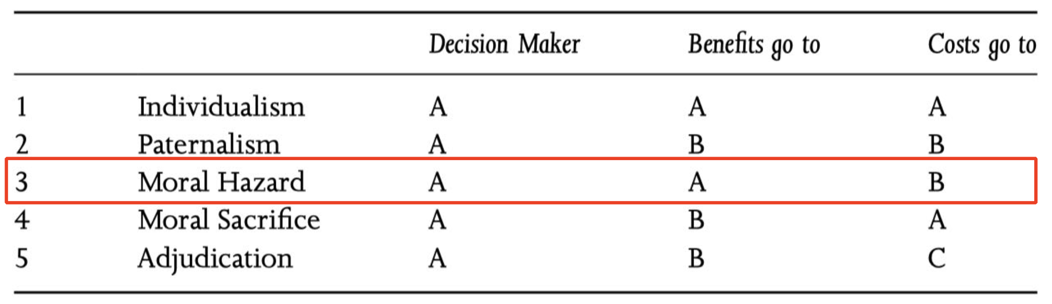
The slides highlight moral hazard (situation where someone takes a risk because someone else will bear the cost if things go wrong) using Wolff’s framework.
A policy involves moral hazard when:
The decision-maker (A) chooses the risky action, A receives the benefits, but B bears the costs.
Examples:
- Financial institutions taking risks because the public bears bailout costs.
- Governments imposing pandemic restrictions where costs concentrate on children or specific workers.
- Environmental policies where one group profits while another absorbs harm.
This helps identify unfair or ethically problematic distributions of risk.

7. Checklist for CBA
A structured set of questions to evaluate new technologies under uncertainty:
- Are costs and risks tolerable?
Basic feasibility and safety check.
- Does the technology generate meaningful benefits?
Not all innovations solve important problems.
- Do the benefits address urgent/critical issues?
The relevance of benefits matters.
- Are there safer alternatives?
Even if benefits are real, another policy might achieve them with lower risk.
- Long-term economic consequences?
Technologies often create path dependencies, new costs, or sectoral disruptions.
- Long-term political consequences?
Could the technology shift power, institutions, or public trust?
Purpose:
Promotes holistic assessment under uncertainty.

8. Pandemic School Closure – The Decision Challenge

Context
By April 2020, nearly all countries closed schools – despite high uncertainty about:
- whether children significantly transmit COVID-19,
- how much closures reduce spread,
- long-term costs to education and inequality.

Policy Trade-off
Slowing virus transmission
vs.
High socio-economic and health costs (learning loss, child welfare, labor shortages).
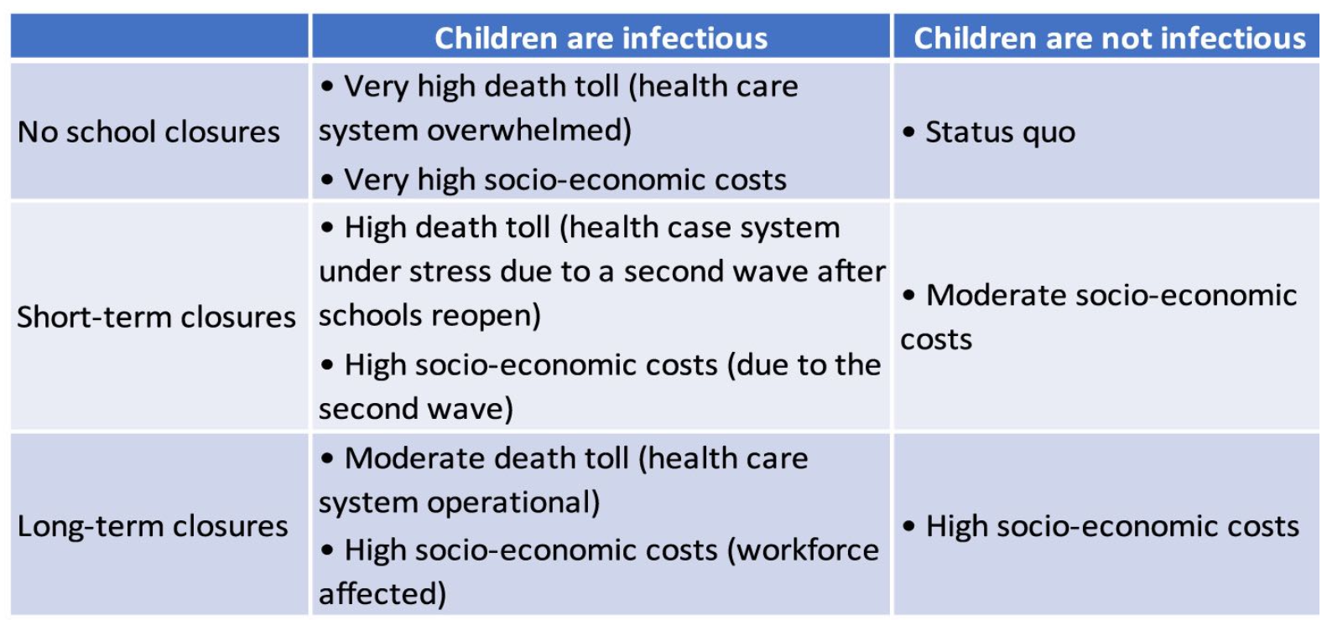
The slide’s grid shows outcomes under different assumptions:
- If children are infectious → closures matter.
- If children are not infectious → closures cause large costs with minimal public health benefit.
This is a textbook case of radical uncertainty, not risk.

9. Formalizing the Decision Problem (Models 1-3)
Three models predict different effects of school closure:

Model 1: Children are vectors; benefits increase linearly with closure duration.

Model 2: Children aren’t vectors; closures produce no health benefits.

Model 3: Children are vectors but only early on; benefits decline over time.

Meaning
In this decision problem, the policymaker must pick a school-closure duration before knowing which epidemiological model is actually correct. Each model predicts different benefits from keeping schools closed, so the policymaker faces genuine uncertainty.

10. Decision Rules under Uncertainty

Subjective Expected Utility (SEU)
The policymaker assigns subjective probabilities (priors) to each model (probability that that is the true model).
The best action maximizes weighted expected utility.
SEU = choose the action with the highest average payoff, weighted by how likely you think each model is true.
Works only if probabilities are meaningful – often not the case in radical uncertainty.

Maximin rule
Choose the action with the best worst-case outcome.
Meaning:
Very cautious: protect against the absolute worst scenario.
Used under high uncertainty, but often criticized for being overly conservative.

Minimax Regret
Core idea:
Regret is the loss you feel after the fact – the difference between the payoff of the action you chose and the best payoff you could have gotten if you had known which model was true.
Procedure:
- Compute a regret matrix: For each model, compare every policy option to the best possible option under that model and record the regret (the gap).
- Choose the policy that minimizes the maximum regret: Pick the action whose worst-case regret is the smallest across all models.
Meaning:
Minimax regret doesn’t assume the worst outcome will happen (less pessimistic than maximin). Instead, it aims to avoid the most painful “I should have chosen differently” scenario. It protects
policymakers against severe hindsight regret when models disagree about policy outcomes.

Smooth Ambiguity Rule
Adds an “attitude toward uncertainty” term.
The smooth ambiguity rule extends the basic expected-utility idea by adding a term that captures the policymaker’s attitude toward uncertainty. Unlike standard approaches, it distinguishes between:
- Uncertainty within a model (e.g., unknown parameters but structure is fixed), and
- Uncertainty across models (competing models give fundamentally different predictions).
Some policymakers are especially averse to this model-level ambiguity – they dislike having to rely on one model being the “right” one.
Meaning:
This rule captures the psychological or political discomfort that comes with ambiguity across models. A policymaker may prefer policies that perform reasonably well across all plausible models rather than those that rely heavily on a specific model being correct. It therefore incorporates not just payoffs but also an explicit penalty for ambiguity, reflecting a preference for robustness when the scientific basis is uncertain.

11. The Precautionary Approach
Maximin and minimax regret correspond to a precautionary mindset:
- When scientific certainty is lacking,
- and potential harms are severe,
- policymakers lean toward protective action.

Critiques
- Can discourage innovation,
- may promote fear-based policy,
- may ignore probabilistic evidence.

Rio Declaration (1992)
Lack of scientific certainty is not a reason to postpone measures to prevent serious environmental harm.
Meaning:
Better safe than sorry – especially when consequences are irreversible.

12. Decision Process Diagram
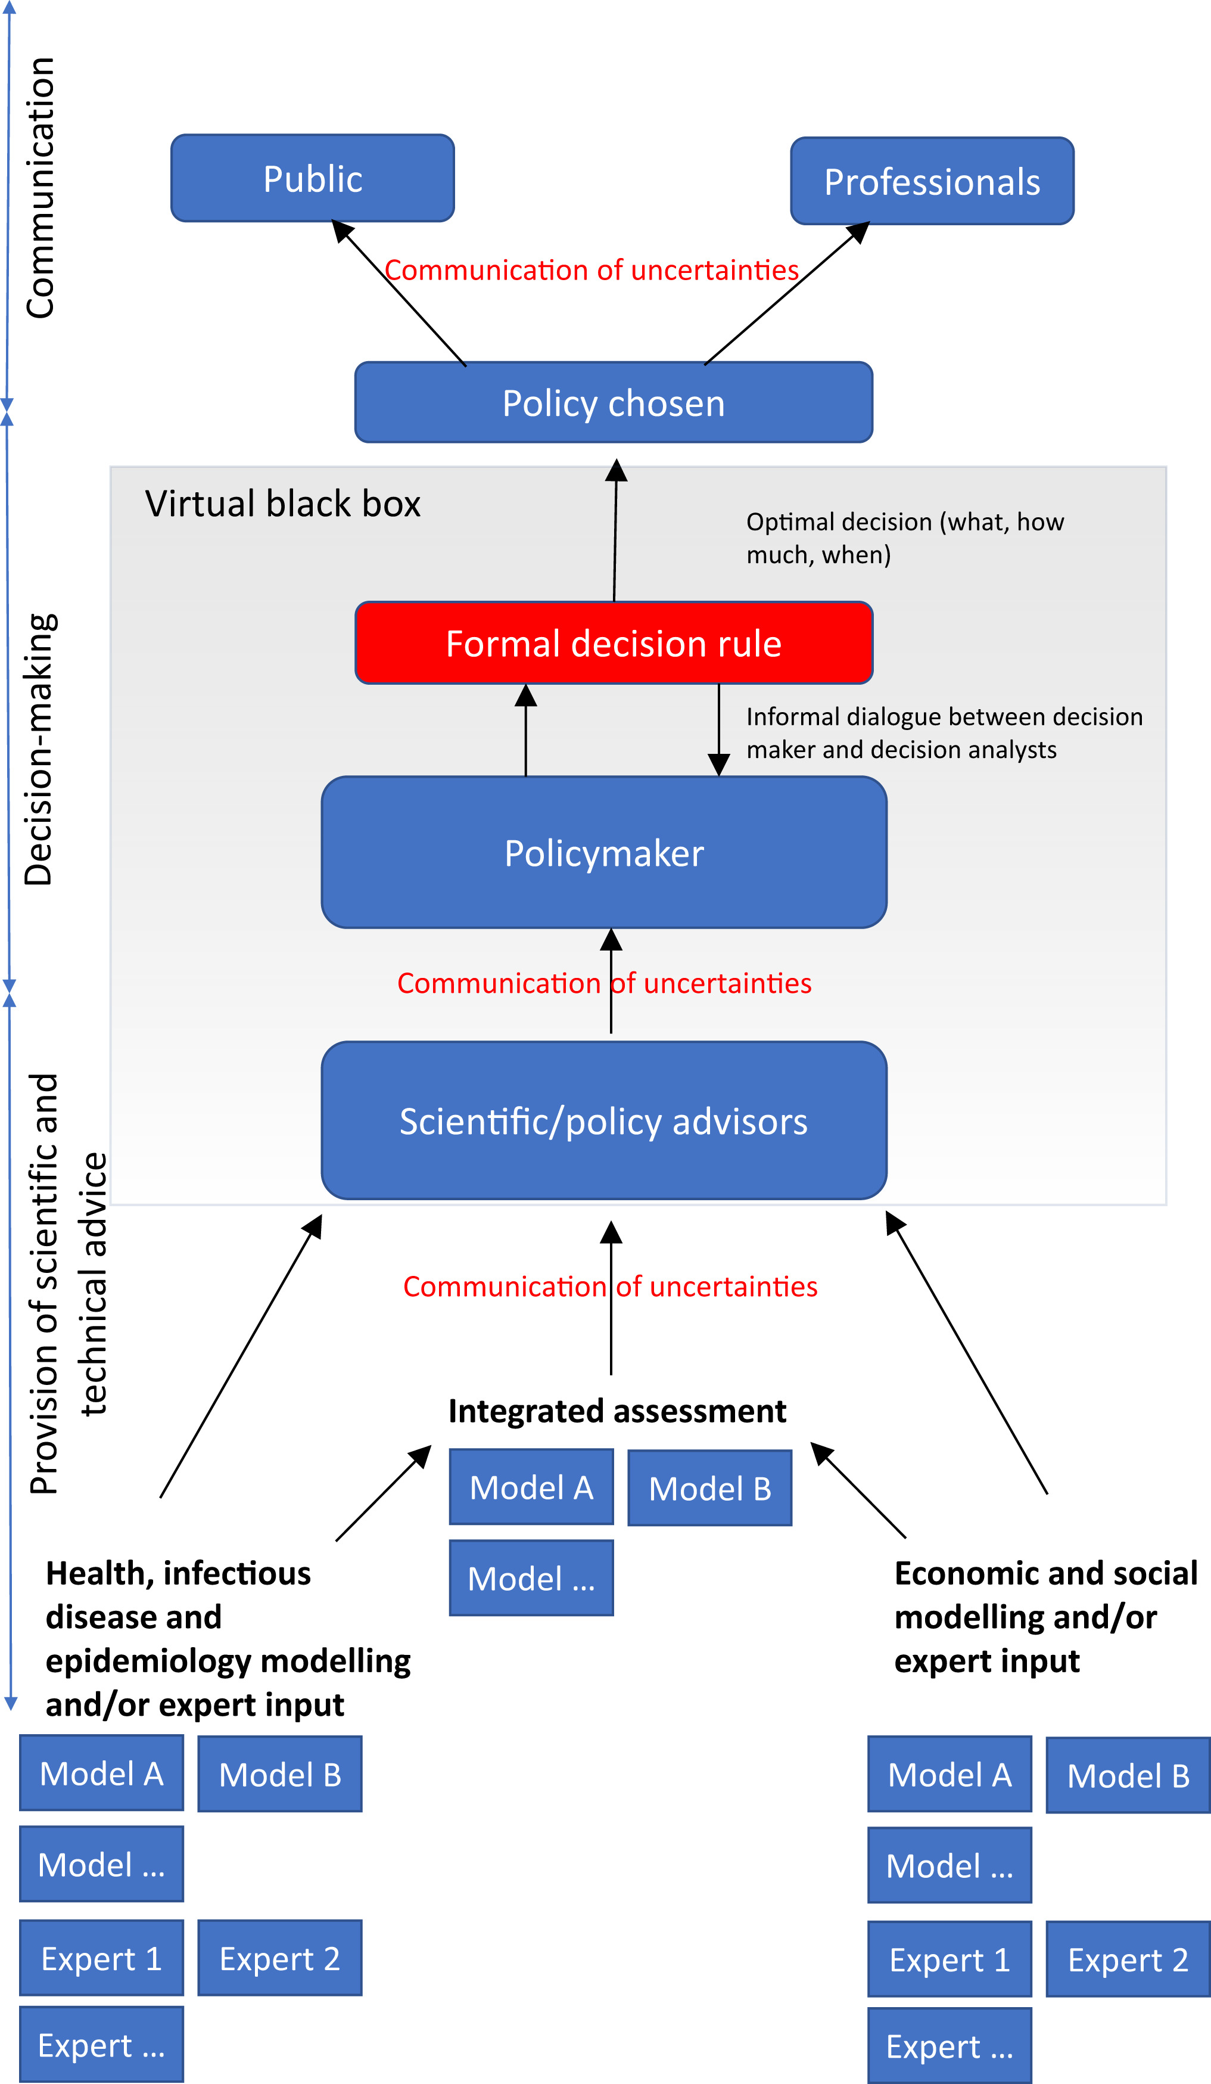
The diagram illustrates how uncertainty flows upward through the policymaking system:

Bottom layer: Experts + Models
- Epidemiologists, economists, social scientists.
- Provide model outputs, each with its own uncertainties.
- Communicate both results and the uncertainty behind them.

Middle layer: Scientific/Policy Advisors
- Integrate different models.
- Translate technical uncertainty into something decision-makers can understand.

Policymaker
- Receives conflicting model predictions and uncertainty assessments.
- Applies decision rules (SEU, maximin, regret, precaution, etc.)
- Chooses a policy under time pressure and incomplete information.

Formal Decision Rule (in the box)
- Represents the implicit or explicit framework used to make the choice.
- Often not visible to the public ("black box").

Top layer: Policy Choice → Public & Professionals
- Decision must be communicated clearly, including uncertainty.
- Public perception and compliance depend heavily on how uncertainty is framed.

Meaning of the whole diagram:
Policy decisions under uncertainty rely on:
- how experts communicate uncertainty,
- how policymakers process it,
- and how the public interprets the resulting action.
It visualizes the full chain from uncertain science → policy choice → public communication.

13. Expertise and Policy-Making
Since 2020, two big problems with expertise have become highly visible:
1) how expert evidence is used, and
2) how expertise has become politicised.

1) Expert evidence is framed and forwarded as “fact”
Policymakers and the public often treat expert statements as if they were undisputed facts.
But in reality:

Experts frequently disagree
They may disagree about:
- research methods,
- how to interpret data,
- or what counts as “good evidence.”
During Covid-19, examples such as inconsistent mask recommendations revealed to the public that “the science” is not monolithic.

Experts are cautious about forecasting
Scientists know models have assumptions and uncertainties.
This caution can be misinterpreted politically as weakness or incompetence.

Disagreement weakens trust and enables blame-shifting
If experts publicly disagree, politicians may say:
“Experts can never agree on anything,” which allows them to shift responsibility for unpopular decisions.

Lack of open discussion makes things worse
There is often no accessible explanation (for citizens) of why experts disagree.
Without this transparency, people lose trust and assume experts are unreliable or agenda-driven.

2) Expertise is increasingly politicised

Science is not value-free
Just like policy-making, science involves:
- choices about what questions to study (agenda-setting),
- which risks matter,
- and what counts as legitimate knowledge.
Political values can influence the scientific agenda and the gatekeeping of expertise.

Public distrust due to perceived closeness between experts and government
People may worry that experts advising governments are:
- too close to political power,
- influenced by groupthink,
- or captured by political preferences (“epistemic capture”).
This perception grew during the pandemic when advisors became public figures (e.g., Lauterbach, Tegnell).

Non-experts are in a disadvantaged position
Because:
- expertise grants power and status,
- contradicting experts is costly (socially and intellectually),
- and it can feel unsafe for ordinary citizens to question scientific authority.
Often, the only viable reaction is deference – trusting what experts say, even if one does not fully understand it.

Thin line between expertise and lobbying
Experts can unintentionally act like lobbyists when:
- their professional interest aligns with specific policies,
- or when they argue strongly for one interpretation of uncertain evidence.

14. Four Types of Policy Learning (Dunlop & Radaelli 2013)
Learning depends on two things:
- Problem tractability – how clear and solvable the problem is (low tractability = high uncertainty).
- Certification of actors – how available and authoritative expert knowledge is.

This creates four learning modes:

(1) Learning in Reflexivity (low tractability, low expert certification)
- The problem is unclear and there are no authoritative experts.
- Actors reflect on their own beliefs, values, and assumptions.
- Learning is slow and contested.

(2) Learning as a By-Product of Bargaining (high tractability, low certification)
- The problem is clear enough to solve, but no one controls expert knowledge.
- Learning happens through negotiation, compromise, and political bargaining.

(3) Learning in Epistemic Contexts (low tractability, high certification)
- High uncertainty, but widely accepted experts exist.
- Policymakers rely strongly on certified knowledge communities (e.g., epidemiologists early in Covid-19).
- Technical learning dominates.

(4) Learning in Hierarchy (high tractability, high certification)
- Problem is solvable and experts are authoritative.
- A top-down approach: policymakers follow expert guidance with little contestation.
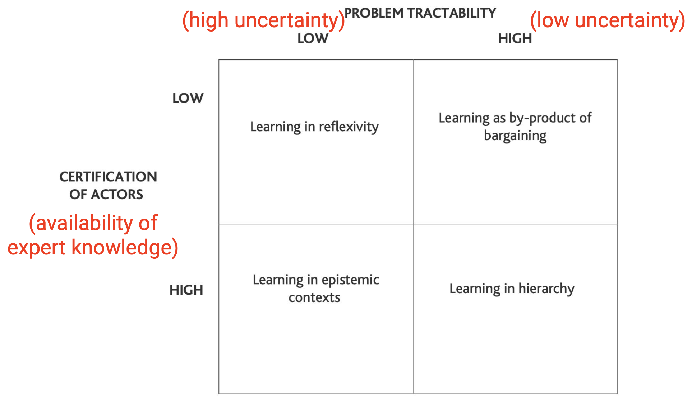

9. The “Irony of Epistemic Learning” (Dunlop 2017)
Example: EU policy on growth hormones in cattle.

Stage 1: Epistemic learning reduces uncertainty
Scientists inform policymakers:
- Natural hormones are low-risk for consumers.
- Remaining uncertainty concerns only two specific synthetic compounds.
Knowledge becomes clearer and more precise.

Stage 2: Learning by bargaining changes everything
Political dynamics take over:
- Policymakers respond to pressure from activists, interest groups, and member states.
- Political negotiation overrules scientific advice.
- The EU ultimately bans hormone-treated beef.

=> Better knowledge did not lead to better political use of knowledge.

The irony
Even though scientists successfully reduced uncertainty:
- policymakers used the newly clarified issue to justify political decisions,
- and the scientific community became sidelined.

In other words:
The irony of epistemic learning is that better knowledge does not necessarily increase the influence of experts; instead, it may empower political actors to pursue their own goals once scientific uncertainty is no longer an obstacle.

Reading#16: Risky New Technologies

1. Radical Uncertainty in New Technologies
(New concept not in slides: distinction between uncertainty and radical uncertainty)
Wolff introduces a deeper category beyond “known-unknowns”:

Radical uncertainty
- We do not know the full range of possible outcomes, nor their probabilities.
- Examples: ozone depletion from CFCs, asbestos diseases, plastics pollution, synthetic biology, solar geoengineering.
- Under radical uncertainty, cost–benefit analysis breaks down because the model assumes known outcomes and probabilities.
This is different from the lecture’s distinction between within-model vs. between-model uncertainty: Wolff argues that with new technologies, we don’t even know the models.

2. Limits of Cost–Benefit Analysis (CBA)
(Lecture didn’t cover CBA’s structural assumptions)
Wolff identifies five conditions under which CBA works—conditions usually violated in real technological decisions:
- Outcomes & probabilities are known.
- All values can be expressed in money.
- Decisions occur repeatedly (not one-offs).
- Probabilities “play true” (no group is systematically harmed).
- Losses are not catastrophic.
New technologies violate almost all of these:
- Catastrophic risk (nuclear, GM crops, geoengineering).
- One-off, irreversible decisions.
- Winners and losers are not randomly distributed, but systematic.
Thus CBA gives a false sense of precision.

3. The Risk Triangle
(Completely absent from lecture)
Hermansson & Hansson’s “risk triangle” identifies three roles in any risky decision:
- The decision-maker
- The beneficiary
- The bearer of the cost
Only five structural possibilities exist:

1. Individualism — one person decides, benefits, and bears the cost.
→ Morally simple.

2. Paternalism — someone decides “for your own good.”
→ Familiar from health or gambling regulation.

3. Moral hazard — a key new concept
→ The decision-maker benefits if things go well, but someone else pays the cost if things go wrong.
Common in insurance, finance, and technological rollout.

4. Moral sacrifice
→ The decision-maker bears the cost while others get the benefit.
→ Leads to under-supply of socially beneficial innovation (a positive externality problem).

5. Adjudication
→ Government decides, benefits go to one group, costs fall on another.
→ The “normal” structure in public policy.
Why this matters:
CBA normally ignores who bears the risks and benefits — but ethically, the structure of the triangle determines fairness.

4. Political Economy of New Technologies
(Major theme missing from slides)
Wolff argues that technology introduction is not just technical but deeply political:

Technologies redistribute power
- GM crops: patent ownership → monopoly power → political influence.
- Innovations can entrench corporate power, create dependency, and reshape regulation.

Regulatory capture
New tech often requires new regulatory bodies.
Over time, those regulators:
- Depend on industry experts
- Internalize industry perspectives
- Produce rules favourable to the industry
Thus “adjudication” collapses into moral hazard again.
This dynamic is almost entirely absent from your lecture slides, which focused on expert capture but not corporate capture.

5. The Precautionary Attitude (Not the Precautionary Principle)
(Lecture mentioned ambiguity & biases but not this philosophical tool)
Wolff says the “precautionary principle” (Rio Declaration) is not a decision rule — it just says “don’t wait for full certainty.”
Instead, he proposes a precautionary attitude or checklist:

Stage 1 — Technical questions
- Are risks tolerable?
- Are benefits significant?
- Do they solve a real problem?
- Is there a less risky way to solve it?

Stage 2 — Political/economic questions
- Long-term economic consequences?
- Long-term political consequences?
The political part is where most conventional analyses fail.
This checklist captures both:
- Immediate technical risk
- Broader distributional and political effects

6. The Costs of Living With Uncertainty
(Lecture didn’t discuss this psychological/economic burden)
Even if no harm ever occurs, uncertainty itself has a cost: stress, distrust, social division, and loss of autonomy.
GM crops case: People objected not only to potential harms but to the burden of being forced to live with unknowns.

7. the “Irony of Expertise” in Technological Regulation
(Different from the lecture’s “epistemic capture” concept)
Wolff argues that:
- Experts reduce uncertainty by clarifying risks.
- But this knowledge empowers policymakers and corporations, who can then sideline the experts themselves and reinterpret the science to suit political agendas.
This irony: better knowledge → weaker expert influence.
This is a different dynamic from the lecture’s “groupthink” or “expert–politics proximity.”

8. Externalities in Technological Innovation
(Not in slides)
Wolff links the risk triangle to microeconomics:
- Moral hazard = negative externality
(Costs pushed onto others → overproduction of risky technologies)
- Moral sacrifice = positive externality
(Innovators bear costs but others gain → underinvestment in socially valuable innovation)
Thus markets systematically misallocate innovation unless corrected.

9. Political Consequences of Saying “Yes” to a New Technology
(Slides did not discuss downstream institutional effects)
Wolff emphasizes that approving a new technology creates:
- New industries
- New regulatory agencies
- New interest groups
- New dependency structures
- New political alignments
Technology is not just an artefact — it is a reconfiguration of power.

Short Closing Message
The central insight missing from the lecture slides:
For Wolff, managing risky technologies is not mainly about forecasting or managing uncertainty. It is about who gains power, who bears risks, who shapes knowledge, and what political structures evolve once the technology exists.

Lecture 17: Guest Lecture by Dimitri Minic (French Institute of International Relations)

Bypassing of Armed Struggle (Dimitri Minic)

Definition:
Bypassing armed struggle means achieving political and strategic goals without relying mainly on traditional military force.
Instead of winning through large-scale battles, states use tools like:
- information and propaganda
- cyber operations
- economic pressure
- political influence
- legal manipulation
- strategic threats
War is not eliminated — it is shifted into non-military domains.

Why this approach developed

1. Power imbalance
Russia cannot match NATO economically or militarily, so it seeks asymmetric strategies to compensate.

2. Nuclear weapons
Direct war between major powers is too risky due to nuclear escalation. Influence must be exercised below the level of open war.

3. Perceived Western pressure
Russian elites believe the West uses media, NGOs, and democracy promotion as geopolitical tools.
Russia responds by using similar methods in its own strategy.

4. Information age
Technology enables:
- manipulation of opinion
- disinformation
- cyber infiltration
- social destabilization
War becomes psychological and political, not only physical.

How it works in practice
Instead of invasion, the focus is on:
- shaping narratives
- dividing societies
- undermining trust in institutions
- pressuring elites
- using energy or trade as leverage
- constant strategic intimidation
The goal is to:
weaken the opponent internally rather than defeat them on a battlefield.

Main takeaway (Minic)
Russia does not abandon warfare — it redefines war.
Power is exercised through influence, destabilization, and psychological pressure.
Armed force remains possible, but it is no longer central.

Implications
- War becomes less visible and harder to detect
- Boundaries between peace and conflict blur
- Civil society becomes a strategic target
- Western deterrence based on military force alone becomes less effective

Lecture 18: Regulating Emerging Technologies

1. “Uberization” (Uber) Regulating Process
Uberization refers to a mode of economic and social organization in which digital platforms use real time data, smartphones and algorithmic intermediation to match supply and demand for services, typically provided by independent contractors rather than employees, outside or at the edge of existing regulatory frameworks, forcing governments to react. In public policy this raises two big questions:
- How can the state keep up with fast moving innovation
- How can it protect public values without killing useful new services

Uber is the classic example, but the same logic applies to AI systems, algorithms in welfare or policing, and other emerging tech.
Benchmark Criteria | Strict Regulation (strong government control) | Laissez-faire (let the market decide, minimal regulation)
Efficiency (how well society’s resources are used) | Why?  - Negative externalities (congestion being caused on road & pollution)  - Information asymmetry (Users don't clearly know: a)who the driver is, b)how safe the car is, c) vehicle safety)  - Transaction cost (Without regulation, users and drivers must personally judge risks, contracts, safety, etc.) | Can Lead To:  - Monopoly power (One app can dominate the market and kill competitors)  - Consumer-surplus  - Tax revenues (under some assumptions - If regulated lightly but taxed properly, the state may benefit financially)
Fairness | - Labour rights  Drivers risk:  - no job security  - no benefits  - unstable income  - Universal access (Public transport values inclusivity; Uber does not guarantee service in poor or rural areas) | If competition stays strong:  - consumers benefit from lower prices  - drivers may gain flexibility  - markets may remain dynamic  But only if platforms don’t become monopolies.
Uncertainty | - If tech could cause mass accidents or job loss, regulators may prefer caution.  - But full bans could also hold back innovation.  - So the optimal policy is often a mix of strict and flexible rules depending on what happens.  For example:  - Allow innovation…  - But supervise safety, labor standards, and competition.

2. Why AI Matters for Public Policy
What do recent headlines show: deepfake porn, election manipulation, misinformation targeted at Progressive Slovakia, and the Dutch algorithmic scandal over benefits fraud.
Key idea: AI is no longer a niche tech issue. It is central to:
- Rights and privacy (deepfakes, surveillance)
- Democracy (election manipulation, targeted misinformation)
- Welfare states (algorithmic fraud detection, benefits allocation)
So regulating AI is not just about innovation or industry policy, it is about core public values.

3. Varying understandings of AI
1) OECD 2019 definition of AI
AI is a machine based system that, for a given set of human defined objectives, can make predictions, recommendations, or decisions that influence real or virtual environments.
Such systems operate with different levels of autonomy and perform human like cognitive functions.

2) UK Government definition of AI
AI is a research field that spans philosophy, logic, statistics, computer science, mathematics, neuroscience, linguistics, cognitive psychology, and economics.
It uses digital technologies to create systems capable of performing tasks that are commonly thought to require intelligence.

3) EU Commission definition of AI
AI refers to systems that display intelligent behaviour by analysing their environment and taking actions, with some degree of autonomy, to achieve specific goals.
- achieve specific goals

4) How the three understandings relate
If you need a comparison in an answer, you can write:
- OECD and EU focus on AI systems as products that act in the world with some autonomy toward goals.
- The UK focuses on AI as an interdisciplinary research field that produces such systems.
- All three share core elements: use of digital or machine based systems, orientation toward tasks or goals, and presence of intelligent behaviour or cognition with some autonomy.
a) Meaning of “artificial”
- Artificial refers to the non natural side of AI
for example machines, computers, technical systems.
- It covers systems that are created, whether directly by humans or by other machines,
whose purpose is to replicate functions usually performed by humans
such as perception, pattern recognition, decision making.
You can phrase it like:
Artificial in AI signals that we talk about constructed systems, not organisms, that are designed to mimic human capacities.
b) Meaning of “intelligence”
- Intelligence points to the ability to learn, reason and make decisions.
- The exact meaning is contested, even inside neuroscience and cognitive science, so any legal definition is partly a choice, not a neutral fact.

4. AI’s impact at different stages of the policy cycle

1) Agenda setting and policy formulation
AI can support the early stages where problems are defined and options designed.
- Accuracy, efficiency, speed
Large datasets can be processed quickly, which helps identify patterns in unemployment, crime, health, etc and produce more precise diagnoses and forecasts.
- Legitimacy and collaboration
AI based tools can make consultation broader and more transparent, for example by analysing large volumes of comments or survey responses and feeding them into drafts. This can strengthen the perceived legitimacy of choices.
- Accountability and trust
If models and data are documented and auditable, AI can make it clearer on what evidence a proposal rests, which in principle can improve trust in how problems are framed and solutions chosen.
Example: using machine learning to forecast hospital demand across regions, then using these predictions to justify a new health infrastructure plan.

2) Policy implementation
AI affects how policies are delivered on the ground.
- Cost savings and productivity gains
Automation of routine classification, verification or routing tasks cuts admin costs and frees human staff for complex cases.
- Reduced fraud
Anomaly detection and risk scoring can help identify suspicious benefit claims, tax declarations or procurement contracts.
- Better service and decision making
Personalised service delivery becomes possible, for example tailoring employment services to individual job seekers based on predicted success of different interventions.
Example: an algorithm that screens tax returns for unusual patterns and flags a small subset for human audit, instead of random checks.

3) Policy research and evaluation
AI also transforms how policies are studied and monitored.
- Improved policy analysis
Advanced analytics on administrative and sensor data can uncover causal relationships and heterogeneity that were hard to see with traditional tools.
- Continuous, real time evaluation
Instead of one off ex post evaluations, AI can track outcomes continuously, allowing governments to adjust programmes quickly when indicators start to move in the wrong direction.
- New business and performance models
Data driven insights can change how agencies think about performance, for example shifting from output indicators (number of inspections) to outcome indicators (actual risk reduction).
Example: using streaming mobility data to evaluate the effect of a congestion charge day by day, rather than relying only on annual traffic counts.

5. Are All Policy Makers Data Scientists Now
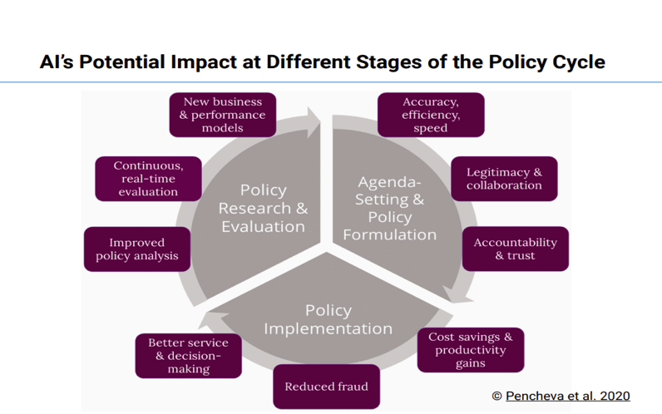
Before the 2010s
Computer systems in the public sector mainly copied paper filing systems rather than transforming them.
- Governments relied on custom built official statistics
examples: unemployment, inflation, crime, disease incidence.
- They used periodic large scale surveys
examples: censuses, household surveys, labour force surveys.
- Most data was non transactional
meaning it was collected for one specific purpose and could not easily be reused for richer policy analysis or linked with other datasets.
So the state had data, but it was slow, static and siloed.

After the 2010s
Digital systems in the public sector start to support transactional, continuously updated data relevant for policy.
- Silicon Valley style innovation in cloud computing and large scale machine learning tools transforms information processing.
- There is a massive extension of government informational regimes
more data sources, greater scope and depth, and the entry of data science into public policy.
- Algorithmization becomes possible
AI is used to bridge the gap between overproduction of data and underuse of that data, for example many applications in public health where huge data streams are turned into risk scores, forecasts or alerts.

6. Algorithms and Algorithmisation in Public Policy
Algorithms
- An algorithm is an encoded procedure that takes input data and produces an output according to specified rules or calculations.
- In government this can be a simple formula for benefit eligibility or a complex machine learning model that predicts risk.

Algorithmisation
- Algorithmisation is when an organisation rearranges its working routines around algorithms for actions and decisions.
- So not just “using a model”, but changing who does what, in what order, based on which scores.

Types of algorithmic systems
- Automation system
Algorithmic system that acts on its own
decisions are effectively fully or largely automated.
- Decision support system
Algorithmic system that provides a recommendation or score to a human decision maker, who formally keeps discretion.

Artificial discretion
- Artificial discretion (Young, Bullock, Lecy 2019) means that part of the discretion of street level officials is shifted to algorithms at the policy implementation stage.
- Even when a human signs off, the agenda and options are pre structured by the system (for example risk scores deciding which cases get attention).

Algorithmization shifts real decision power into algorithmic systems, so these governance principles basically say “if you reorganise your whole bureaucracy around algorithms, you damn well stay responsible for what they do.” In other words, algorithmic accountability, transparency, fairness and human control are the safeguards that make large scale algorithmization in public policy democratically and ethically acceptable.

7. Principles for AI Governance
Principles for an AI Governance Framework World Bank 2024
- Algorithmic accountability
Ensuring that those who build, procure and use algorithms are answerable for their impact.
Core principles:
- Privacy and data protection
- Accountability
- Safety and security
- Transparency and explainability
- Fairness
- Human control of technology
- Promotion of human values
Algorithmic accountability means that people and organisations who design, buy, and use algorithms can be held answerable for impacts.
Example: a city using a predictive policing tool should be able to explain what data is used, how the model works in broad terms, and who is responsible if results are biased or harmful. “The algorithm did it” is not acceptable as an excuse.

8. The Problem Of Algorithmic Bias: The Case of Risk-Based Healthcare Program Enrolment
Health risk algorithms in the US Obermeyer et al. 2019
Under the US Affordable Care Act (Obamacare), hospitals came under strong pressure to reduce health care costs. One key strategy was to prevent expensive complications rather than just treat them once they occur. To support this, the Act created financial incentives for hospitals to allocate extra resources to “high risk” patients for example extra check ups, care management, home visits, so that these patients stay healthier and avoid costly hospitalizations in the future.
To operationalise this, many hospitals now rely on commercial risk algorithms to decide which patients qualify for special care programs. The algorithm produces a health risk score for each patient. Hospitals then set risk thresholds:
- above a very high threshold (for example the 97th percentile) patients are automatically enrolled in an intensive care management program
- above a lower threshold (for example the 55th percentile) patients are at least flagged or referred to a primary care physician for follow up.
The models typically take as input data a mix of demographics, diagnoses, medications, and insurance claims history, and output a single predicted risk score. In practice, this means that access to extra care and resources is mediated by the algorithm rather than by ad hoc clinical judgment alone, which is why the design and fairness of these risk scores matters so much in Obermeyer et al.’s study.

1) Key empirical result
For any given algorithmic risk score, Black patients have more chronic conditions than White patients. At the 97th percentile of the risk score, Black patients have about 26.3 percent more illnesses.
2) Impact on programme access
When Obermeyer et al simulate a corrected, debiased version of the model, the share of Black patients who would be enrolled at the 97th percentile threshold jumps from 17.7 percent to 46.5 percent.
3) One sentence takeaway
The algorithm looks racially neutral on its face but systematically underestimates Black patients’ health needs, so using it for enrolment quietly diverts extra care away from the group that actually needs it more.
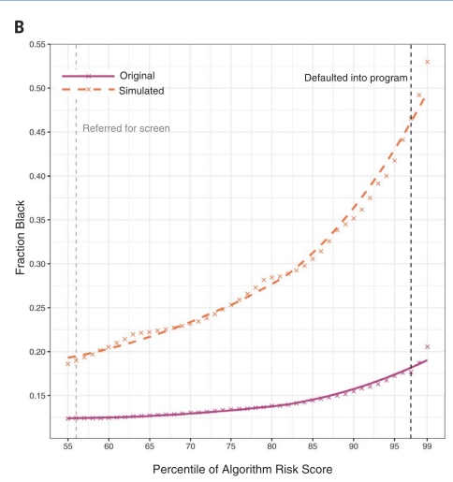
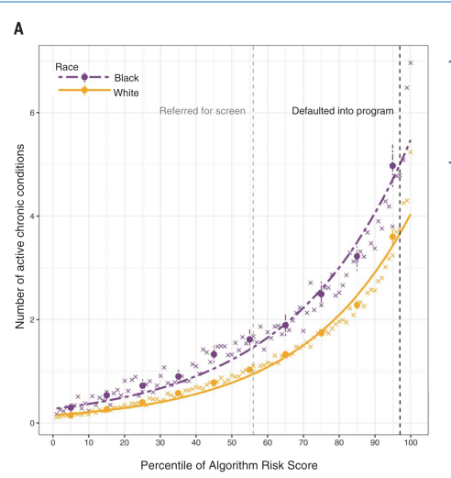
Mechanism of the bias in Obermeyer et al. (2019)
The algorithm is actually very good at what it was trained to do: predict future health care costs. At each level of predicted risk, Black and White patients generate roughly the same costs the following year. So, in terms of costs, the model is well calibrated across races.
The problem is what that cost is used as a proxy for.
• In the US, cost is a bad proxy for health need.
• Because of unequal access, discrimination and lower health care use, Black patients with a given level of illness typically generate lower costs than White patients who are equally sick.
So the model learns:
“lower cost ⇒ lower risk.”
As a result, Black patients who are just as sick but have had less money spent on them are scored as lower risk, and therefore get less access to extra care. The bias comes not from the algorithm mispredicting costs, but from choosing cost instead of health need as the target variable.

Similar issues with predictive policing
Predictive policing uses past crime data to statistically predict which individuals or places have an increased probability of criminal activity. The idea is that by analysing patterns in previous crimes, police can target interventions and prevention strategies more “efficiently” (Meijer and Wessels 2019).
A key application is recidivism prediction:
- Tools like those studied by Dressel and Farid (2018) estimate a defendant’s likelihood of reoffending.
- These risk scores are used in pretrial (bail decisions), parole (early release), and sometimes sentencing decisions.

9. Case: Predictive Policing and Informal Institutions

Predictive policing informal institutions matter Meijer, Lorenz and Wessels 2021
Predictive policing does not have one fixed effect. What happens when an algorithm is introduced depends heavily on informal institutions
social norms, professional culture, and how officers interpret the tool.
- The outcome of algorithmisation is therefore not determined just by the technology, but by how the organisation uses and understands it.
Meijer et al. identify two ideal type outcomes:
- Algorithmic cage
  - Strong hierarchical control.
  - The algorithm’s output is treated as binding. Officers are expected to follow the risk map and have little room to deviate.
  - Example in the article: Berlin. The system constrains professional judgment like a cage.
- Algorithmic colleague
  - The algorithm is treated as a colleague or aid.
  - It provides input, but officers retain substantial professional discretion and can question, ignore or reinterpret the recommendations.
  - Example: Amsterdam. The system is one voice among others in decision making.
So, the same predictive policing tool can either tighten top down control or support professional judgment, depending on the informal norms and organisational culture into which it is inserted.

10. Two Main Approaches to Regulating AI

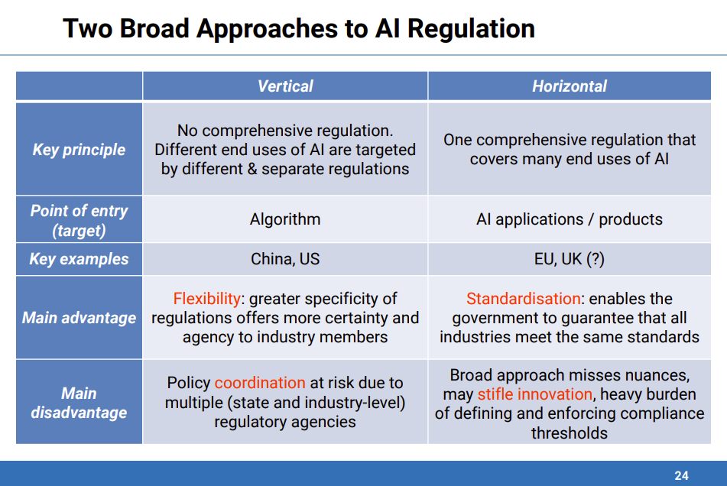
Vertical approach
AI is regulated through existing sectoral regimes, for example financial, health, transport or security law. The focus is on the specific algorithm in its context. This offers high flexibility and granularity, since expert regulators can tailor rules to particular risks, but it creates fragmentation and coordination problems across agencies and levels of government.
Horizontal approach
AI is regulated through one overarching framework that applies across many uses. The focus is on the AI system or product as a general class. This delivers standardisation and a level playing field and makes it easier to guarantee minimum safeguards in all sectors, but it can miss sector specific nuances and impose a heavy compliance and enforcement burden, with potential effects on innovation.

11. The European , American, and Chinese Approaches to AI Regulation

1) The European AI Act is the first comprehensive legal framework for how AI systems are developed, placed on the market, and used in the EU. It is already in force, but many obligations phase in over the next few years.
Main philosophy:
- In force since 12 July 2024, with gradual implementation and several important provisions expected to bite fully only around 2027.
- Built on a risk based, tiered, product safety logic: higher risk systems face stricter requirements for data quality, documentation, transparency, human oversight, and robustness.
- Strongly inspired by GDPR and earlier EU experience with algorithmic decision making, including court cases on automated dismissals in platform work.
Governance is multi level:
- At EU level, implementation is coordinated by the European AI Board and the European Commission’s AI Office for general purpose systems.
- At national level, each member state appoints a market surveillance authority that enforces the Act domestically and reports back to the EU institutions.

2) The US approach to AI regulation
The United States follows a fragmented, sector specific approach rather than a single AI law.
- First federal initiatives
  - 2019 Executive Order on Maintaining American Leadership in Artificial Intelligence
  - 2022 AI Bill of Rights, which is non binding guidance, not legislation
- Regulatory style
  - Risk based and sectoral, with rules spread across many federal agencies
  - In practice this is highly scattered, and many agencies have not fully implemented the requested AI oversight plans
  - Strong emphasis on industry self regulation and voluntary standards
- State level developments
  - California: mandatory algorithmic impact assessments for automated decision tools in some contexts
  - Illinois: Artificial Intelligence Video Interview Act, restricting how AI can be used in hiring interviews
In short, the US currently has a patchwork of guidance and state laws, rather than a comprehensive federal AI framework like the European AI Act.

3) The Chinese approach to AI regulation
China has the world’s first nationally binding legislation explicitly targeting algorithms, framed within the New Generation AI Development Plan (2017), which sets a timetable for AI governance up to 2030.
It follows a vertical, algorithm centric model: separate regulations for different types of algorithms, with a strong focus on information control.
- Recommendation algorithms (2021)
Mainly aimed at controlling online information flows and agenda setting on platforms.
- “Deep synthesis” algorithms (2022)
Target technologies behind deepfakes, focusing on traceability and labelling of synthetic content.
- Generative AI rules (2023, not fully implemented)
Very demanding: include a mandatory algorithm registry and requirements that training data meet standards of “truth, accuracy, objectivity and diversity.”
Overall, China illustrates iterative policy learning in AI governance, gradually expanding and tightening rules while building bureaucratic know how around specific algorithm types.

12. Guiding Principles for the Future Uses of AI in Public Policy
- Human dignity and autonomy
  - Respect individual rights and freedoms when designing and deploying AI.
  - Avoid systems that undermine human agency, for example fully automated welfare sanctions with no meaningful appeal, or tools that nudge people in ways they cannot detect.
  - Rule of thumb: people should still be able to understand, contest and influence decisions that affect their core life chances.
- Democracy and transparency
  - AI systems used by government should be transparent, accountable and open to public scrutiny (documentation, explanations, registers).
  - Preserve democratic values by informing citizens when AI is used and enabling participation in AI related policymaking, for example through consultations or impact assessments published for comment.
- Fairness and equity
  - Prioritise fairness by monitoring and mitigating bias in data and models, especially against historically marginalised groups.
  - Ensure equitable access to benefits (who gets the extra health services, training, subsidies etc.) and guard against reproducing or amplifying existing inequalities like in the Obermeyer health risk case.
- Safety and reliability
  - Make sure AI systems are secure, robust and reliable under real world conditions, not just in the lab.
  - Carry out regular audits, validation and monitoring so that drifts, failures or misuse are detected early, maintaining public trust in digital government.
- Sustainability
  - Align AI applications with sustainable development goals, for example using them to improve energy efficiency or public transport rather than only for surveillance or cost cutting.
  - Consider both the environmental footprint (compute, energy, hardware) and the long term social impacts of automation when deciding whether and how to deploy an AI system.

Reading 18: Dudley, Banister, and Schwanen (2017)

“The Rise of Uber and Regulating the Disruptive Innovator”

1. Uber as a Disruptive Innovator
The article argues that Uber is a textbook case of a “disruptive innovator”:
- Simple, user friendly technology, mainly a smartphone app that handles booking, routing, pricing, and payment.
- Sharing economy model that uses underutilised capacity, private cars that are idle most of the time.
- Aggressive global expansion, backed by huge venture capital investment and a strategy of entering markets first and dealing with regulators later.
Uber tries to frame itself as a neutral “technology platform” and its drivers as “partners” rather than employees, to avoid existing taxi and labor regulations.
Example: in many cities Uber undercut traditional taxi fares by letting almost anyone with a suitable car sign up, which increased competition but also triggered protests and legal battles.

2. Political Dilemma for Regulators
Governments face a serious balancing act:
Dudley et al. - 2017 - The Rise…
- On one hand
  - Uber provides cheaper, often more reliable services, and creates new opportunities for flexible work.
  - It can help fill gaps in urban transport, especially in suburbs.
- On the other hand
  - It threatens the livelihoods of traditional taxi drivers who invested heavily in licenses and training.
  - It challenges rules on safety, insurance, and labor rights, and can make regulators look weak if they cannot enforce their own frameworks.
The term “uberisation” now labels similar disruptions in other sectors, where platforms use tech and spare capacity to overturn existing business models.

3. Uber in London: Winning as a Disruptor
London is the central case study. Uber started there in 2012 and was licensed from the beginning, unlike in some other European cities.
Dudley et al. - 2017 - The Rise…
- Background
  - Transport for London (TfL) was worried about capacity during the 2012 Olympics and may have seen Uber as a helpful extra option.
  - Uber quickly expanded and, by 2015, was a major player with about 14 000 drivers.
- Conflict with black cabs
  - Black cabs hold “plying for hire” licenses, can be hailed on the street, and drivers must pass “the Knowledge” after years of memorising the city’s streets.
  - Private hire vehicles, including Uber, must be pre booked.
Uber’s app, variable pricing, and lower fares allowed it to exploit weaknesses in the existing taxi system. Black cab drivers targeted TfL in protests, accusing the regulator of failing to enforce fair competition.
Example: in June 2014 thousands of black cabs blocked central London in protest, but Uber claimed that app sign ups jumped massively during the protest, which ironically increased its visibility.

4. Exploiting Old Rules and Political Arenas
Uber used regulatory gaps to its advantage.
Dudley et al. - 2017 - The Rise…
- Taximeter dispute
  - Black cabs argued that Uber’s app was an illegal taximeter, which only black cabs were allowed to use under a 1998 law.
  - TfL took the issue to the High Court.
  - The Court ruled that the app was not a taximeter, which legitimised Uber’s model and showed how outdated the legal framework was.
- TfL reaction
  - TfL considered new rules like a mandatory five minute wait time after booking or bans on showing nearby cars on the app.
  - Uber responded with a huge lobbying campaign and a public petition with around 200 000 signatures, plus support from business groups.
  - The head of the UK Competition and Markets Authority warned that TfL’s proposals might harm competition and consumers.
Result: in early 2016 TfL dropped its plans. Uber successfully framed itself as the innovative, consumer friendly option while portraying TfL and black cabs as protectionist and anti innovation.

5. Limits to Disruption: Congestion, Identity, and Jobs
As Uber grew, side effects became more visible.
Dudley et al. - 2017 - The Rise…
- Congestion
  - Private hire vehicles in London grew to over 110 000, with about 30 000 Uber cars by 2016.
  - Mayor Boris Johnson complained that rising numbers undermined the congestion charge policy.
- Iconic status of black cabs
  - Black cabs are part of London’s identity, so their decline is politically sensitive.
  - A 2016 “Taxi and Private Hire Action Plan” under new Mayor Sadiq Khan offered some help to black cabs, for example more bus lane access and tougher enforcement against illegal operators.
- Mixed policy messages
  - Courts allowed some stricter measures, like English language tests for drivers, but struck down others.
  - Think tank reports advised black cabs to compete on quality and convenience instead of relying on protection.
Example: even as Uber won big legal and political victories, policymakers still tried to preserve the black cab as a symbol and as a regulated high quality service, which limited how far Uber could dominate the market.

6. Uber’s Employment Model and the Gig Economy
The biggest vulnerability in Uber’s model is how it treats drivers.
Dudley et al. - 2017 - The Rise…
- Drivers supply their own cars and bear many costs.
- Uber takes a significant commission on each ride.
- Drivers are classified as independent contractors, not employees.
This led to:
- Protests over falling incomes when commissions increased or fares fell.
- Court cases where drivers demanded recognition as workers entitled to minimum wage, holiday pay, and other protections.
- A 2016 London employment tribunal ruling that some drivers should be treated as workers, not just “partners.”
The case is emblematic of the wider “gig economy,” where people juggle multiple jobs and platforms. It raises questions about social protection in a world where traditional employer employee relationships are broken up.
Example: surveys showed that many Uber drivers in London had additional jobs, and for one in five Uber was not their main source of income, highlighting the precarious nature of this work.

7. Uber’s Next Frontier: Political Allies and Autonomous Vehicles
The article ends by looking forward.
Dudley et al. - 2017 - The Rise…
- Political alliances
  - Uber set up an advisory board with former top politicians and officials, trying to move from pure outsider disruptor to an insider with political capital.
- New services and sectors
  - Uber started partnering with municipalities in the United States, for example to provide rides for disabled people where public transport was weak.
  - This blurs lines between public and private, since Uber gains quasi public service roles.
- Autonomous vehicles
  - Uber invested heavily in self driving car research, launching pilot fleets in Pittsburgh and San Francisco.
  - It initially put cars on the road in San Francisco without proper permits and was ordered to pull them, then later agreed to seek permits.
Autonomous vehicles, if successful, could remove drivers entirely, which would massively change employment and the business model again. But the regulatory, safety, and ethical challenges are huge.
Example: if Uber ran a large fleet of self driving taxis, city planning, public transit demand, emissions, and labor markets for drivers would all shift. Governments would have to rethink everything from road rules to social security.

8. Link to Lecture Themes
The Uber case illustrates many lecture points:
- Disruptive platforms can outpace existing rules and force reactive learning by regulators.
- They exploit gaps in old frameworks, showing the importance of updating definitions, just like with AI.
- Political bargaining, public opinion, and institutional identity all shape how far regulation goes, not just expert evidence.
- Employment models based on platforms raise fairness and accountability issues similar to those in algorithmic decision making.
So Uber is not only a transport story. It is a preview of the regulatory struggles that accompany AI and other emerging technologies in many policy areas.

